15/3/2021

1. *p
2. (*ptr)[5] 🡪 **[is a pointer to an array of 5 ints].** Holds only 1 address at a time.  
   will not go to the individual elements of an array. Will jump from *ptr[0]🡪arr1[5] to another *ptr[1] 🡪 arr2[5].  
   It will make 5 pointers pointing to 5 elements of array respectively  
   So we can't access the second value in array using first pointer with increment
3. *ip[5]; 🡪**[is an array of 5 pointers.]**Holds the address of 5 individual array element at a time.ip[0] 🡪 1st element in arr1  
   ip[1] 🡪 2nd element in arr1  
   ip[2] 🡪 3rd element in arr1

Eg: (*ptr)[2];  
arr1[100] = {1,2,…100}  
Will jump twice each time

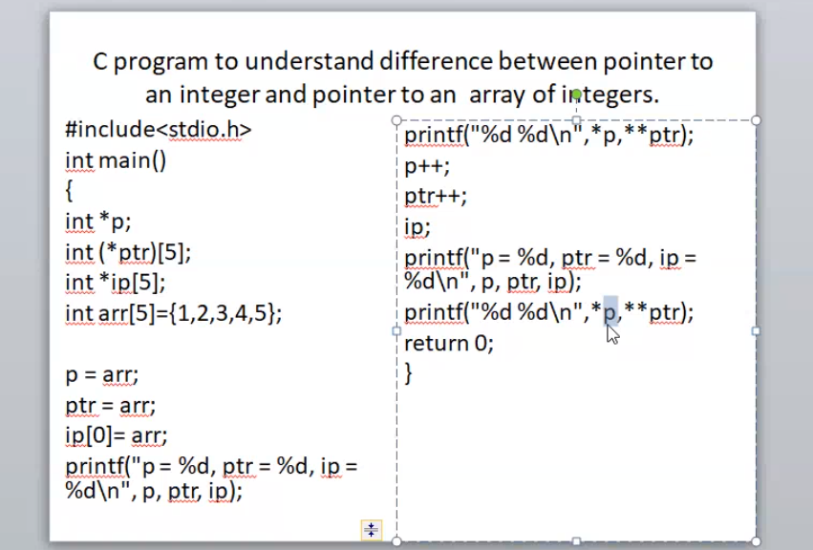

*p 🡪 what is p and *p ??  
**ptr 🡪 what is ptr, *ptr, **ptr???

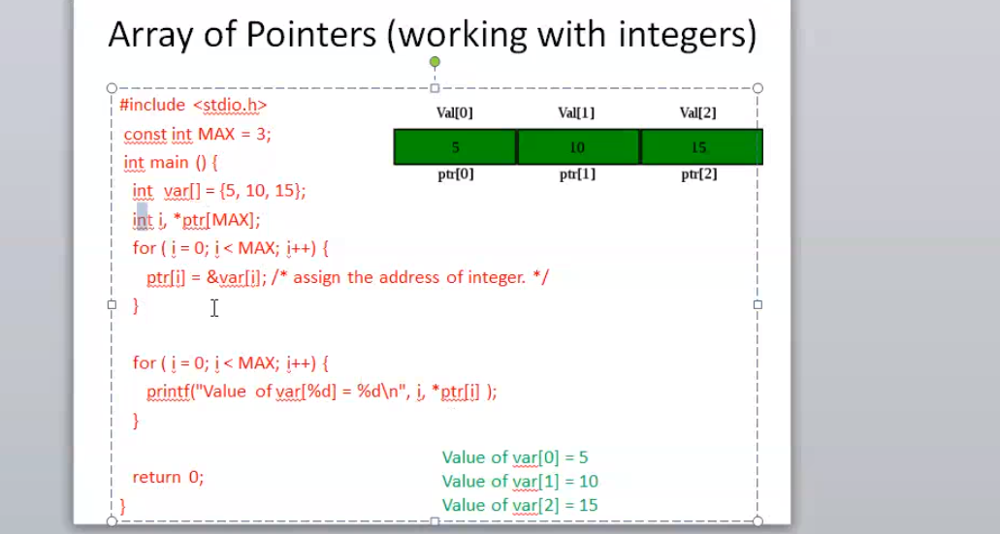

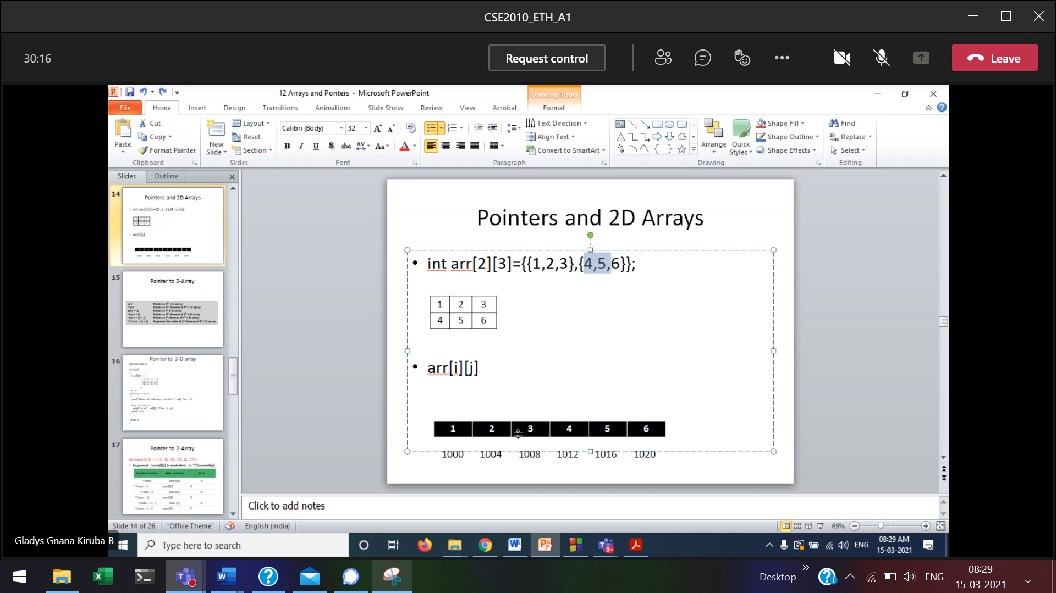

First rows and then only columns

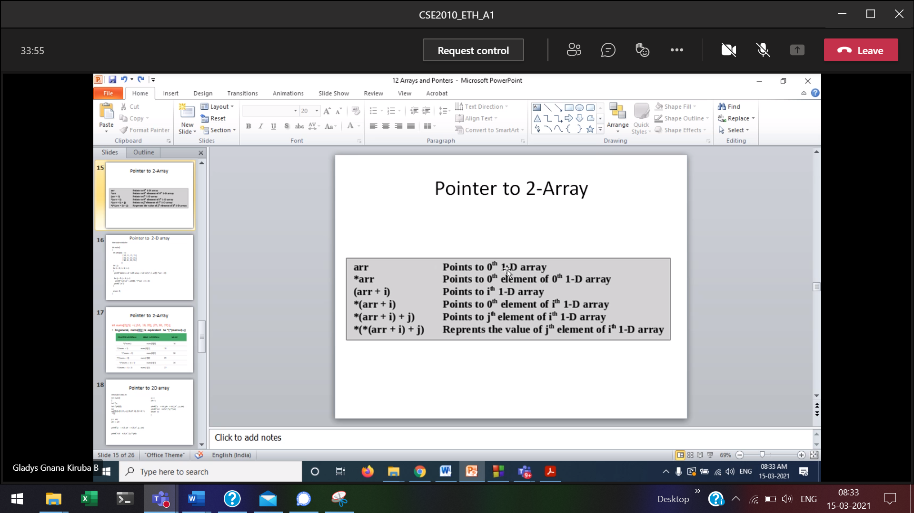

arr 🡪 points to the row number  
(arr+i) 🡪 (Pointing) Going to 0th,1st ,2nd row like that  
*(arr + i) 🡪 (Derefrencing) printing that 0th,1st,2nd row element.

*(arr+i)+j 🡪

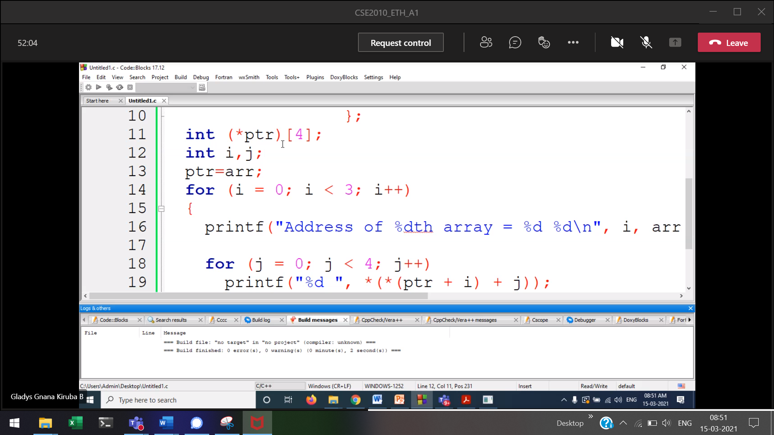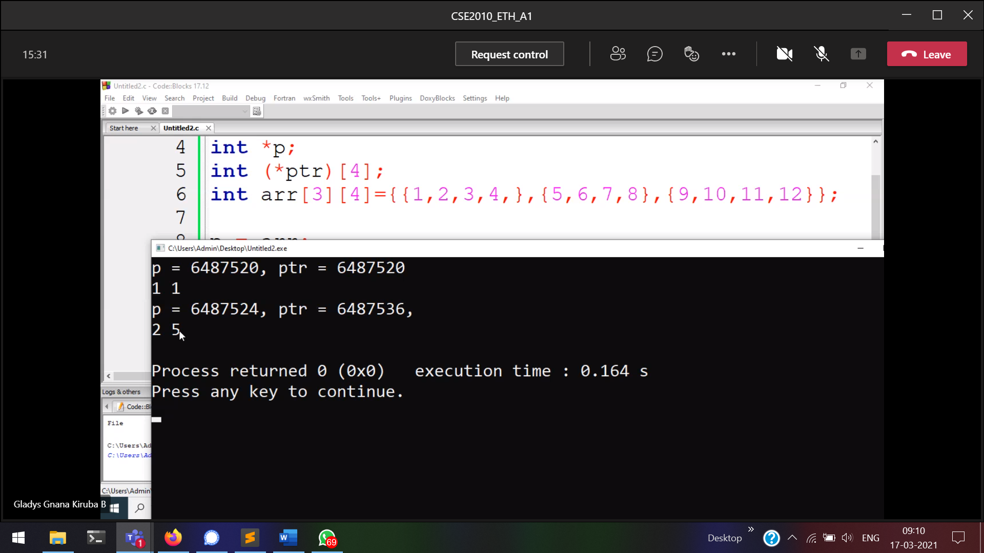



ptr jumping from 1st 1-D array to 2nd 1-D array  
p jumping from 1st element of the 1-D array to the 2nd element of 1-D array.

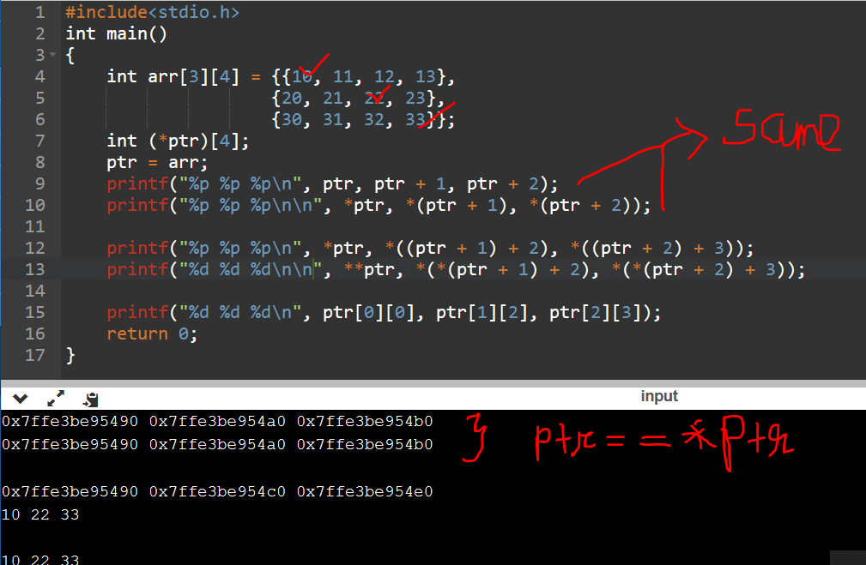

ptr points to the base address  
*ptr gives the base address  
**ptr prints the [0][0] element  
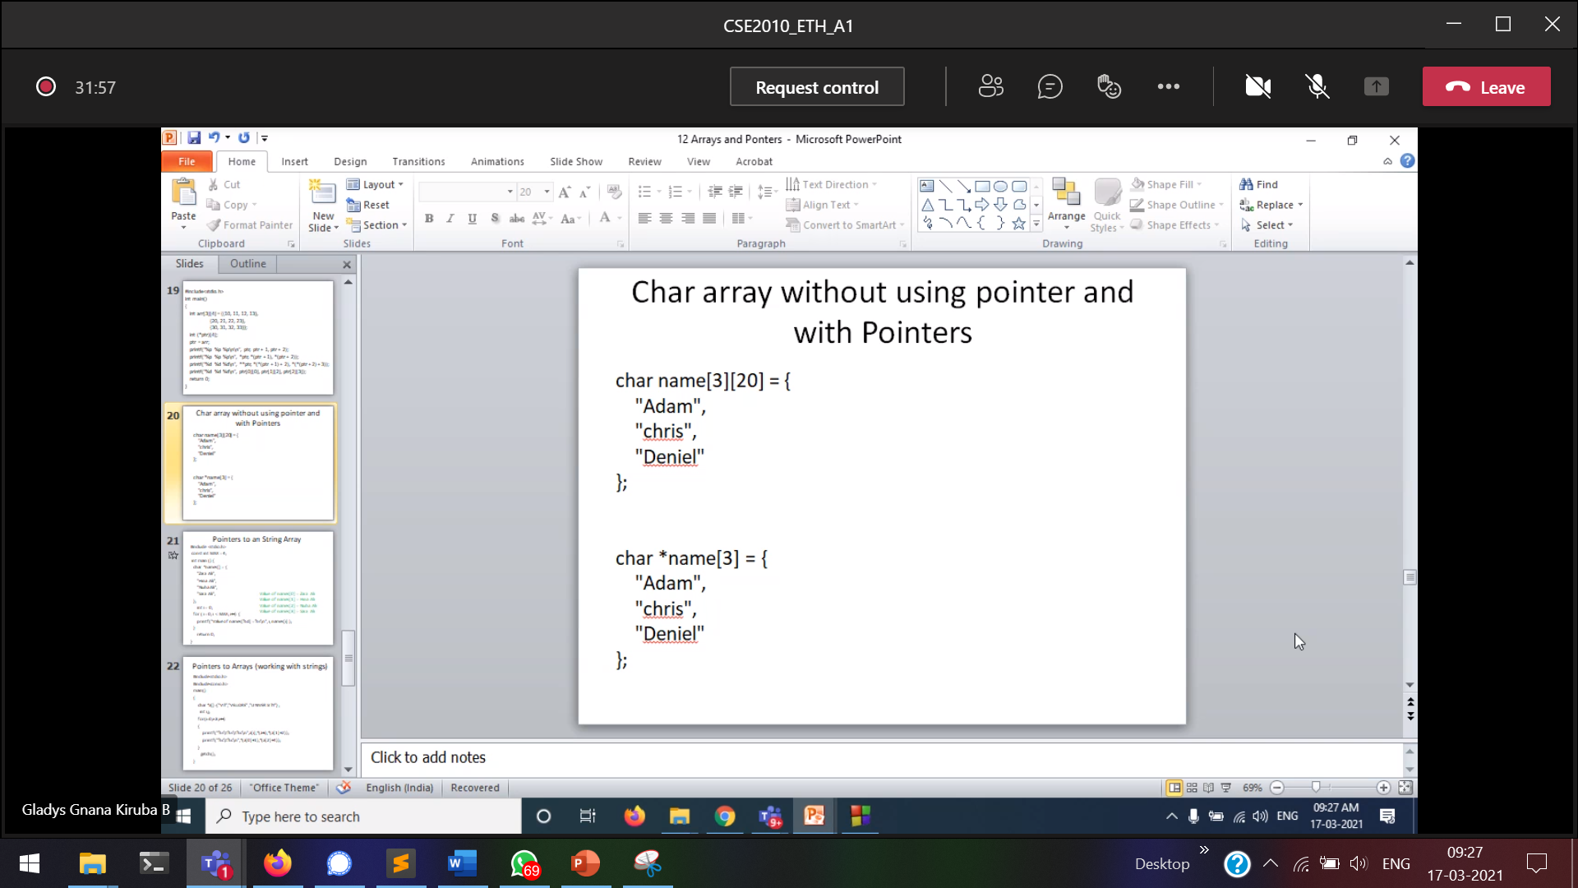

Using pointers in strings since we are not going to access individual character.  
Only full name we want

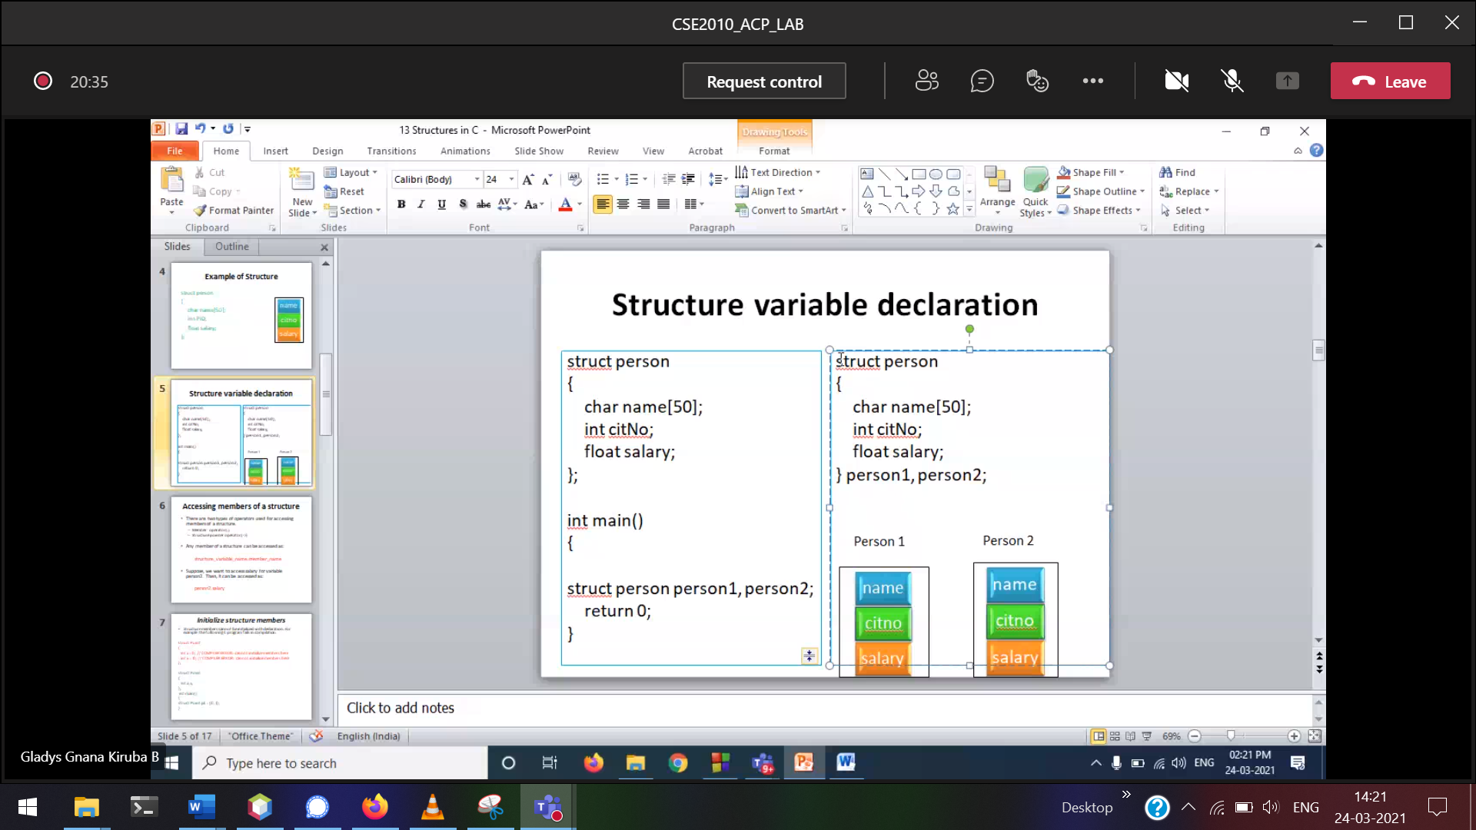

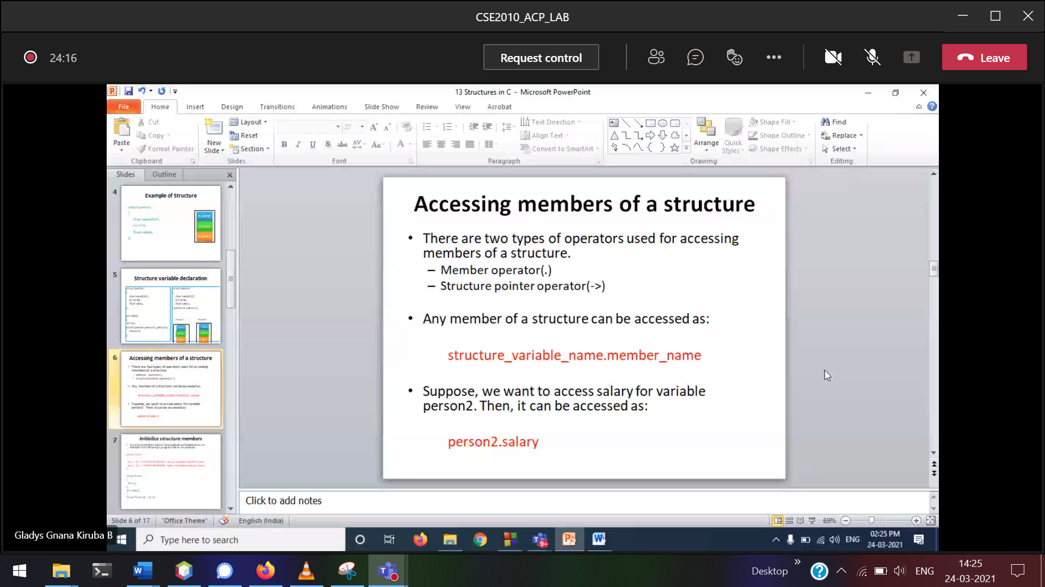

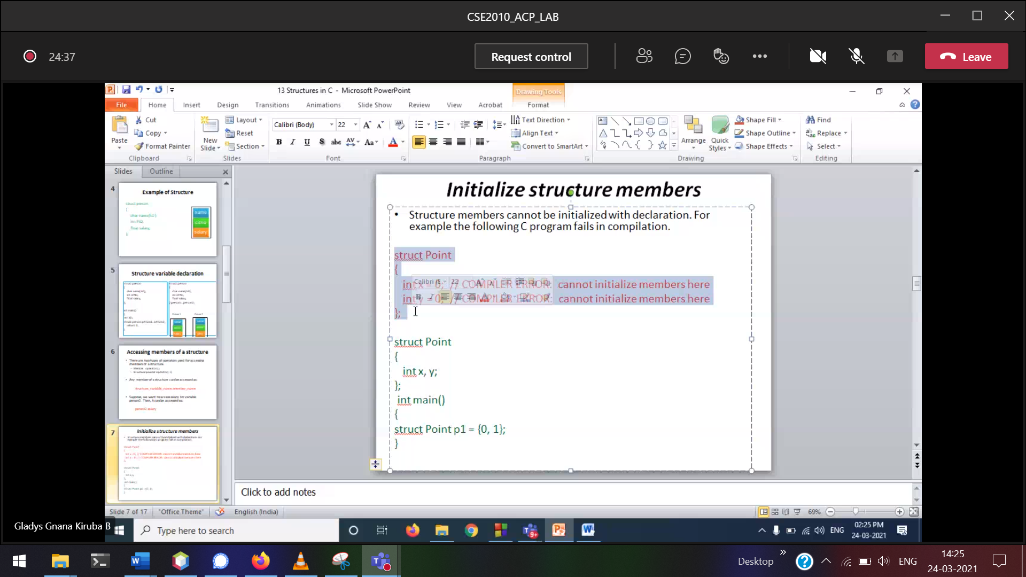structure will provide only definition.   
Declaration should be done only in main()

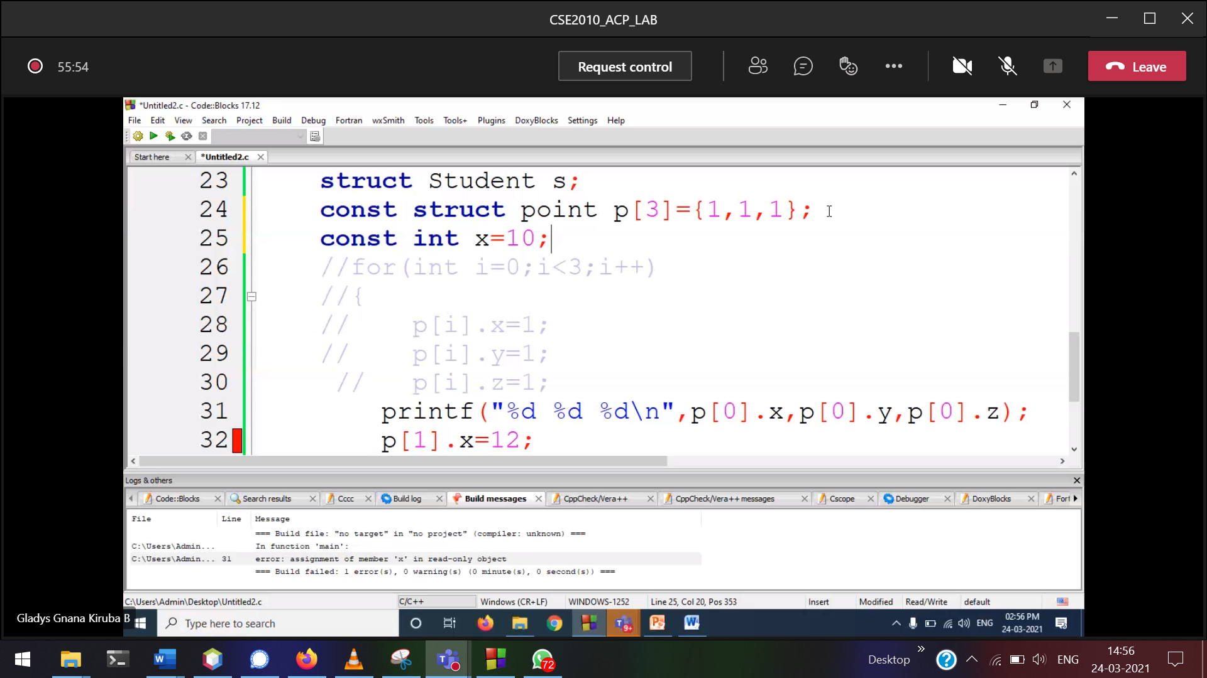

While defining what value, that only will accept.  
After that we cannot abut

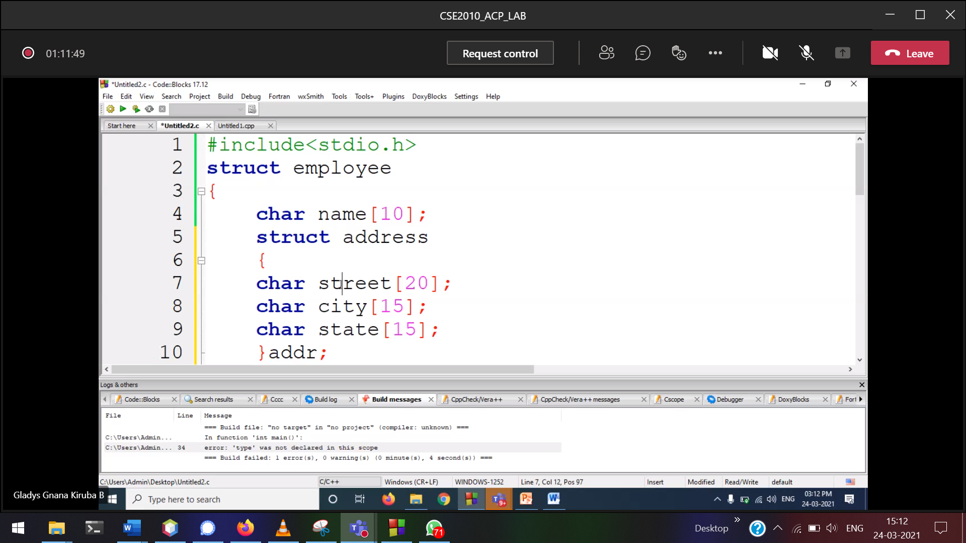

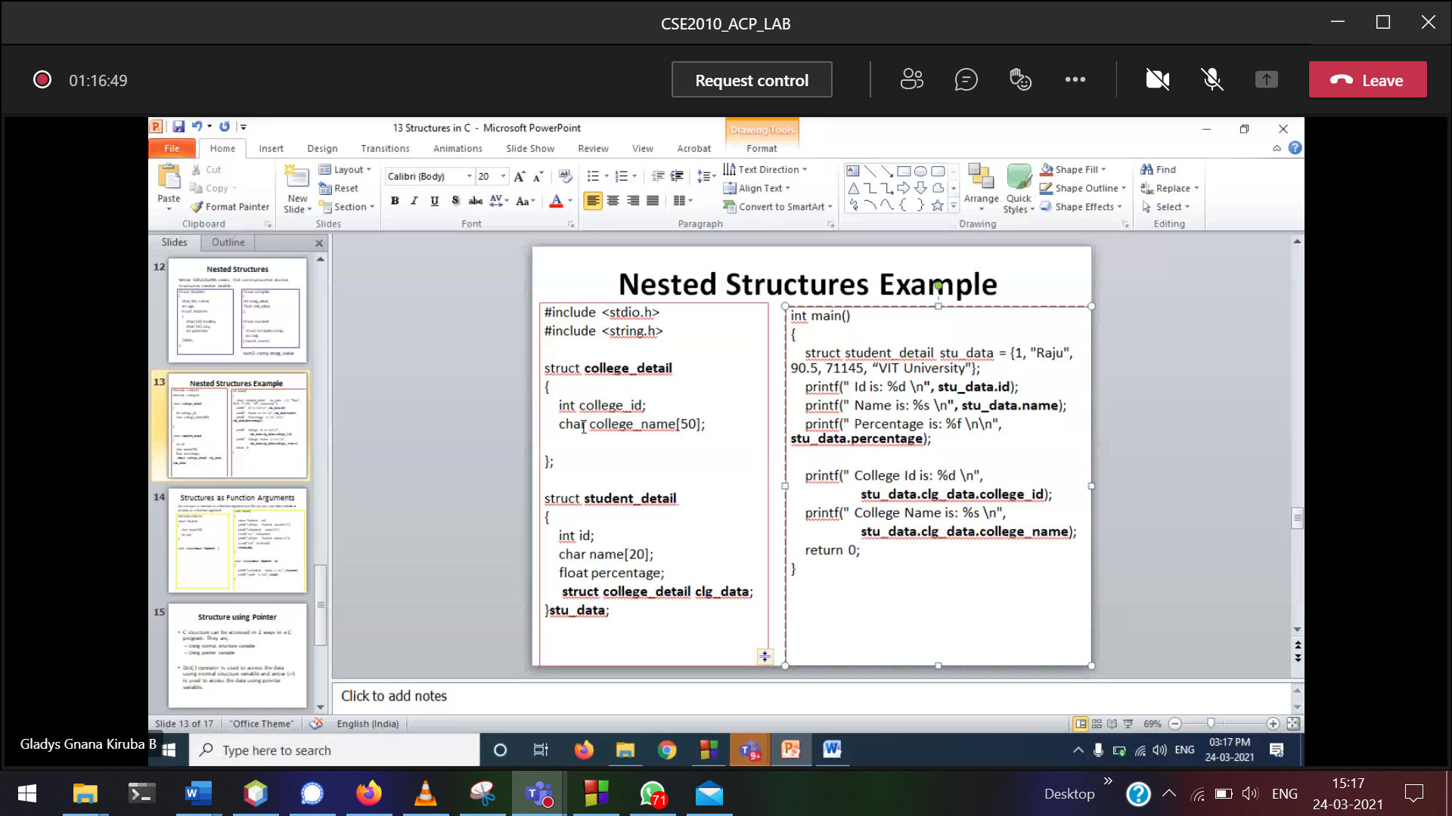 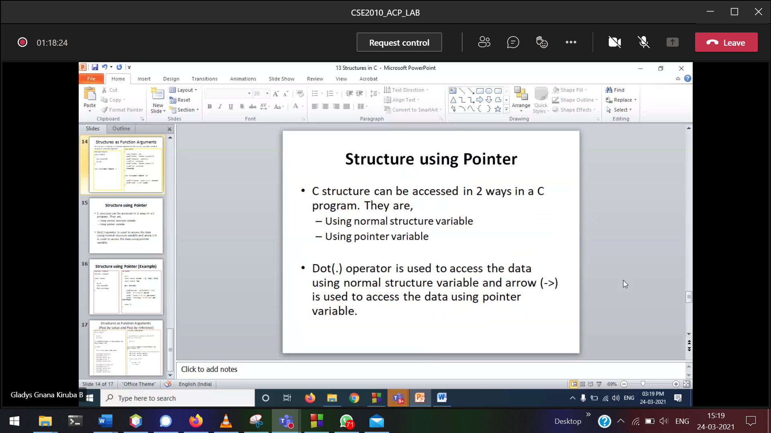

emp name  
emp id  
emp add  
emp des  
emp sal  
n employees

Find the maximum salary

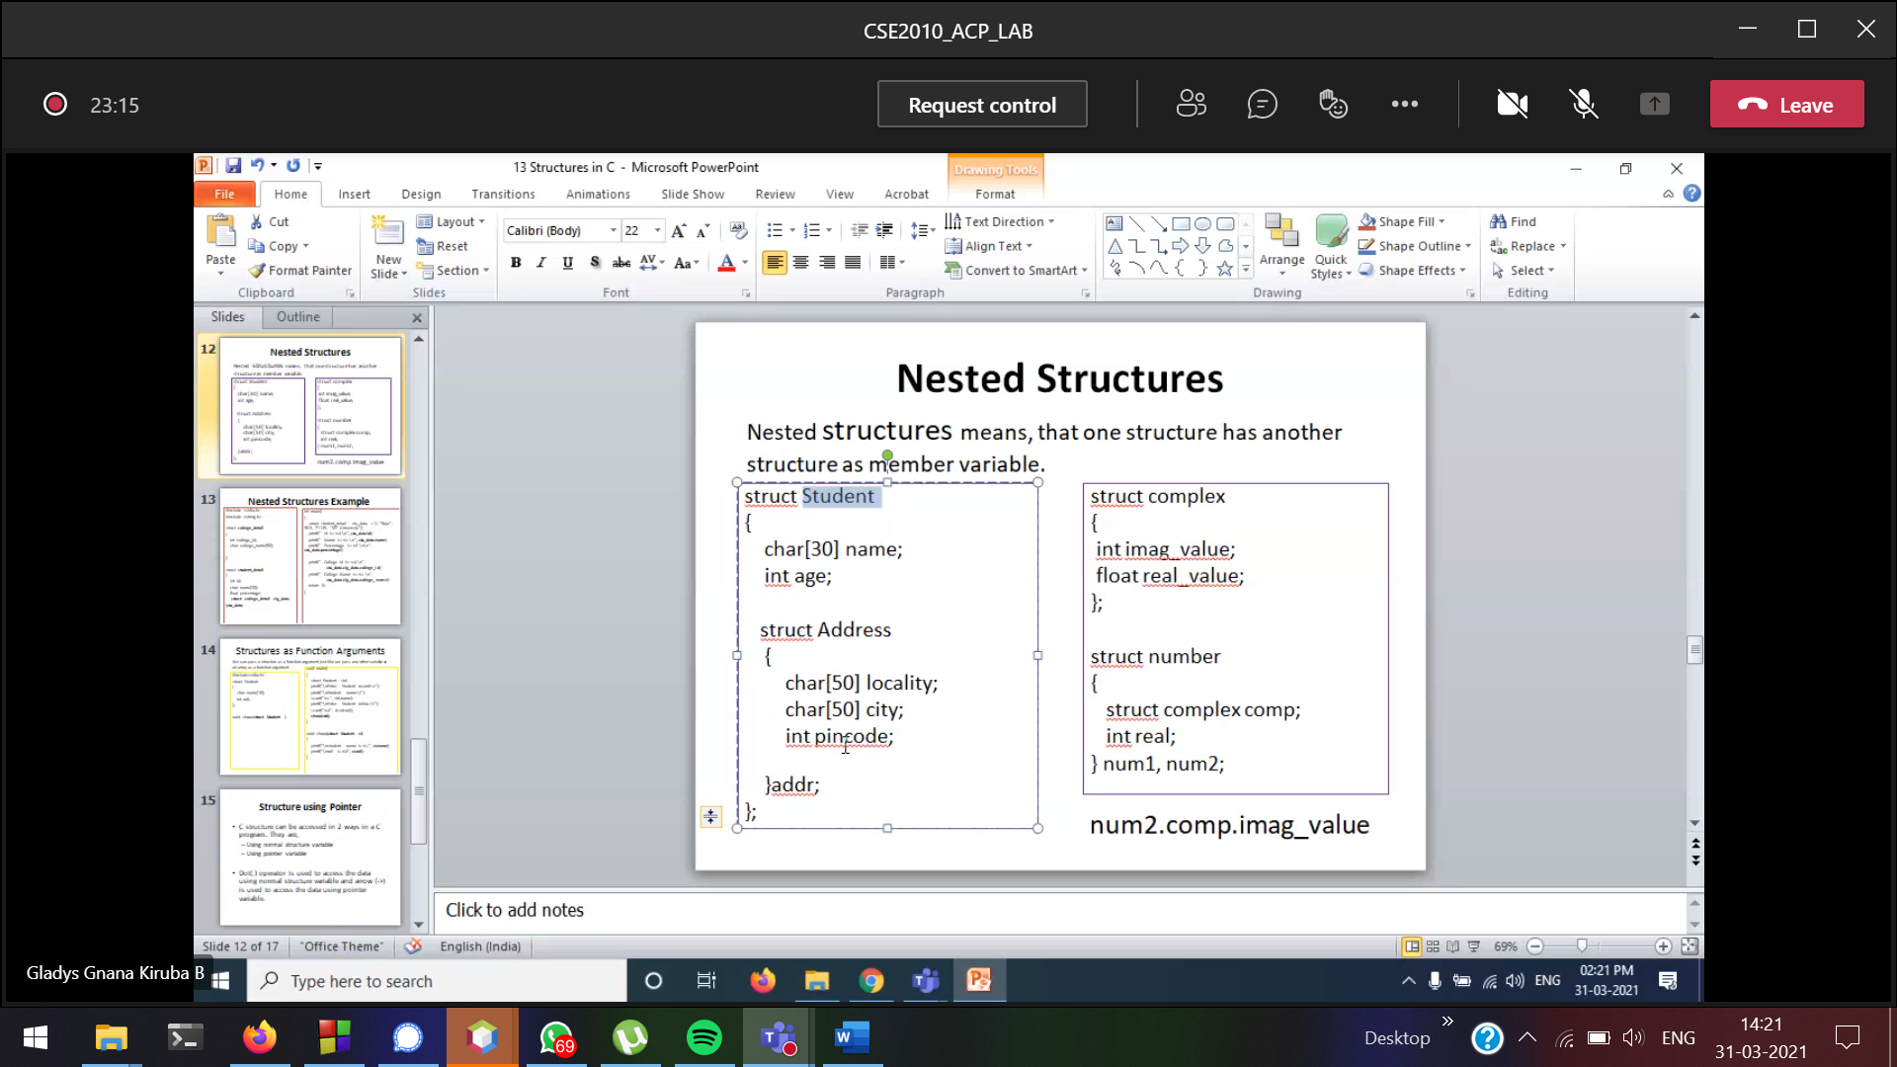

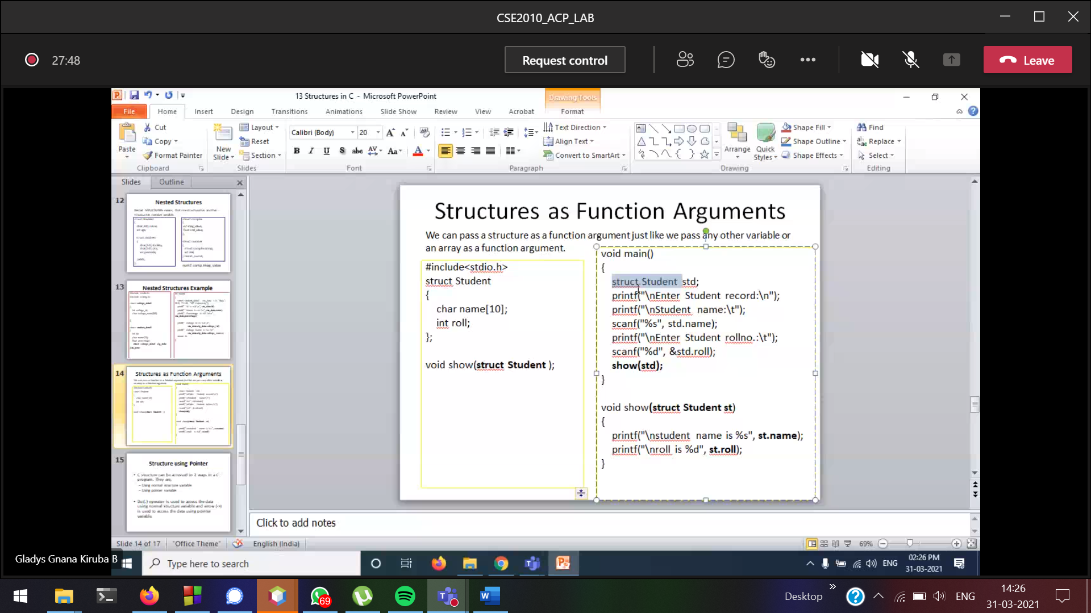

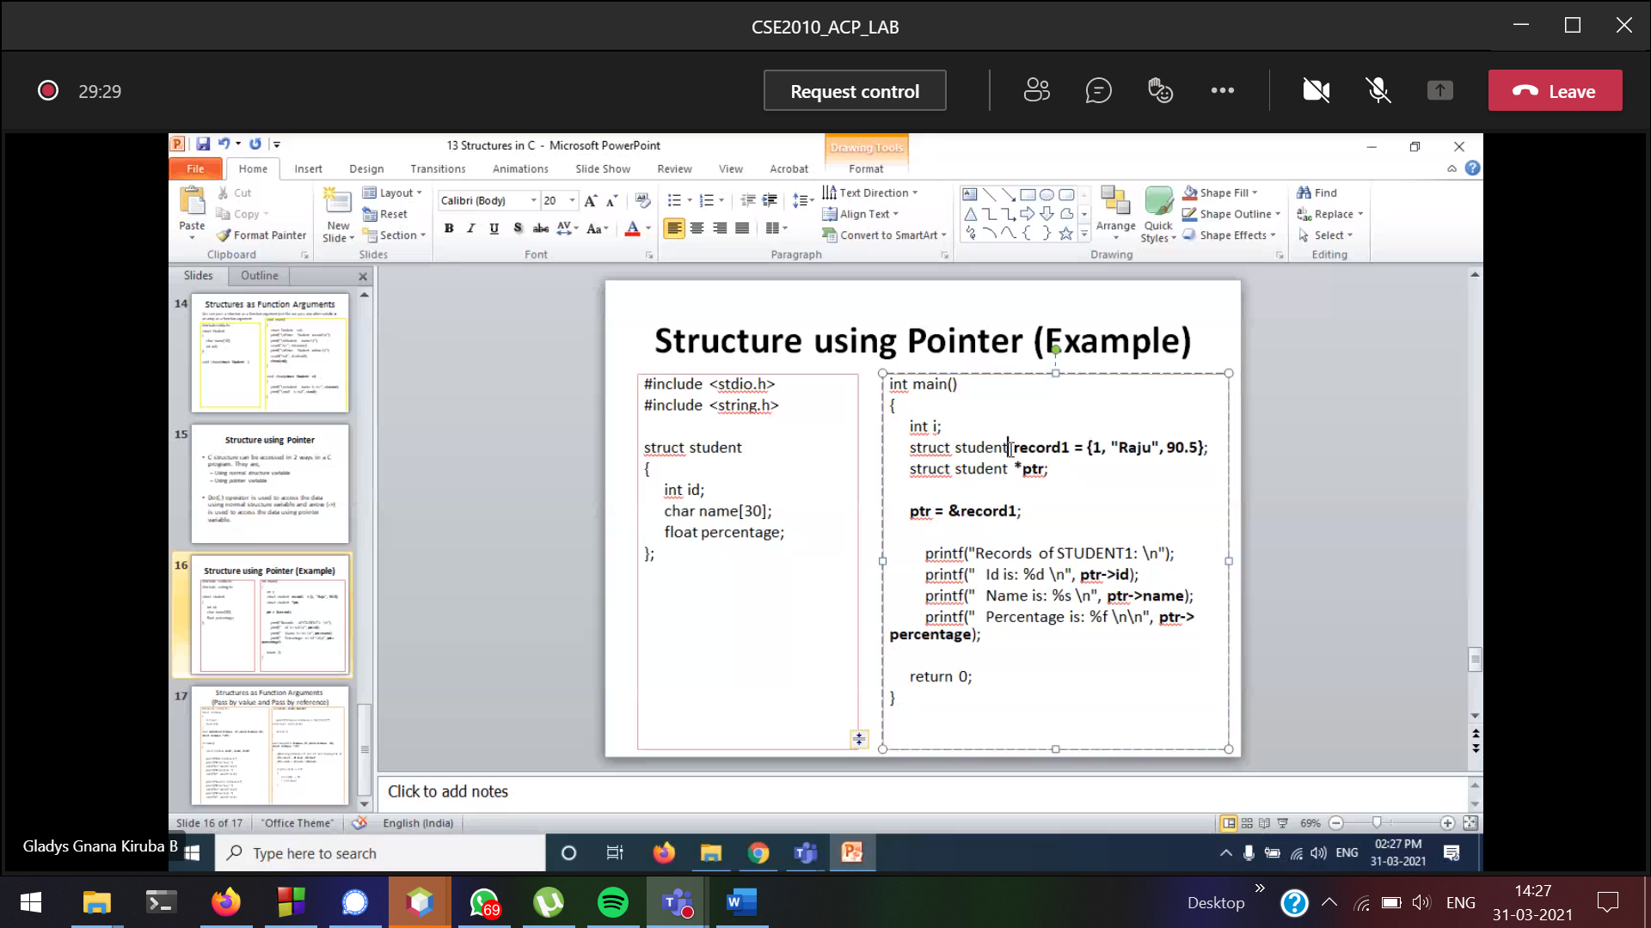

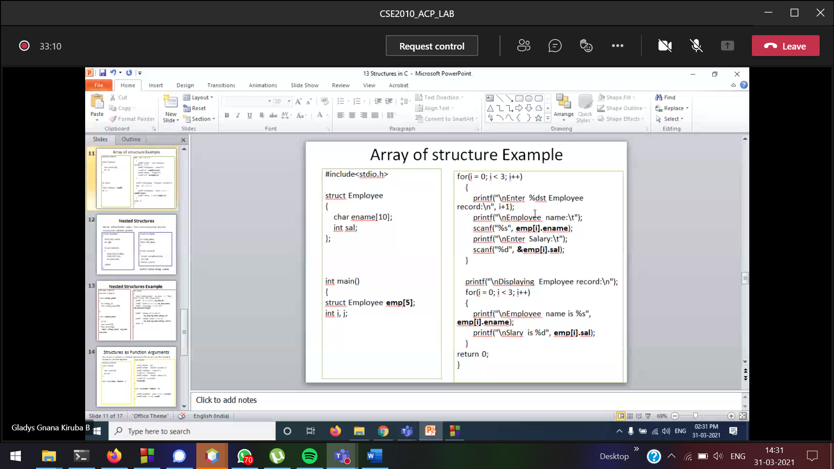

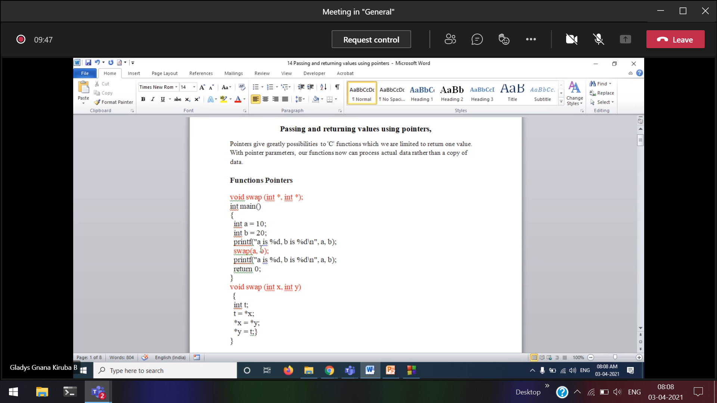

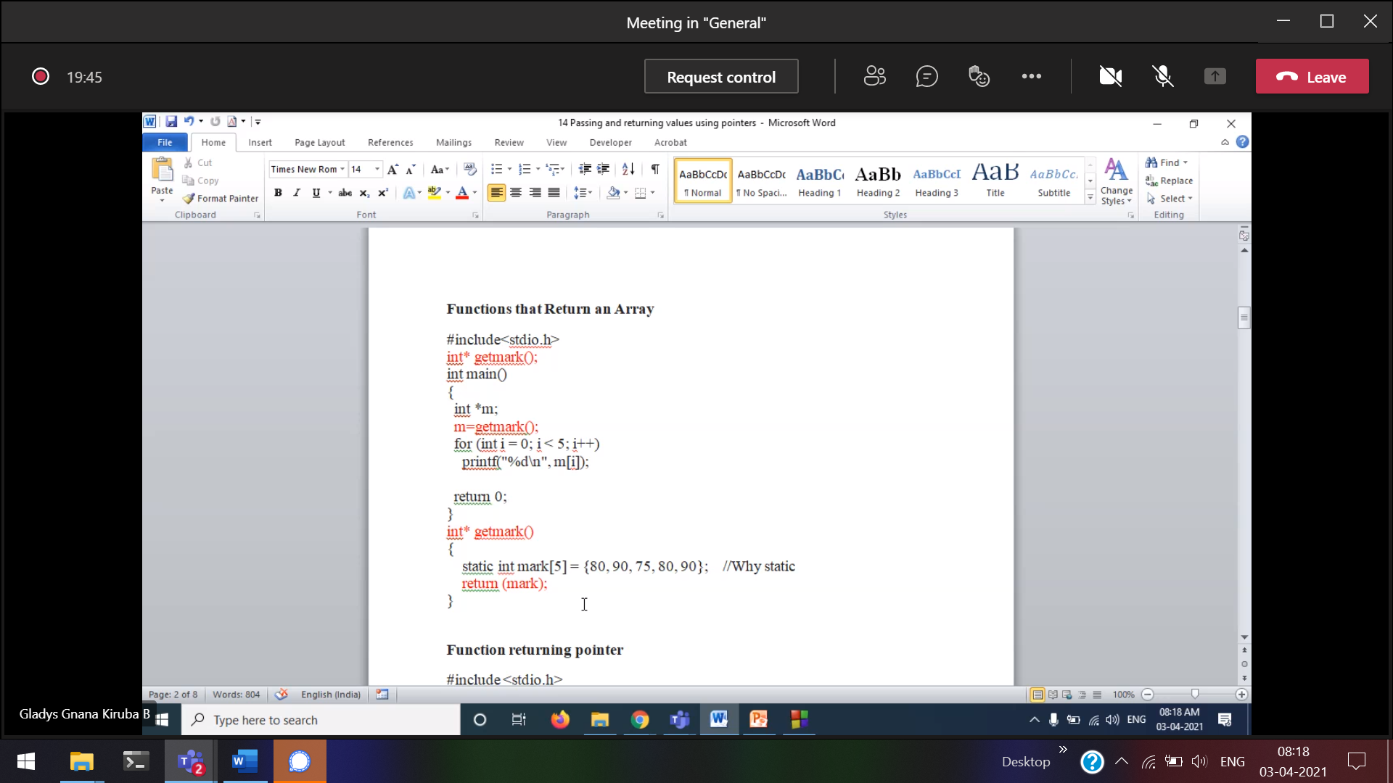

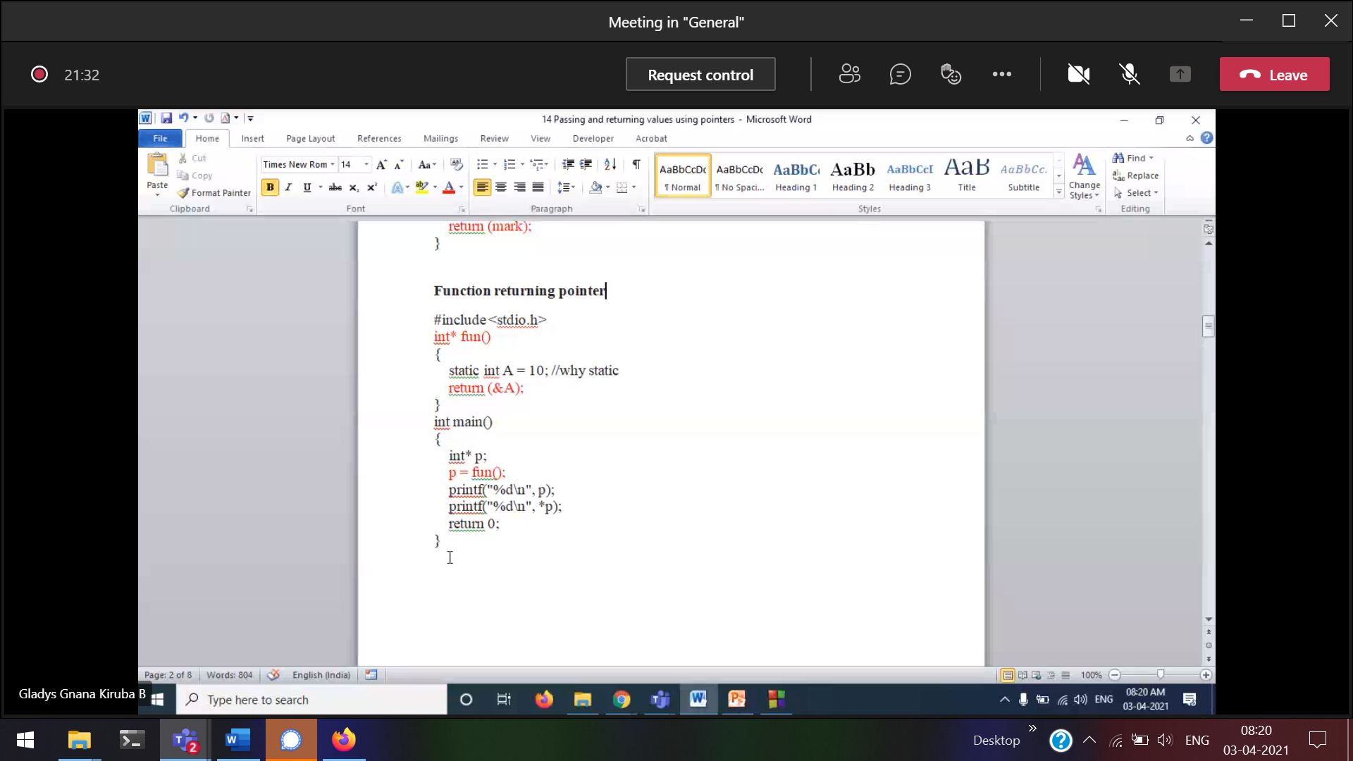

Try without static 🡪 A is the local variable, so after the function it exits. So *p will print as garbage value.  
p 🡪 holds the address of A, *p 🡪 has garbage value.

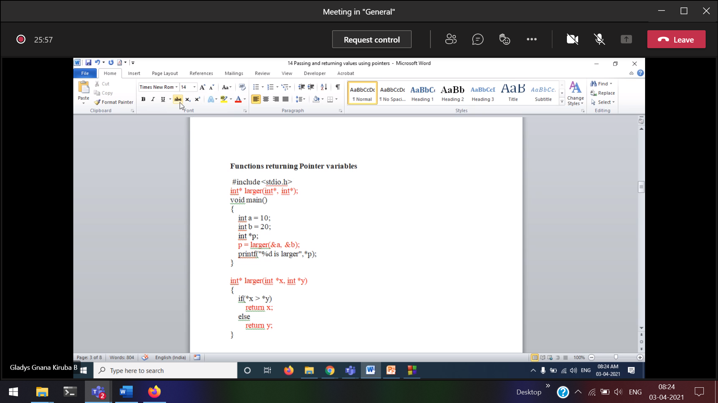

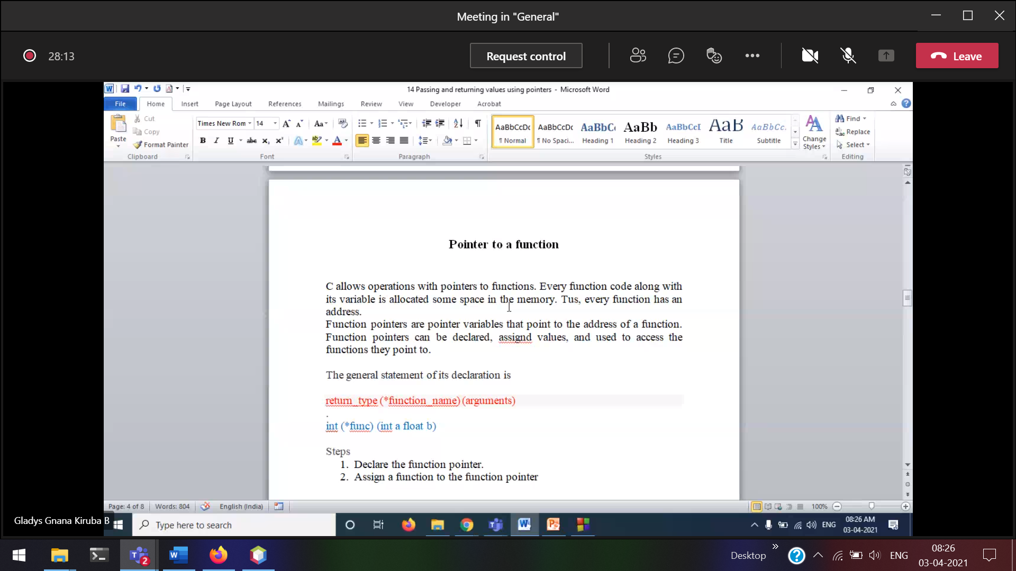

return_type (*function_name) (arguments)  
return_type *function_name (arguments)

What is the difference from the above ???/

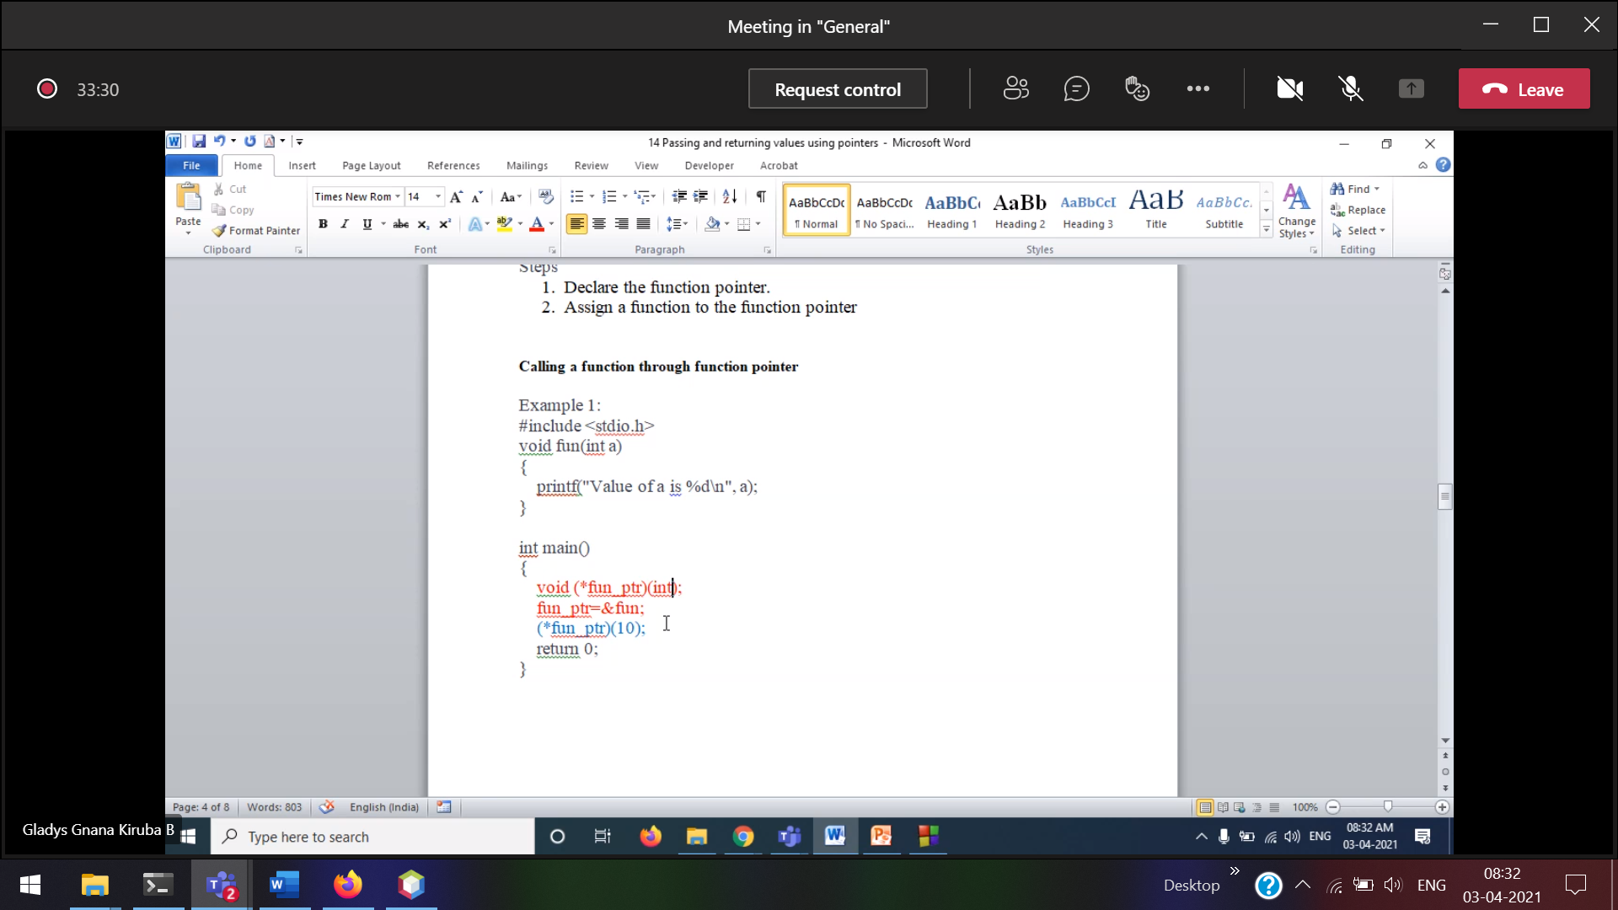

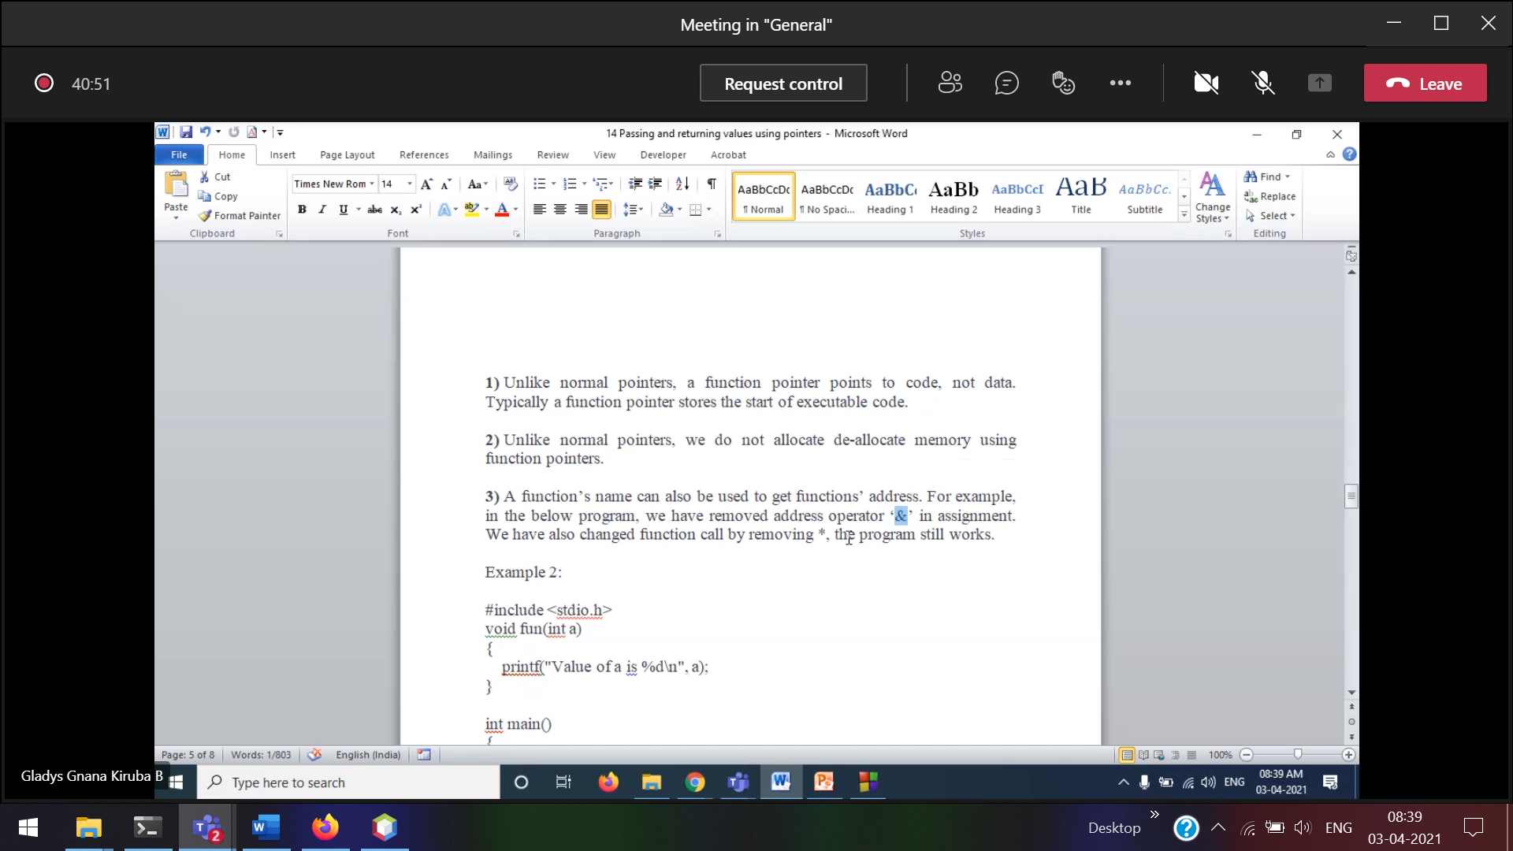

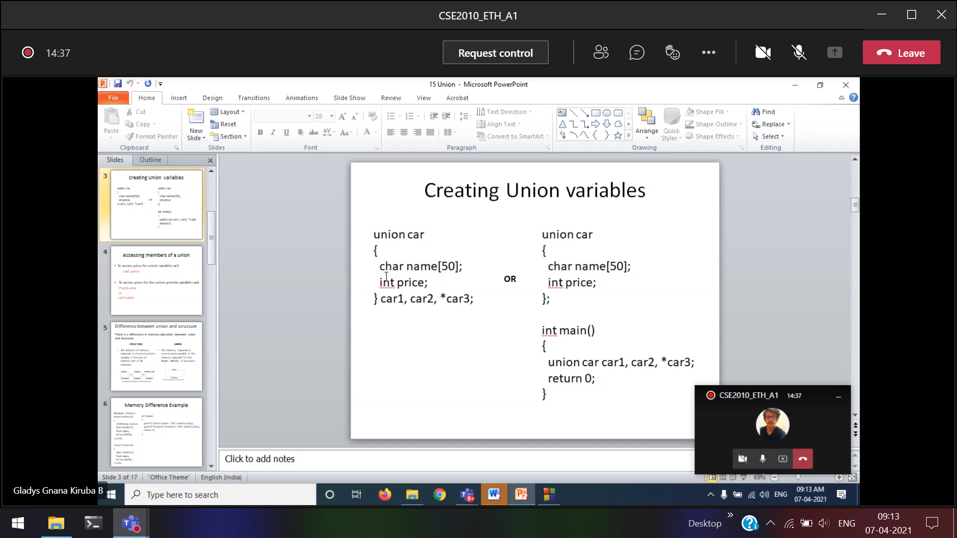

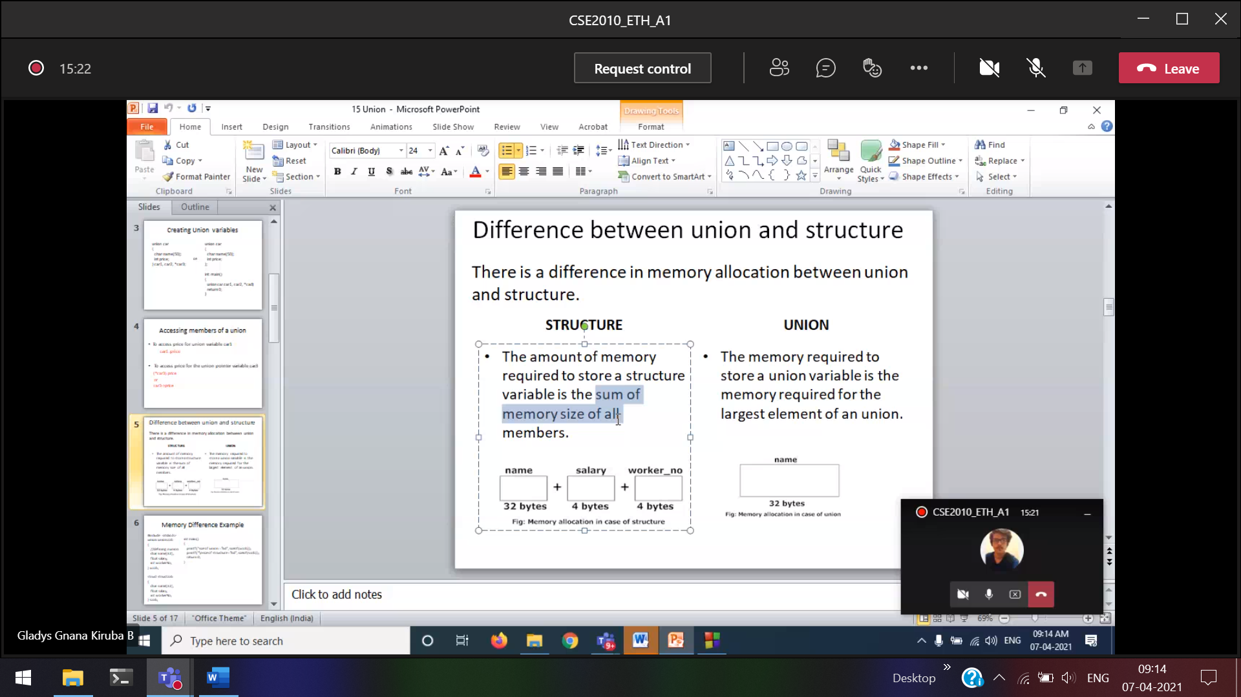

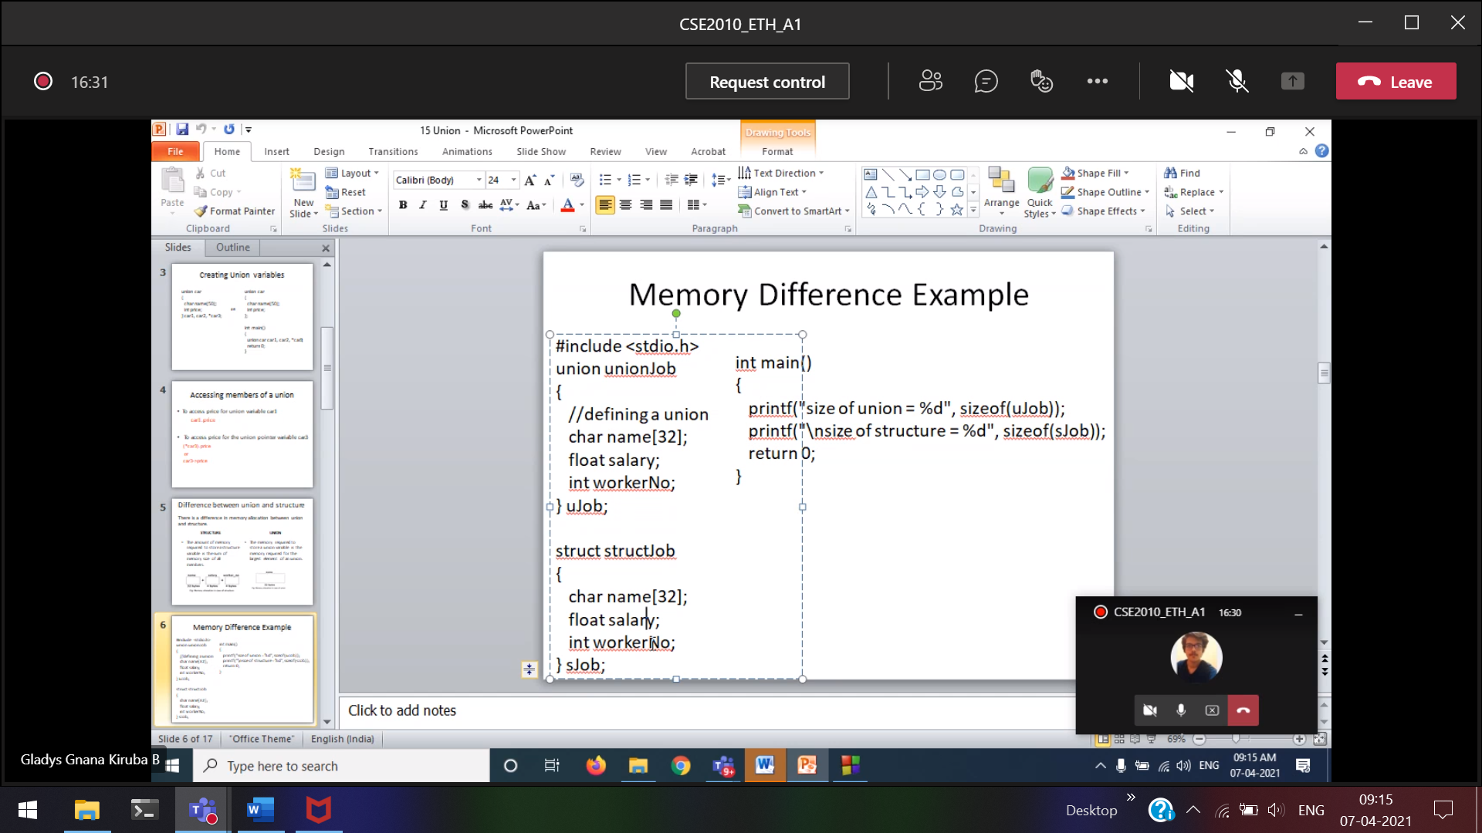

To reduce the memory usage, union can be used.

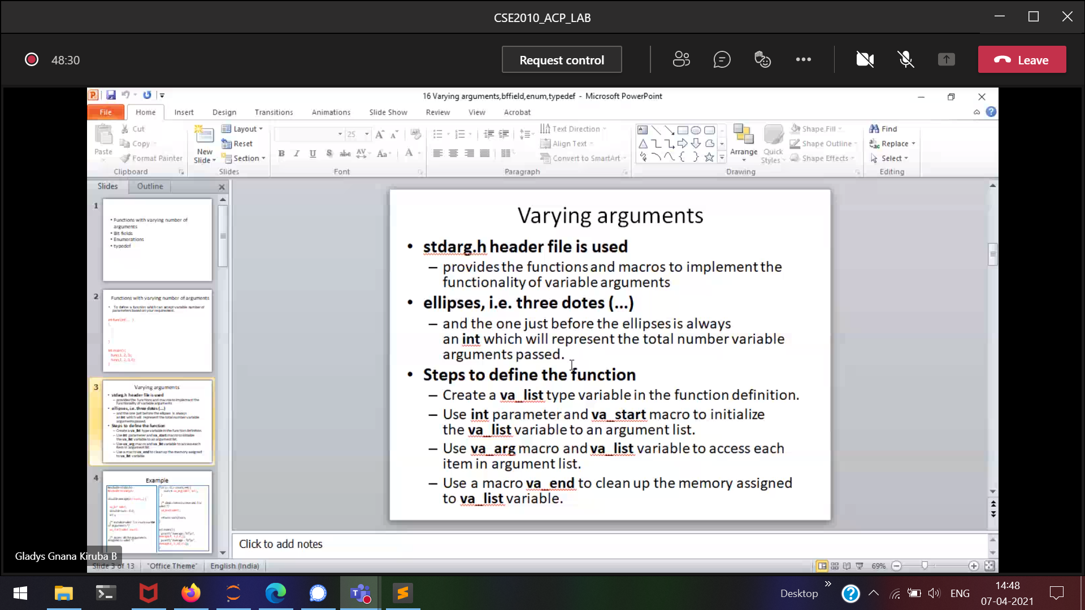

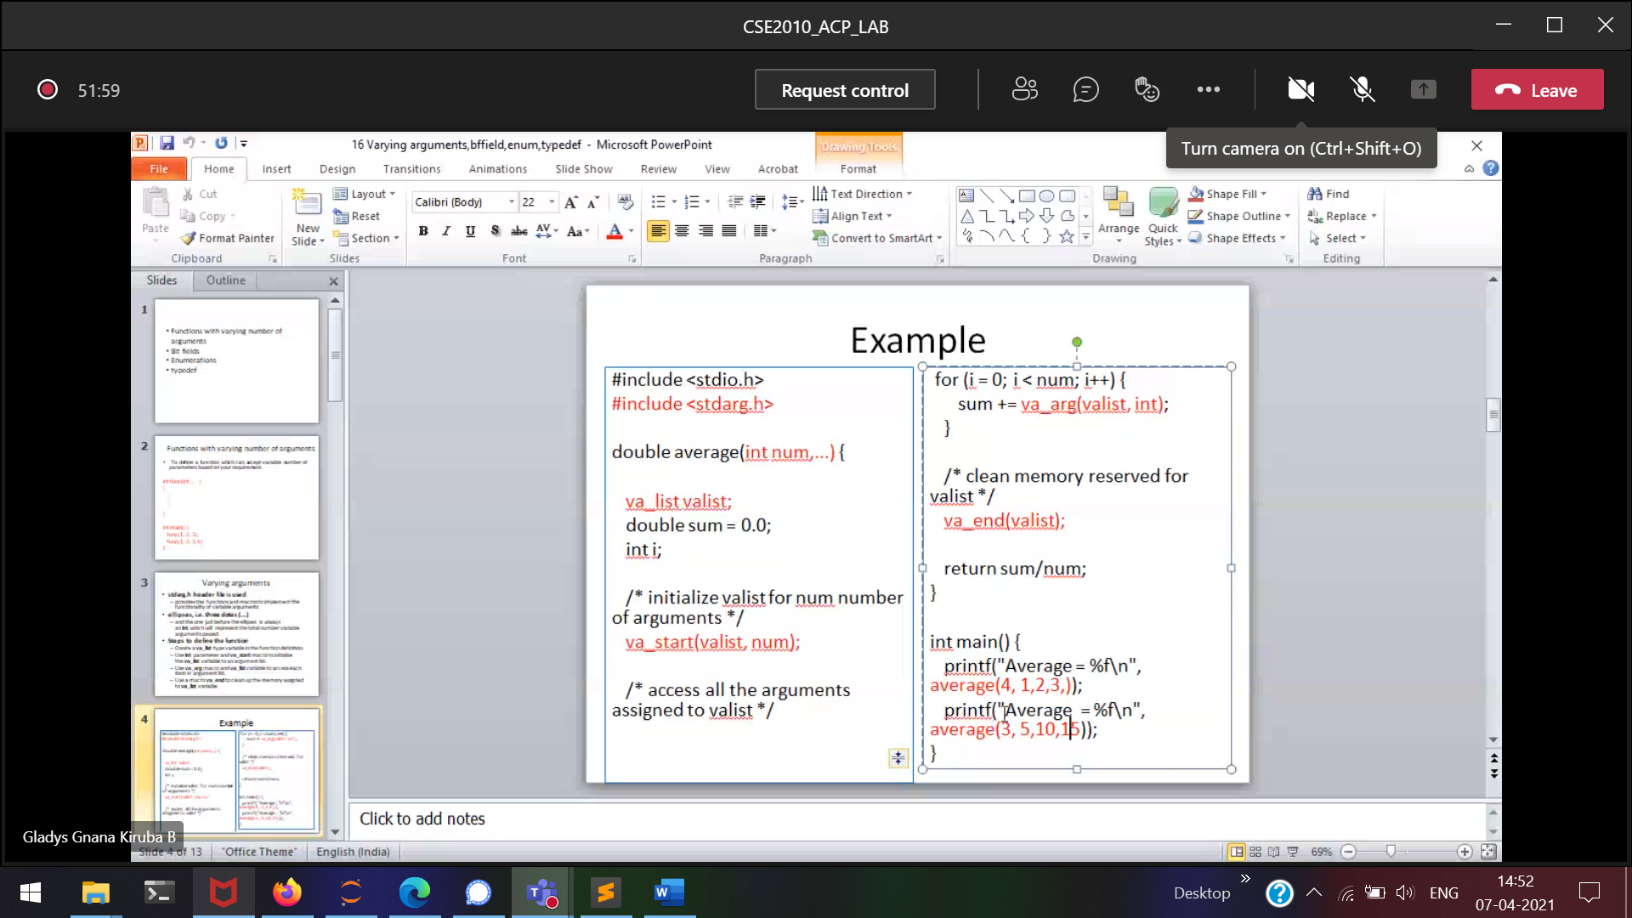

4,1,2,3,4 I am going to pass 4 values  
3,5,10,15 I am going to pass 3 values

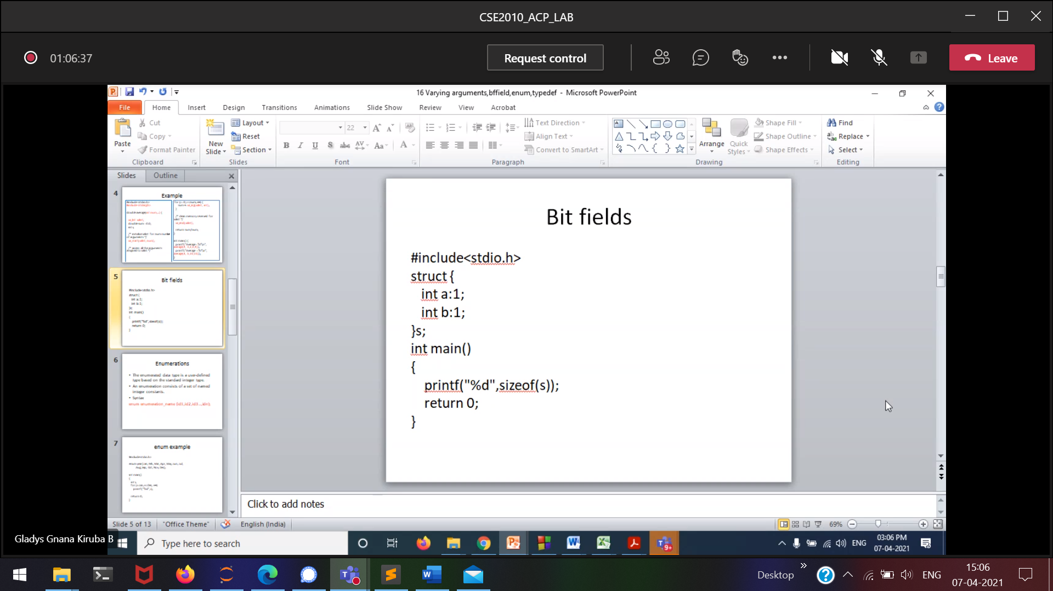

To represent 30, it takes only 5 bits

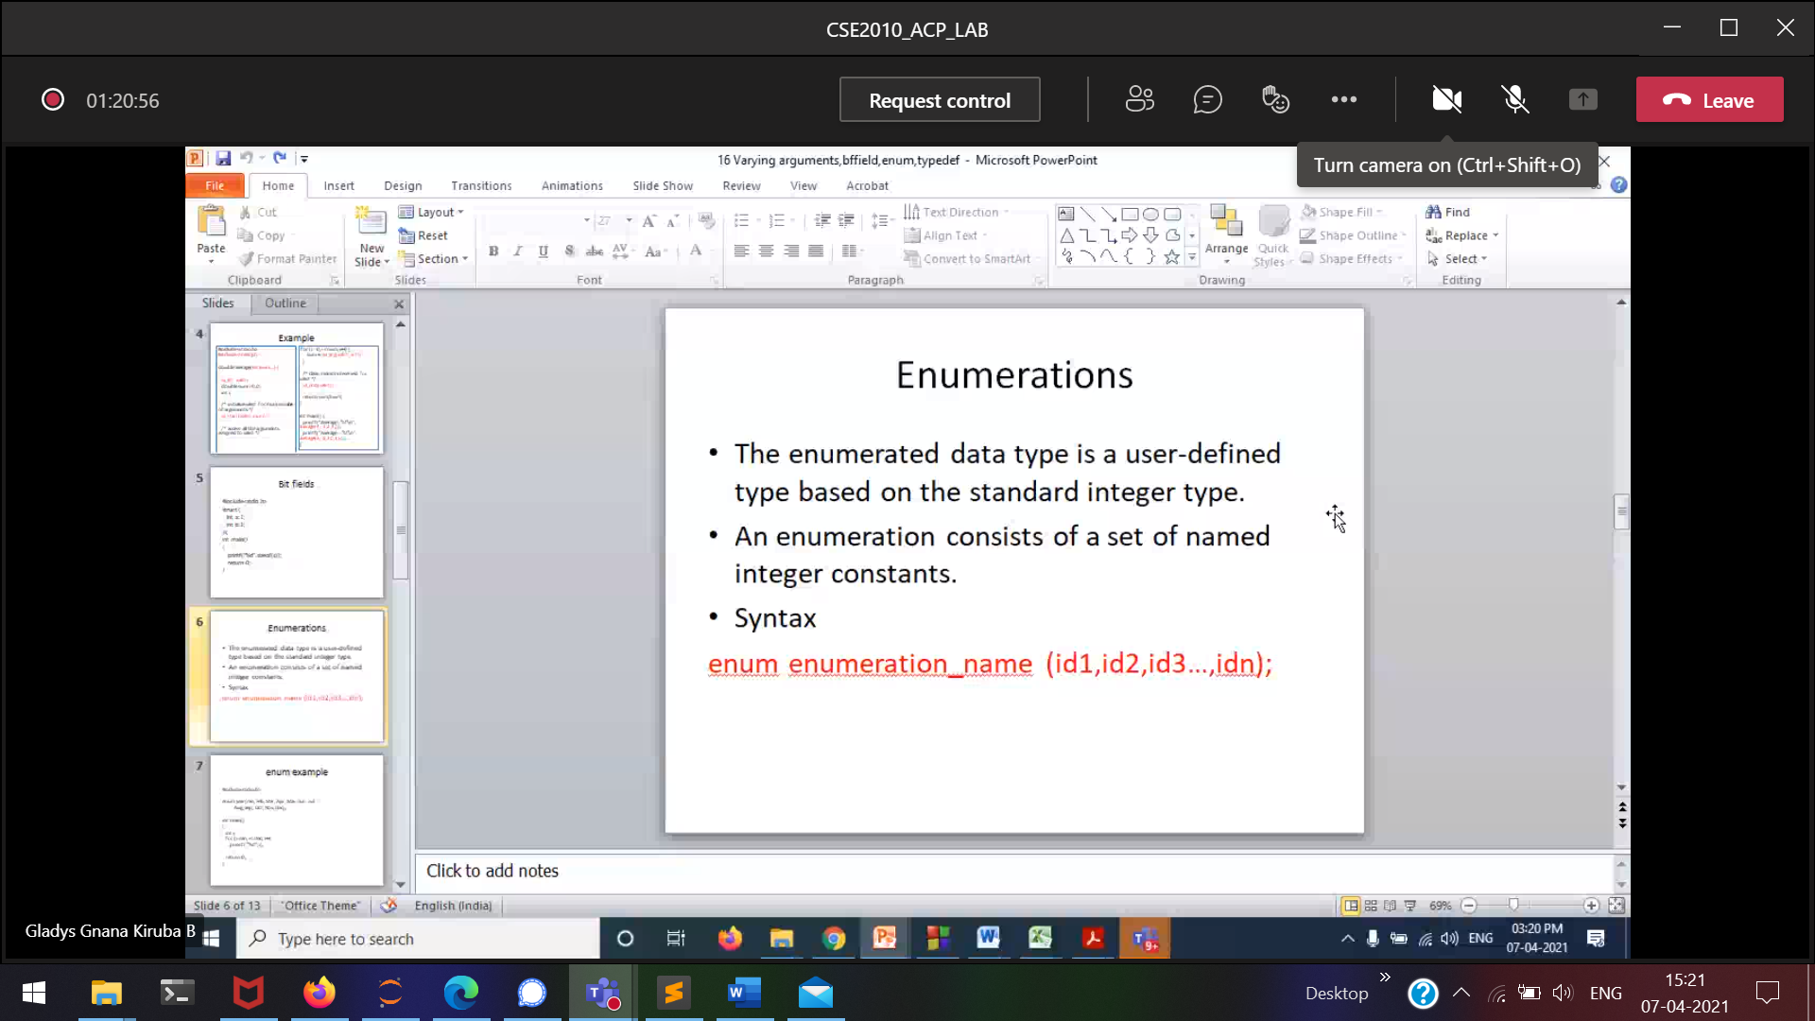

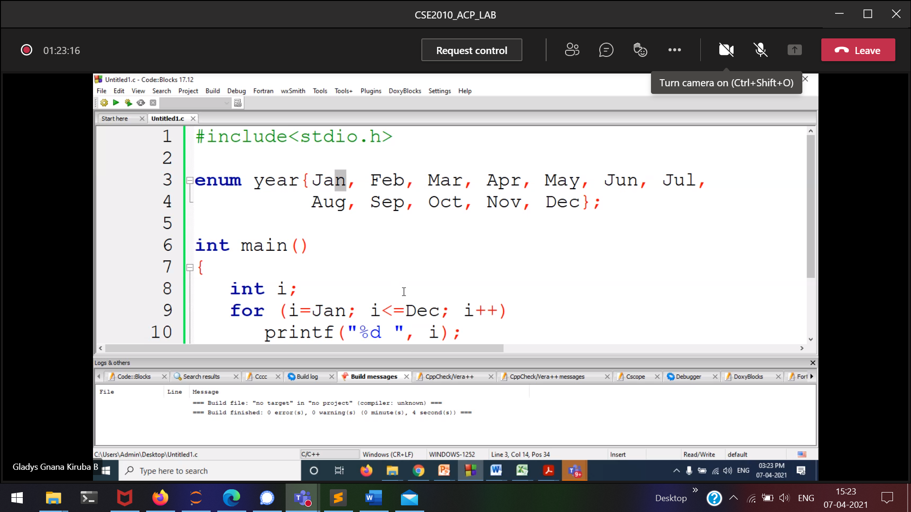

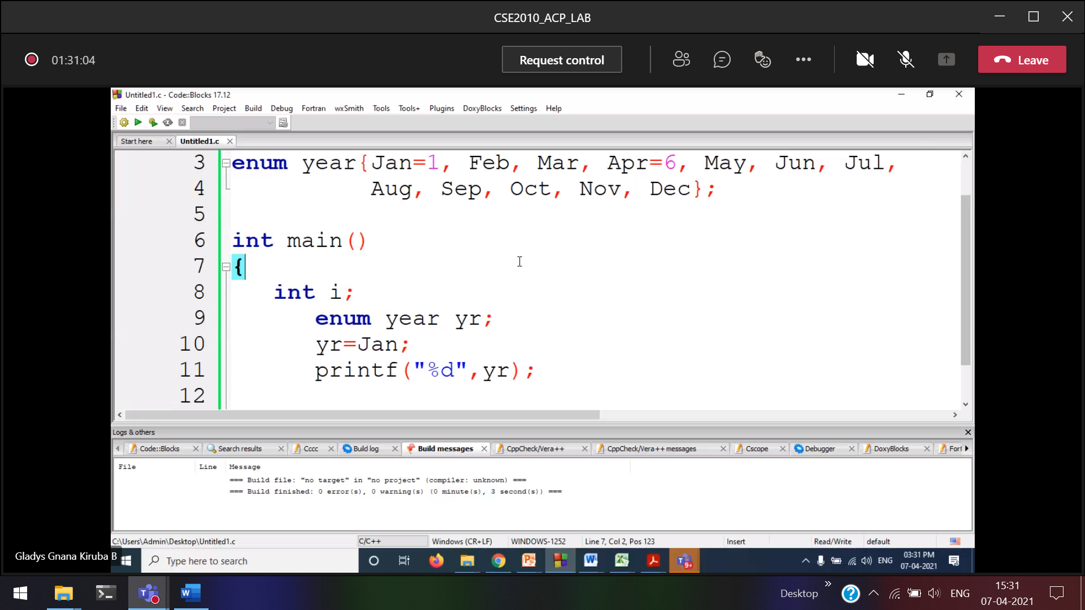

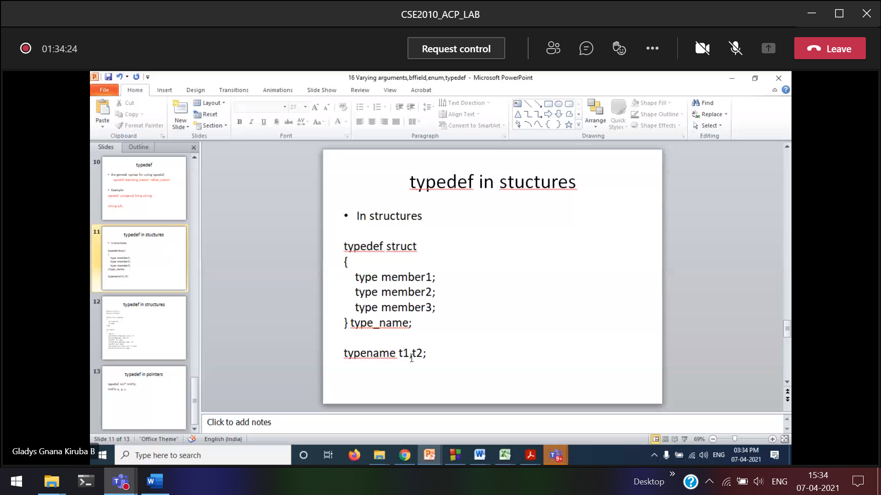

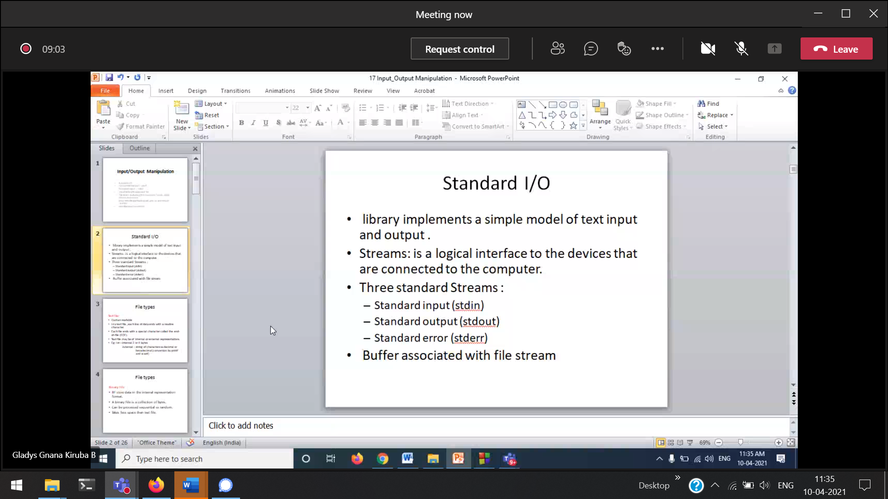

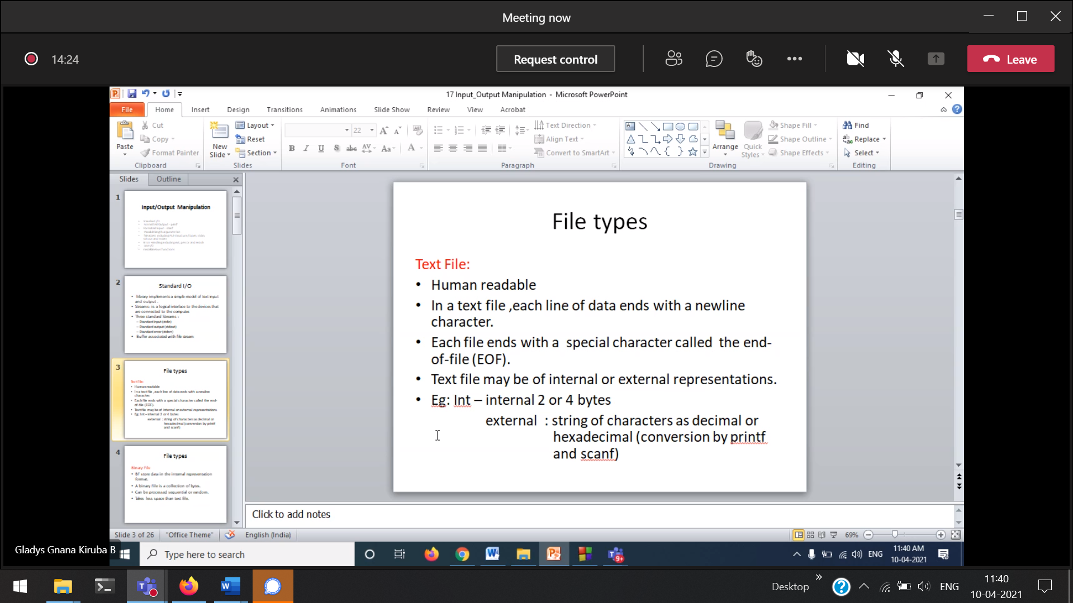

Text file 🡪sequentially accessible   
Binary files 🡪 cannot be accessed sequentially

internal and external

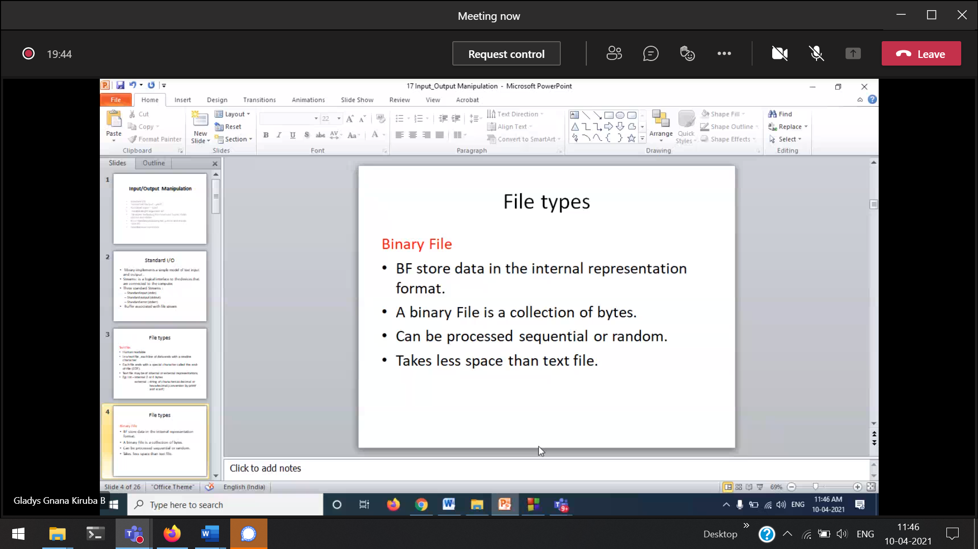

Why binary files takes very less space ??

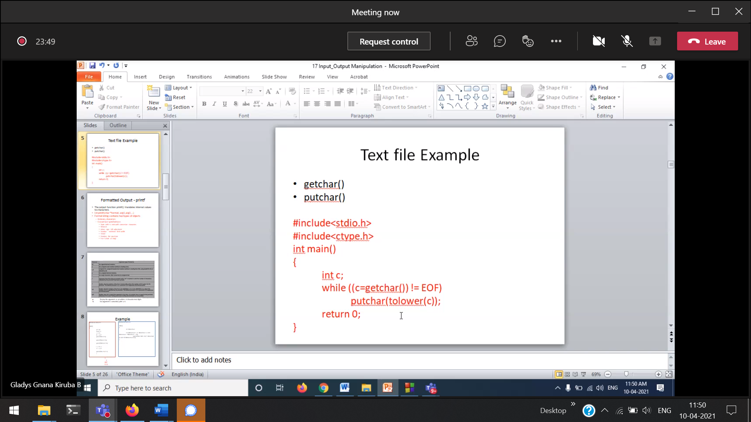

Get the input from the device and printing it in the console.

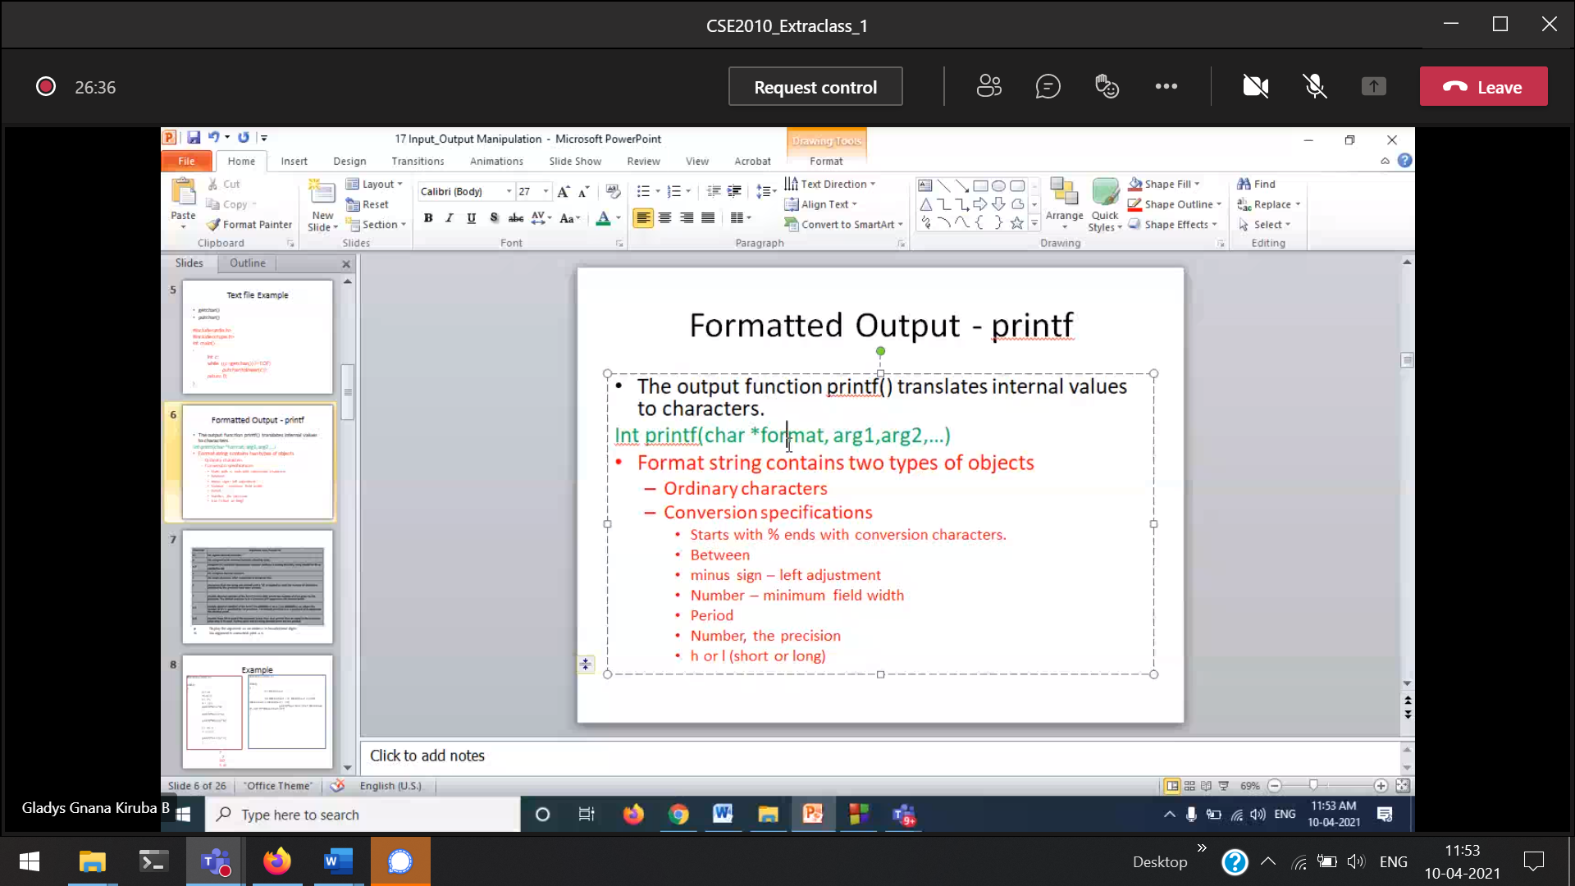

int %d , short int %hd  
int %d , long int %ld

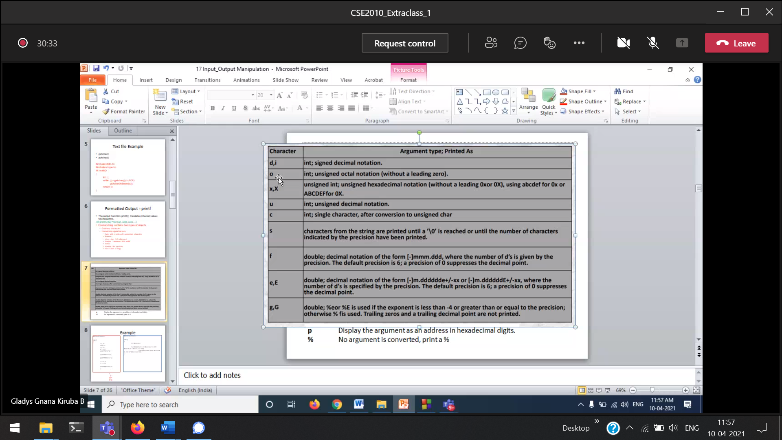

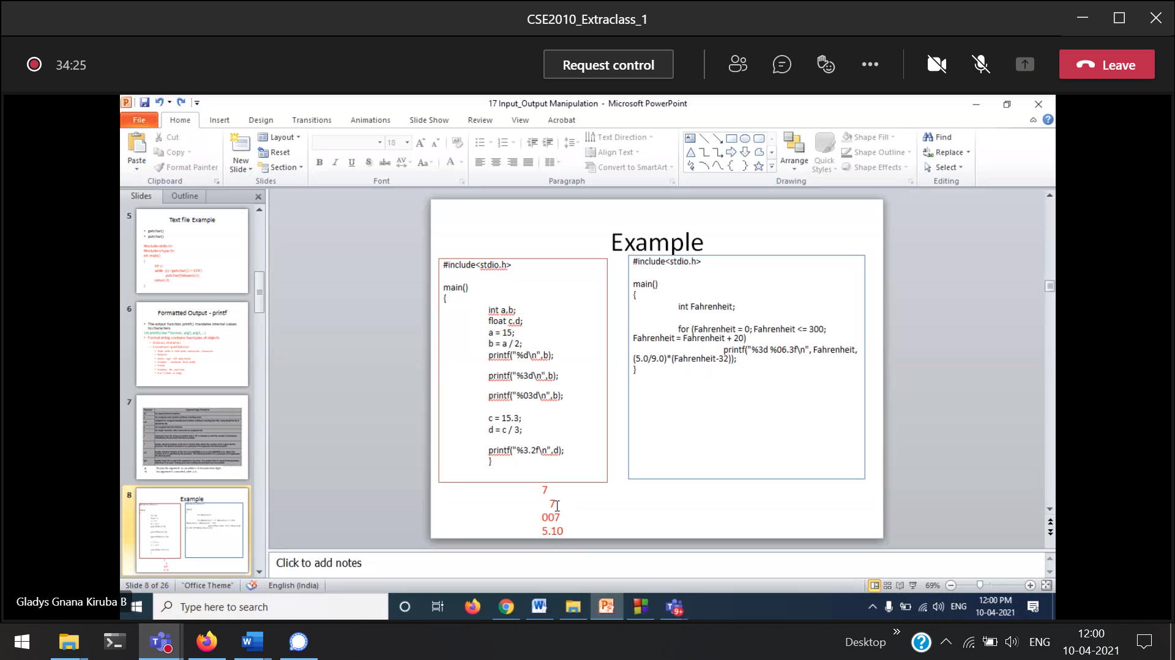

%3d 🡪 width is 3  
%003d

Total width is 6,   
3 is for minimum decimal places.

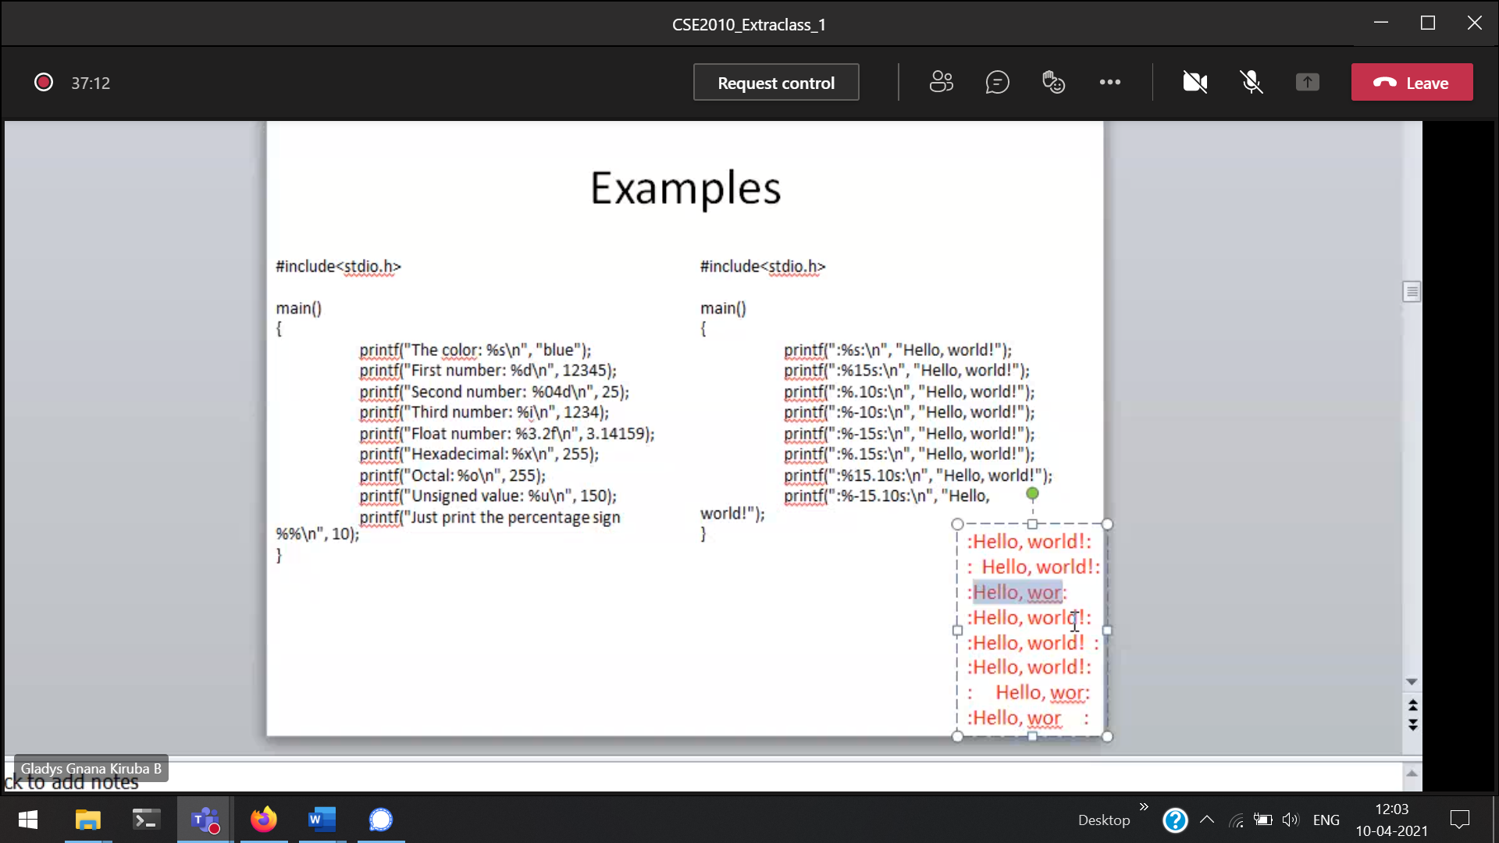

+ 🡪 right justify  
- 🡪 left justify

15.10 🡪 width is 15, maximum only 10

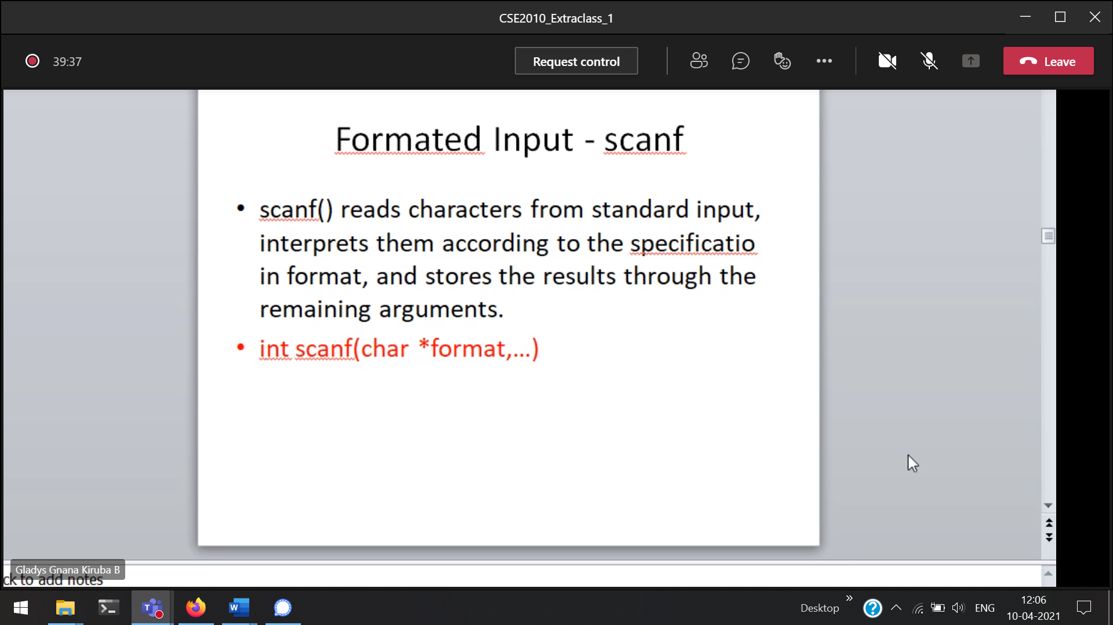

Return type of printf() and scanf() 🡪 int

scanf() 🡪 will return how many inputs it takes

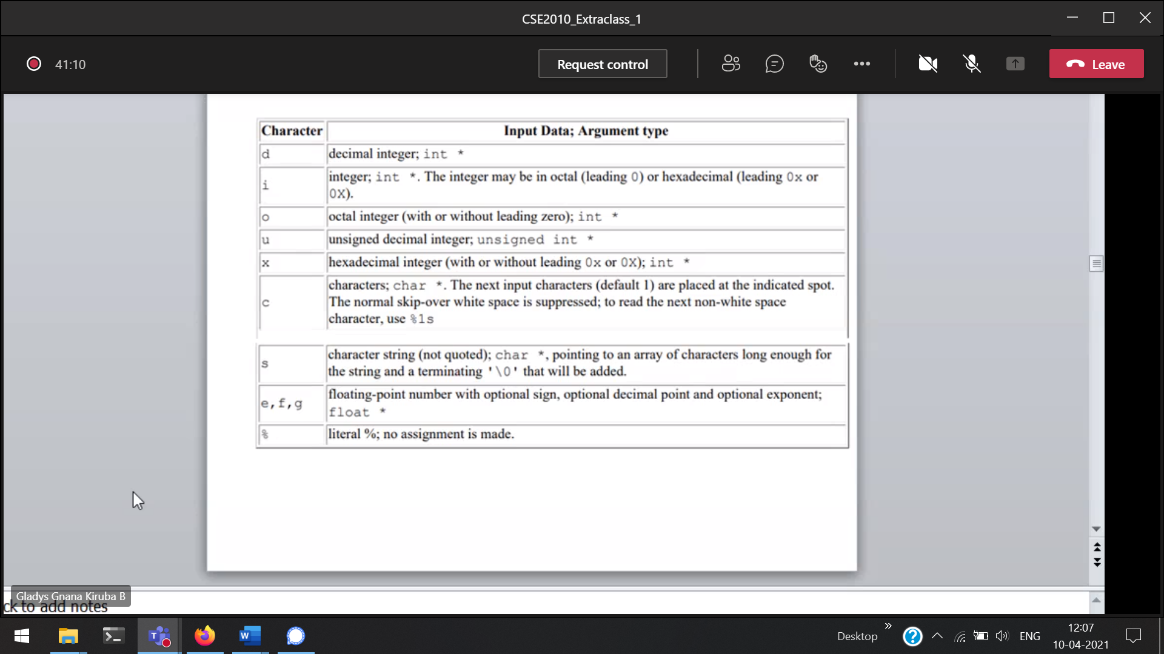

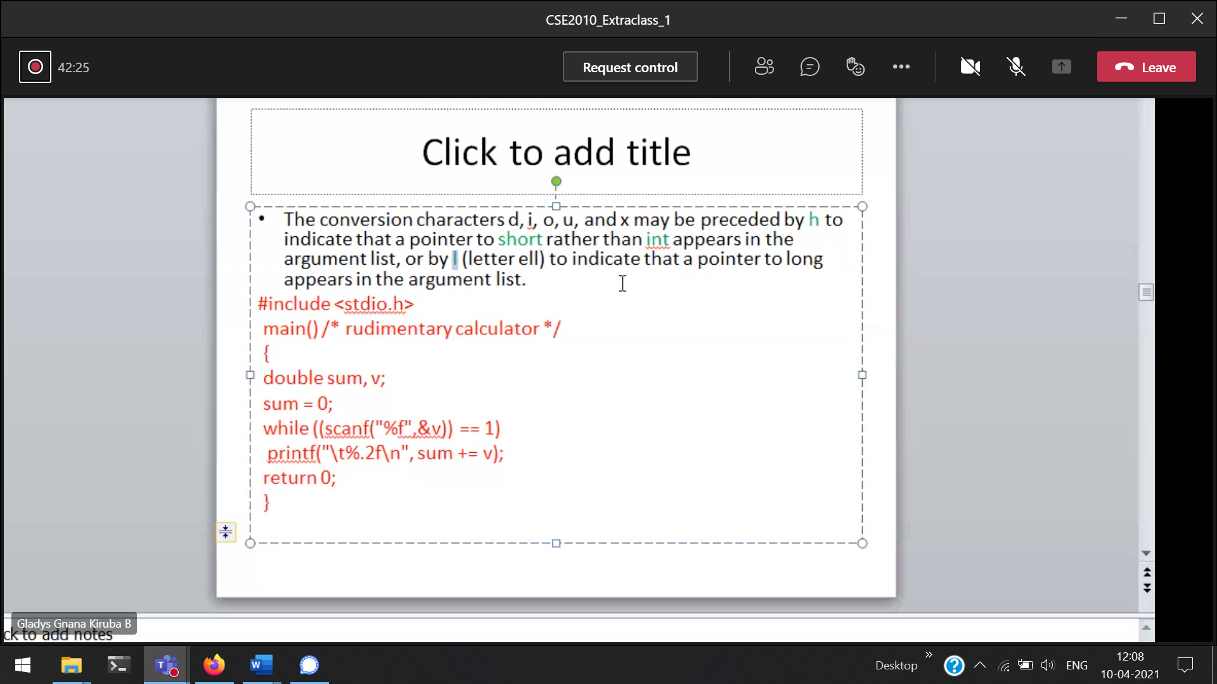

When the loop will be terminated ???

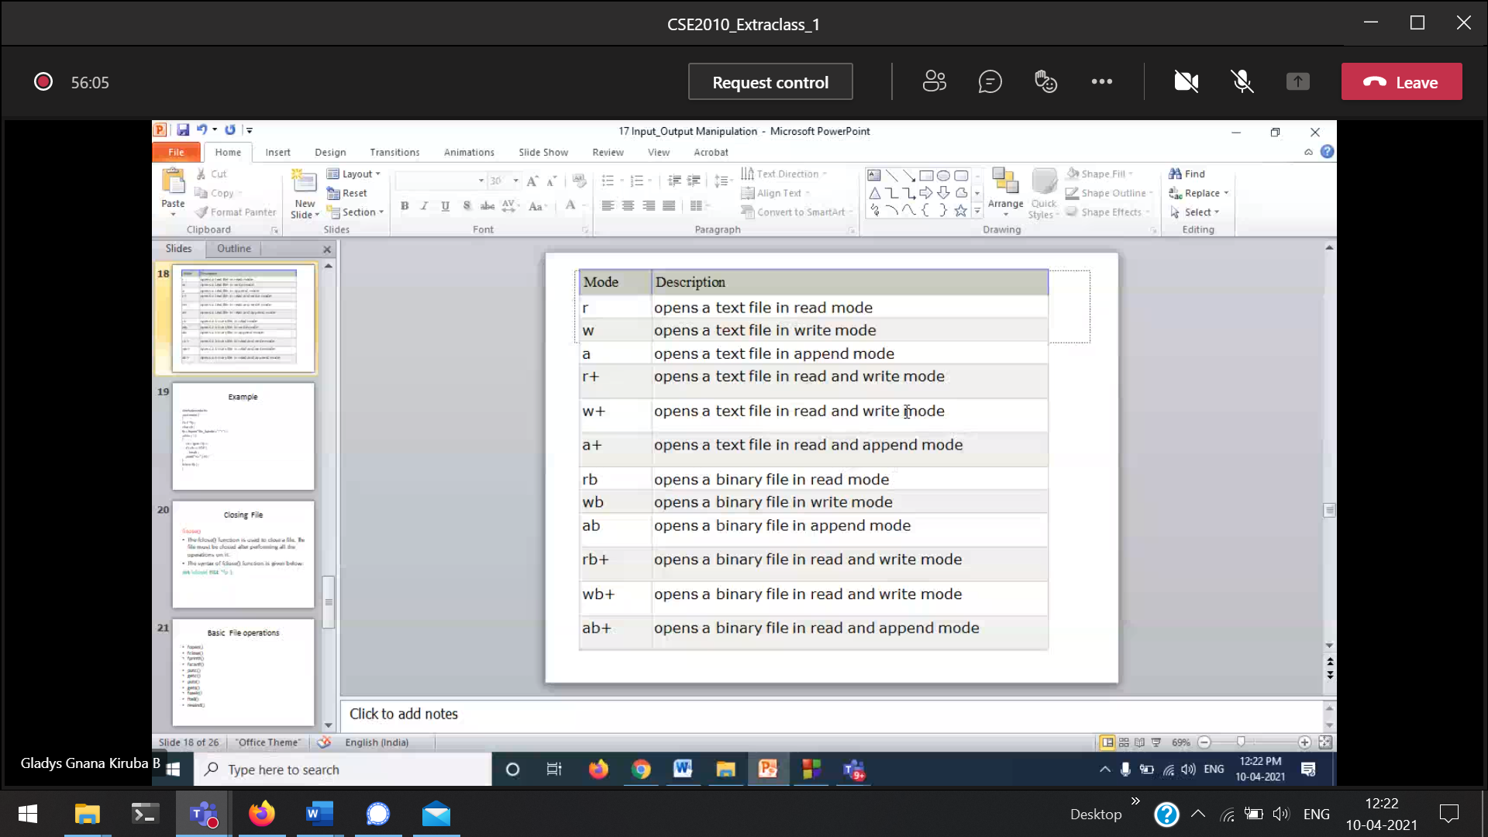

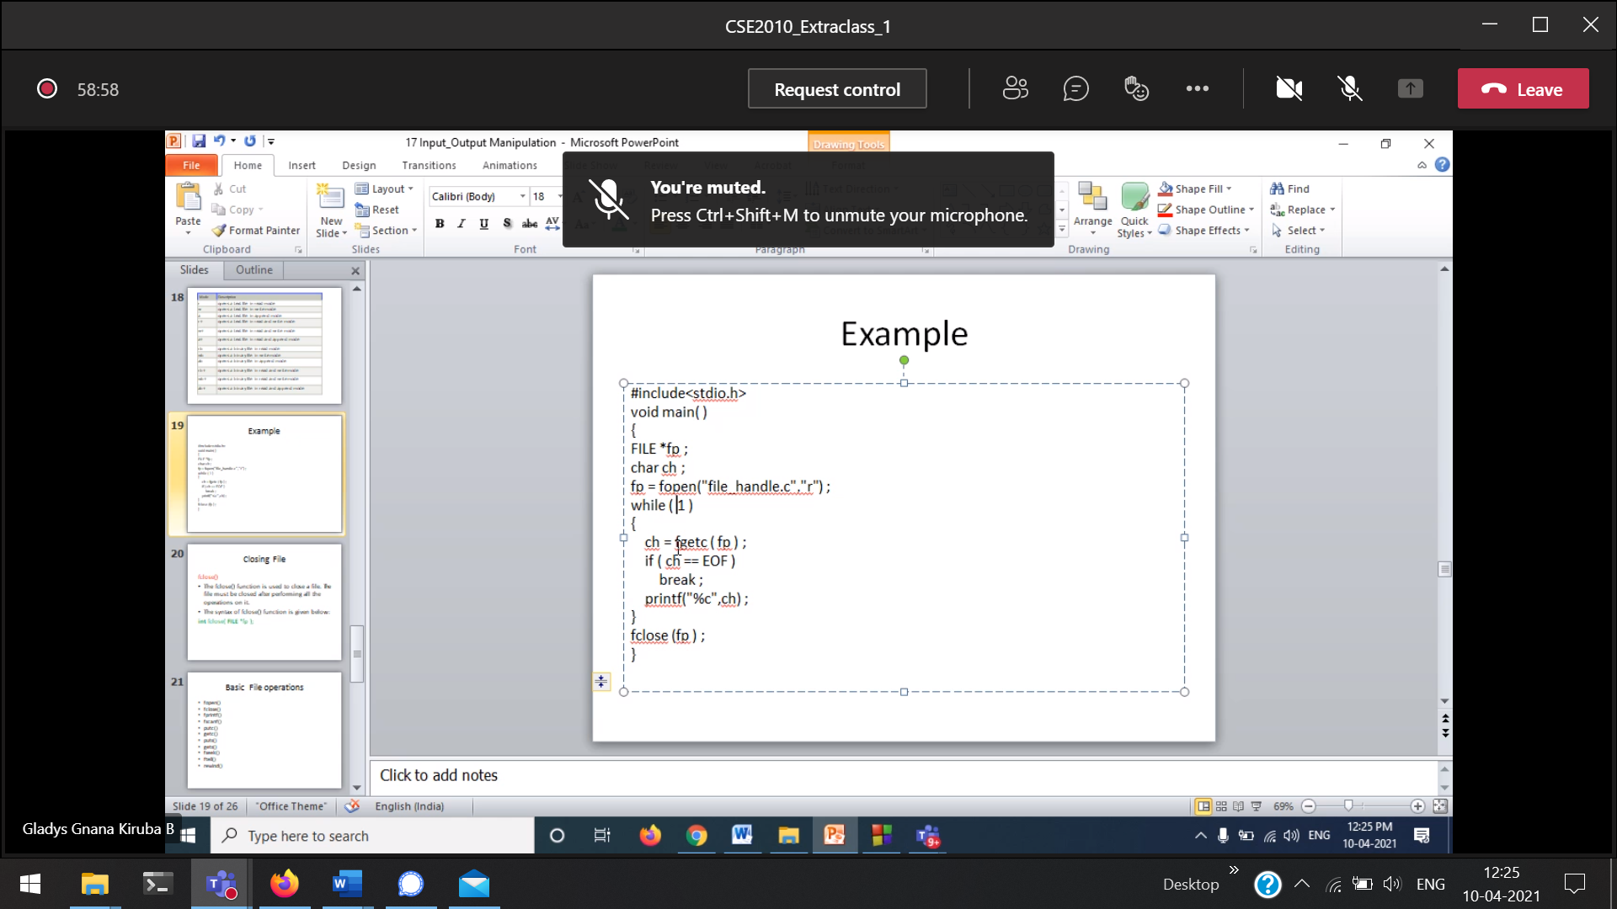

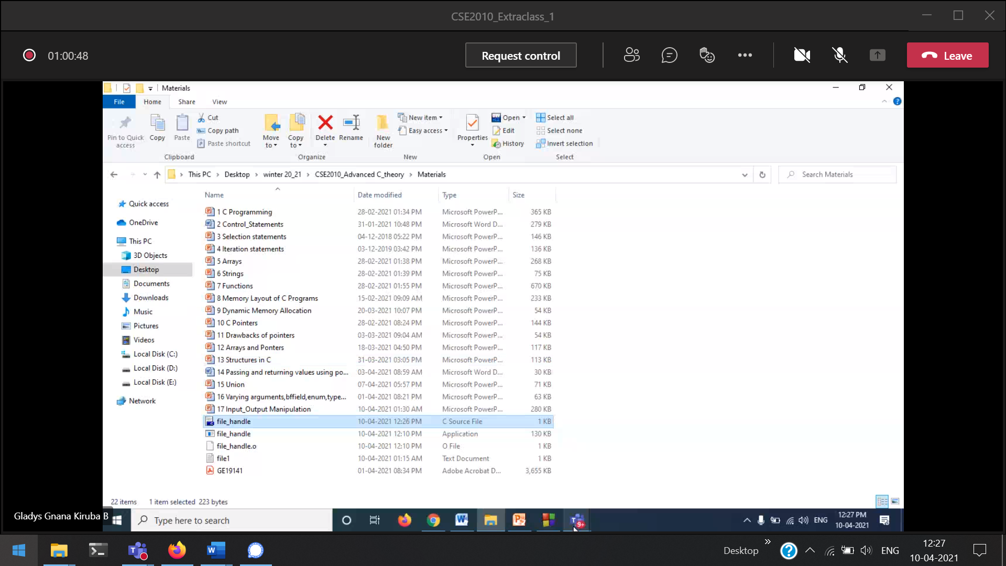

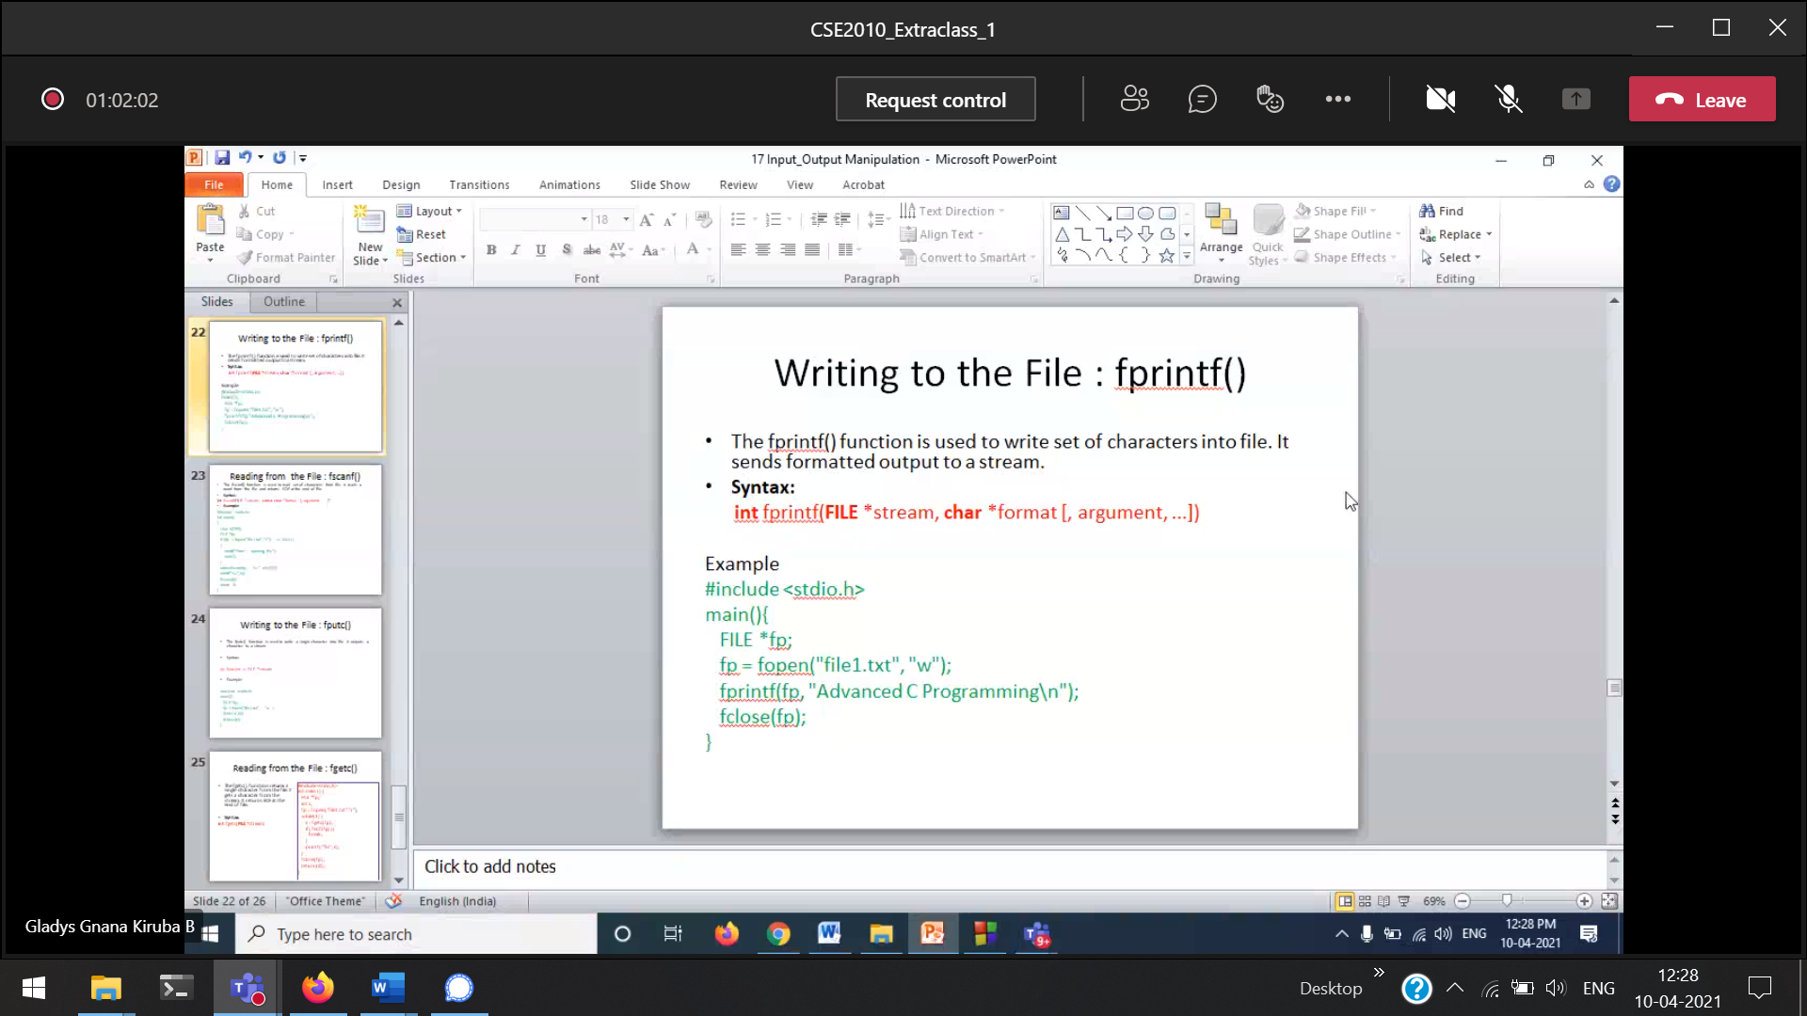

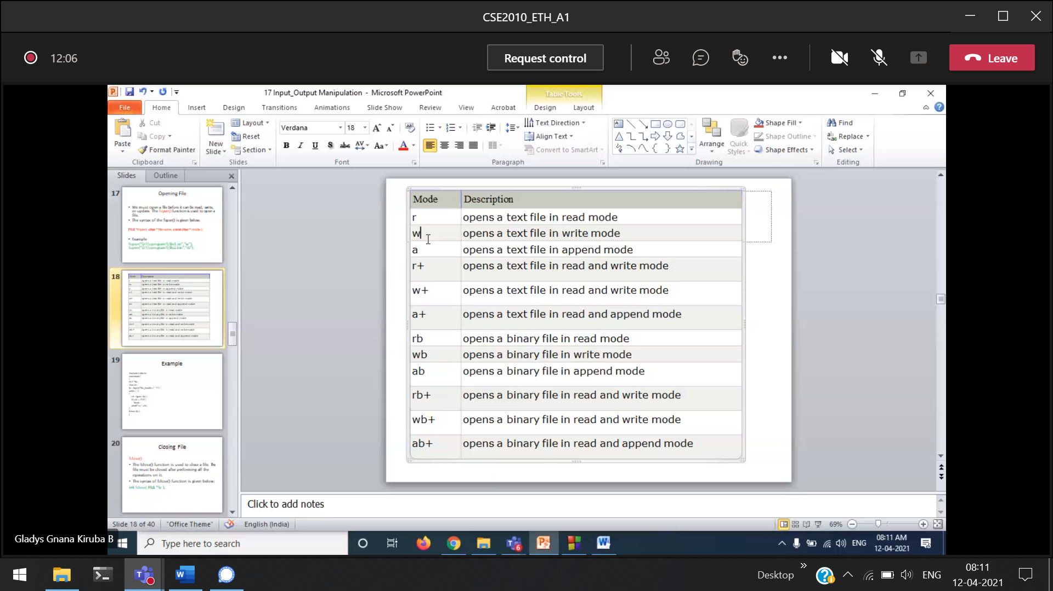

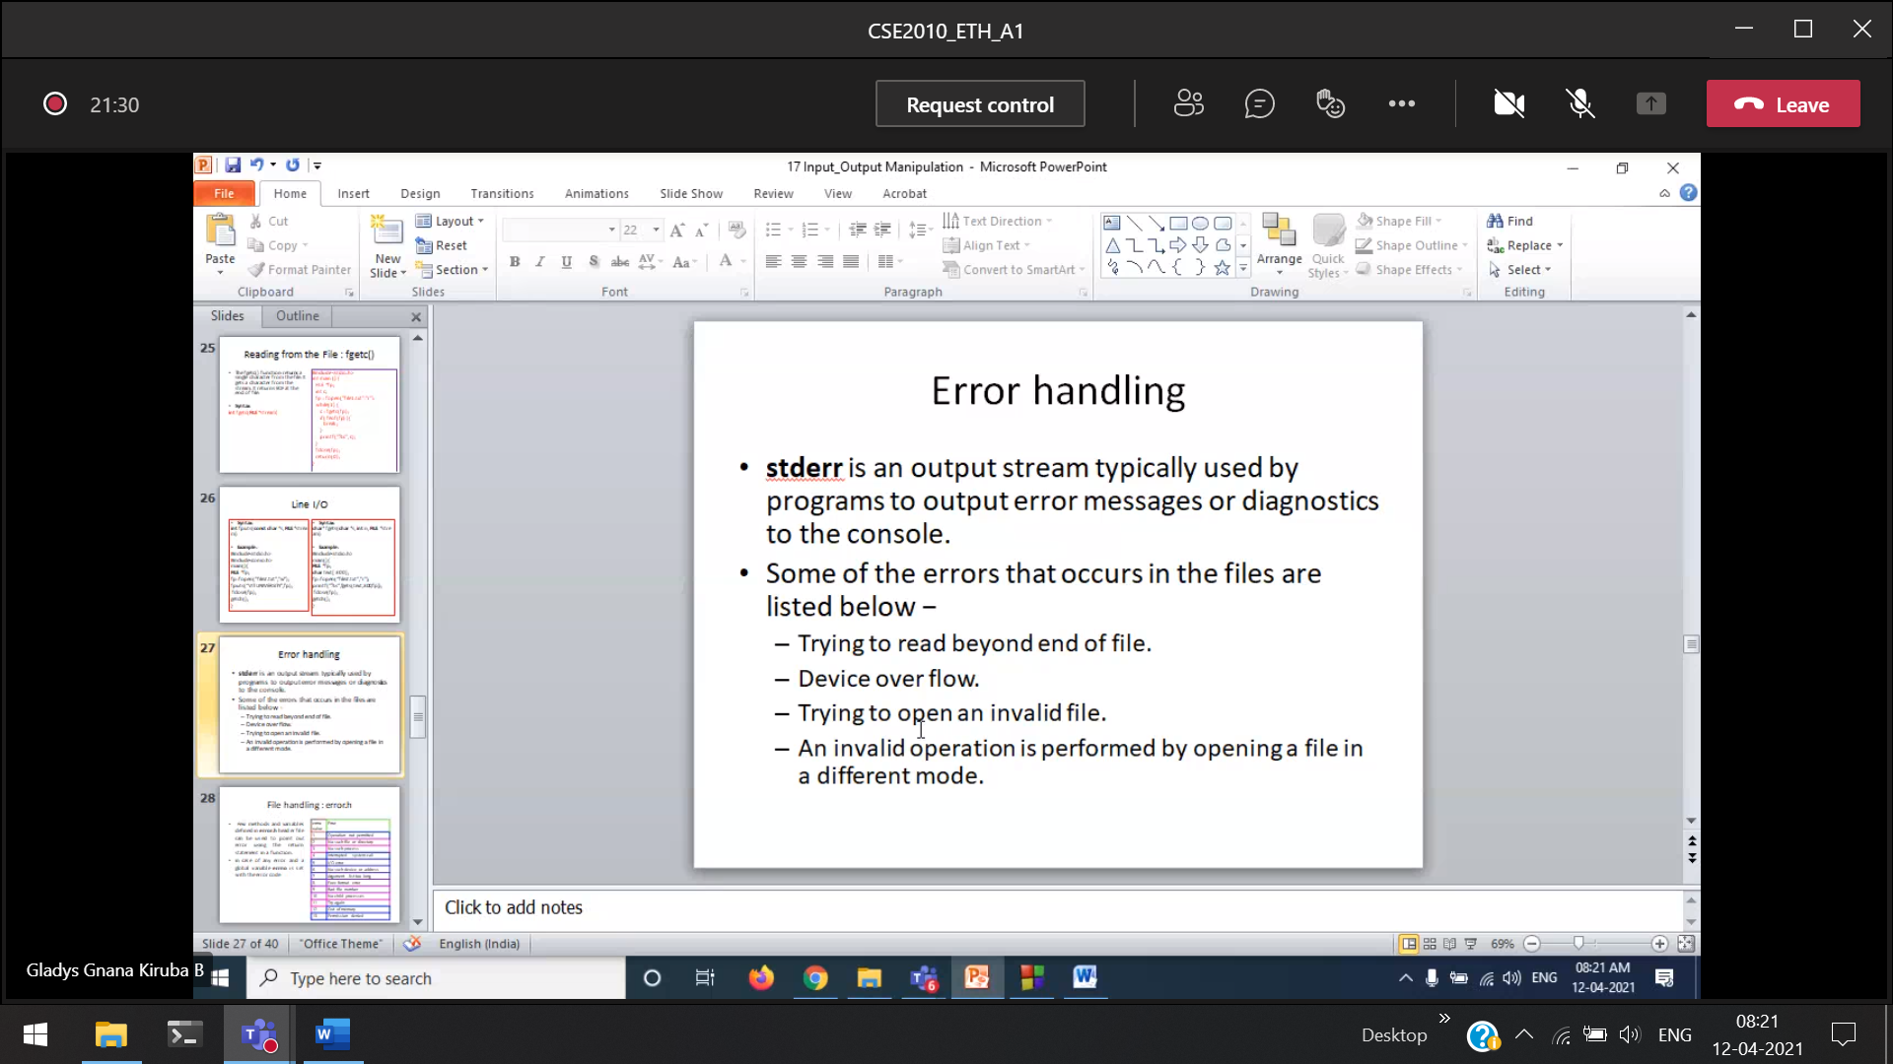

To get the output on the console, not on the file.

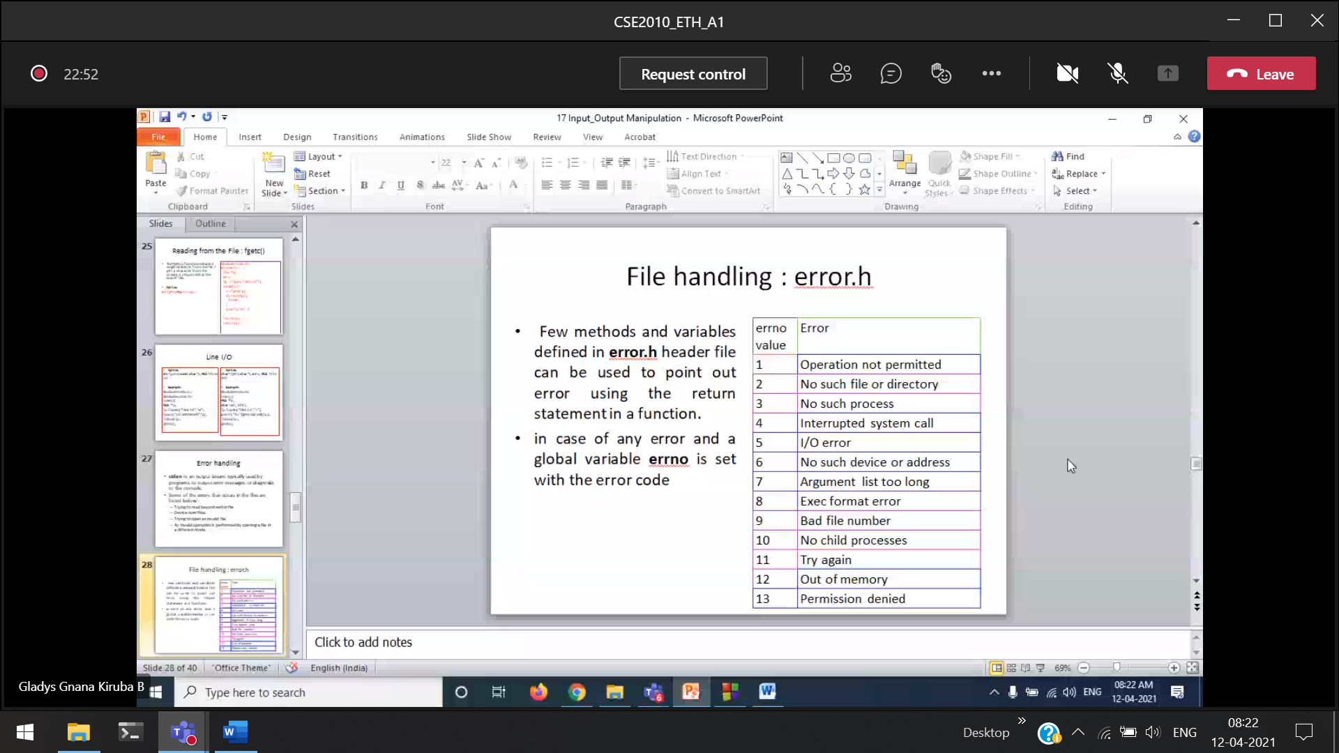

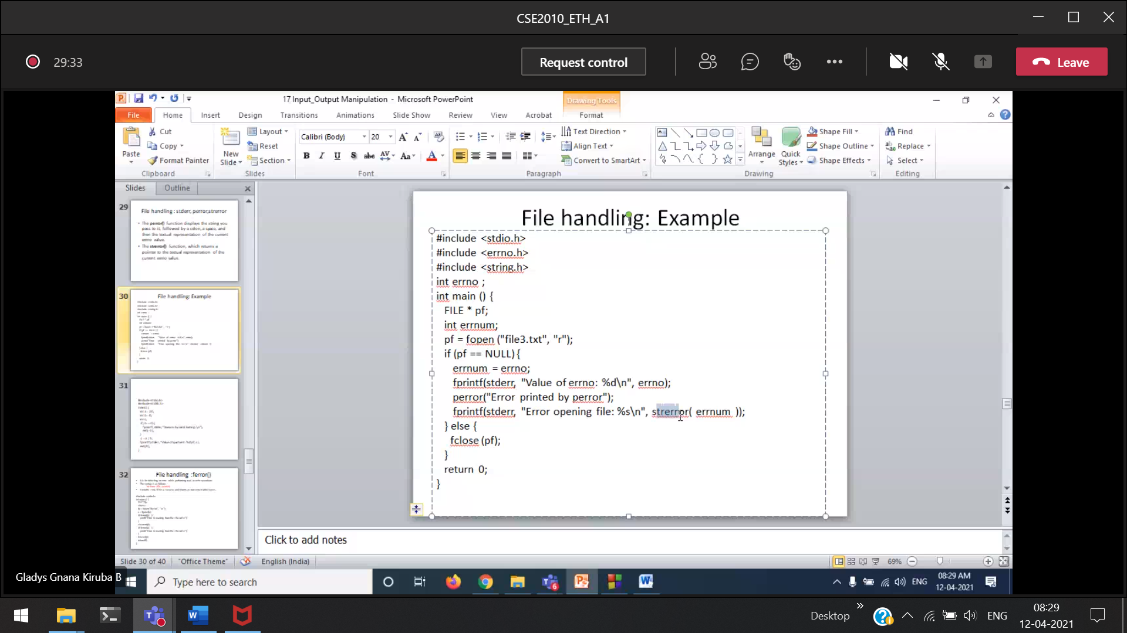

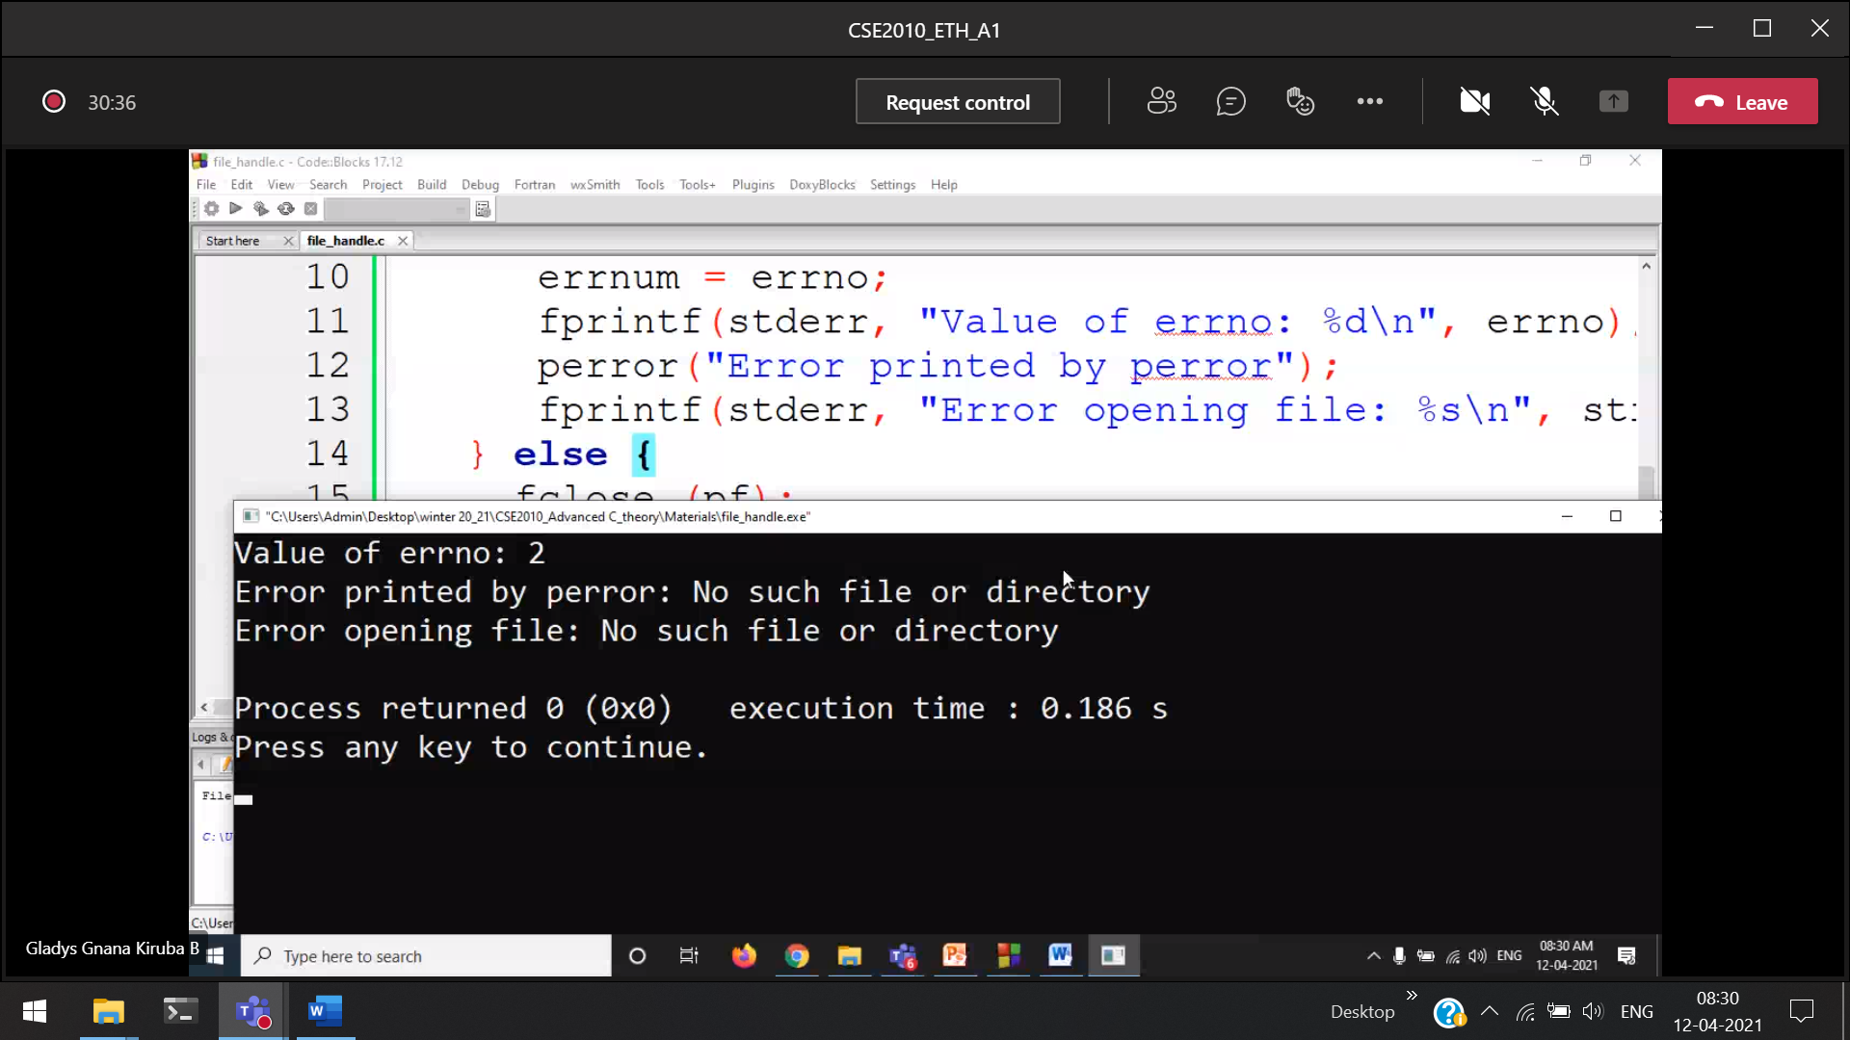

errno 🡪 will give you the error number.  
perror() 🡪 will automatically give you the error according to the error number.

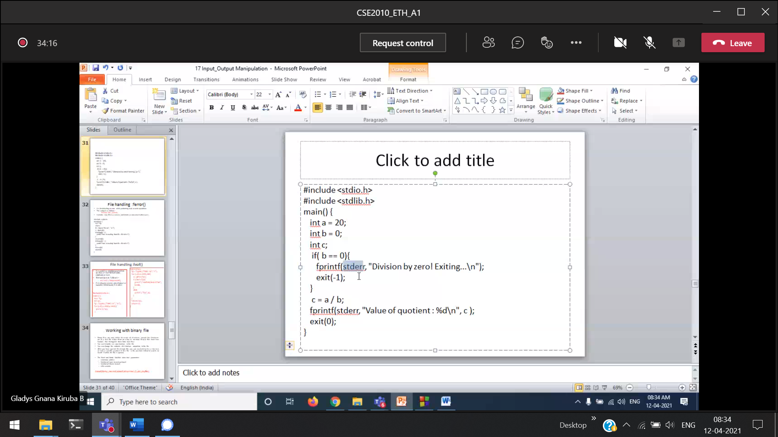

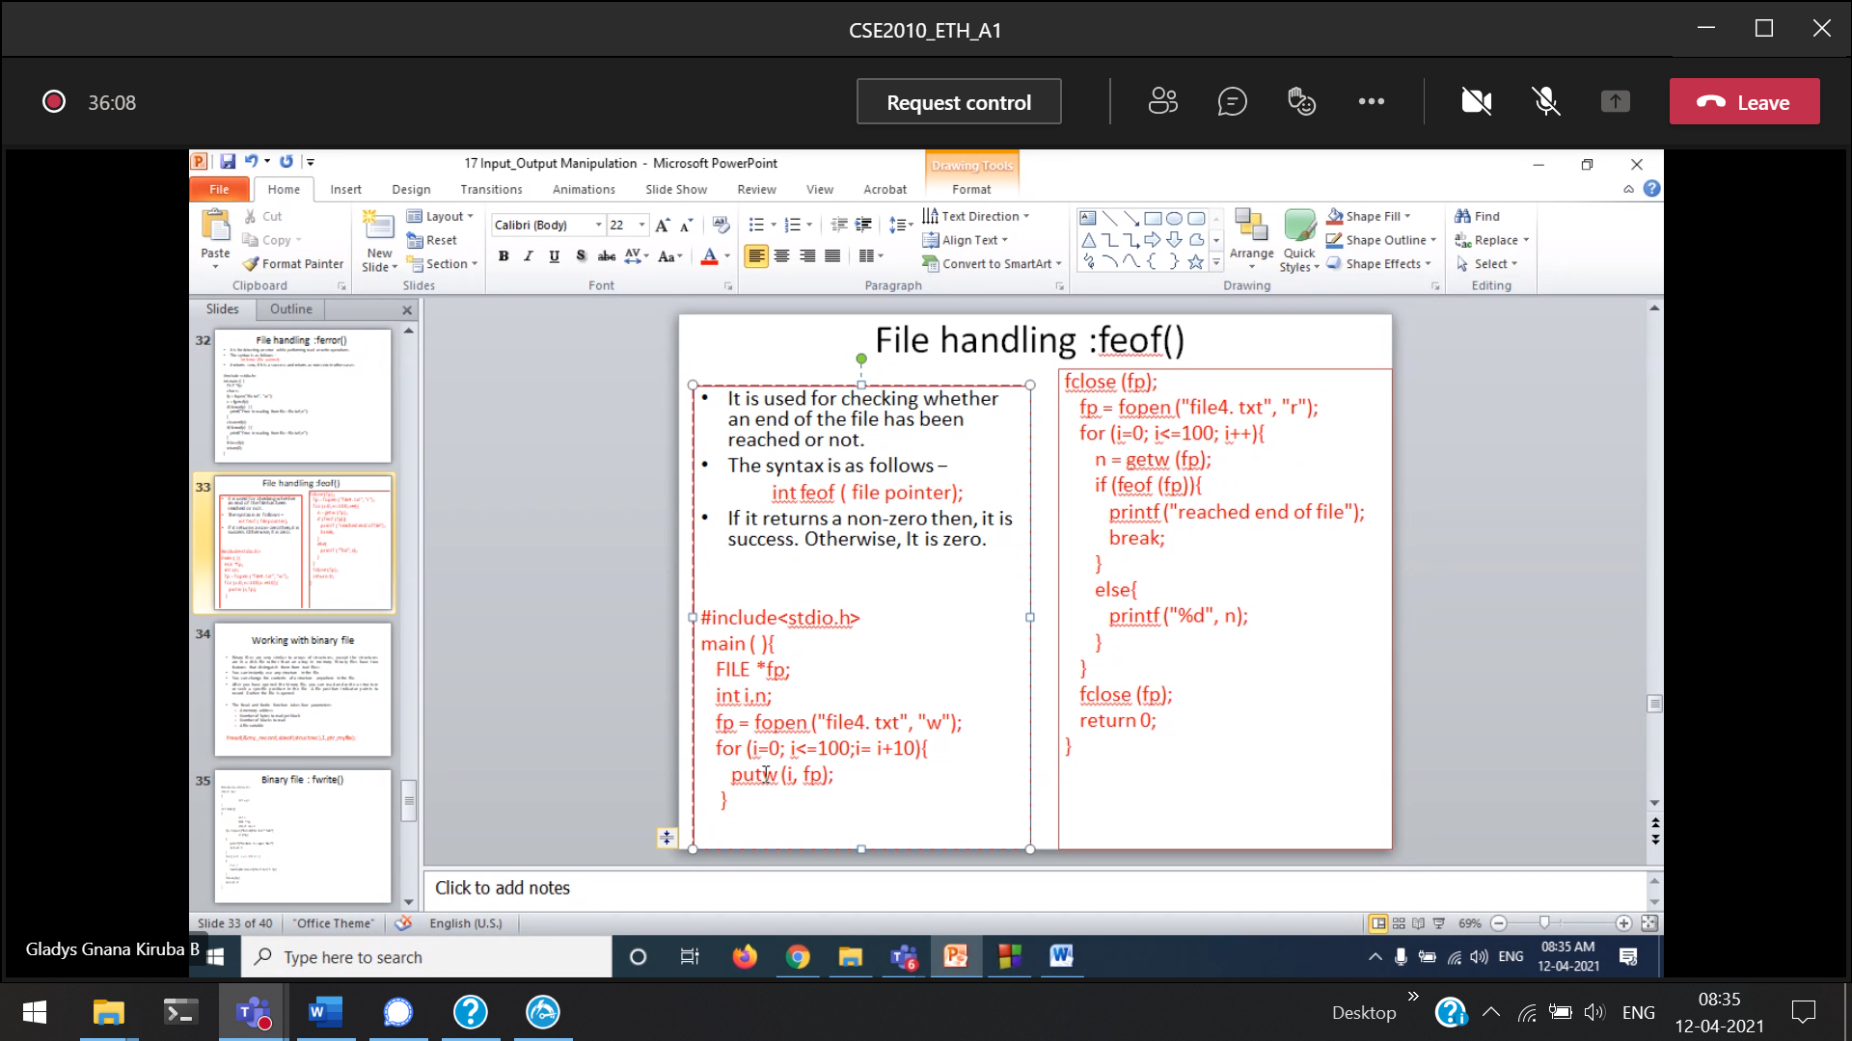

putw()

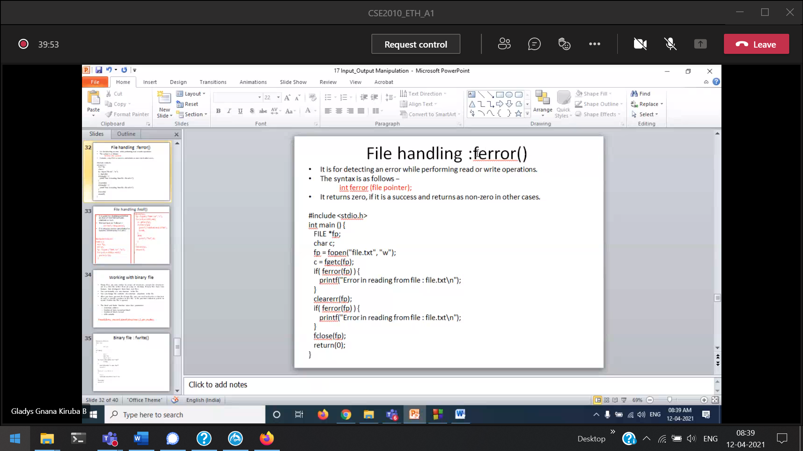

clearer(fp) 🡪 clear the buffer space

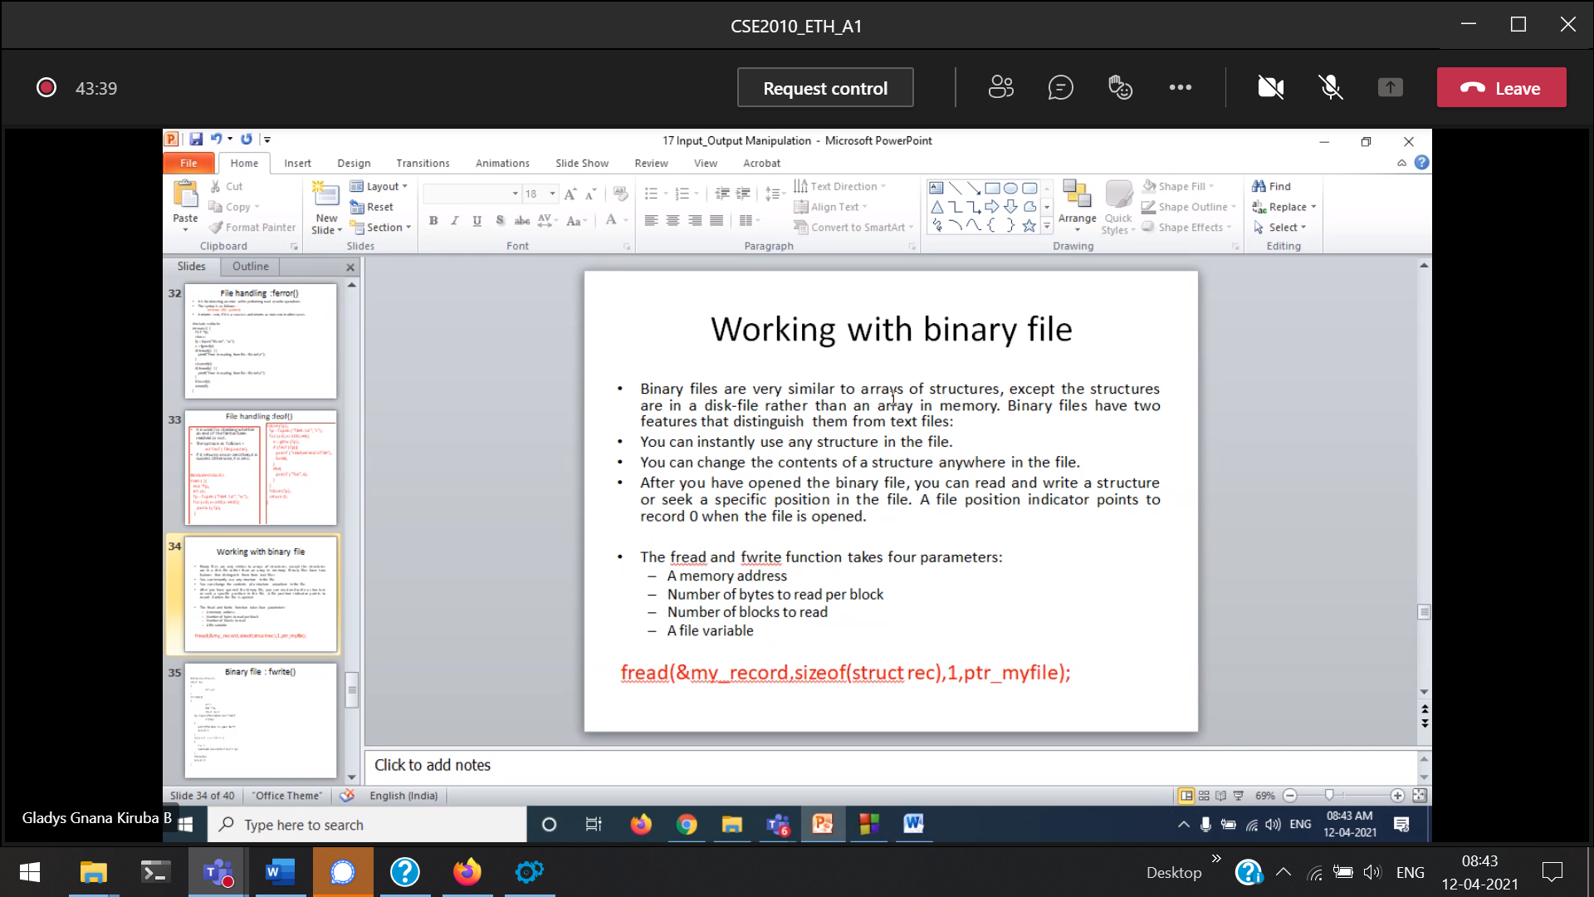 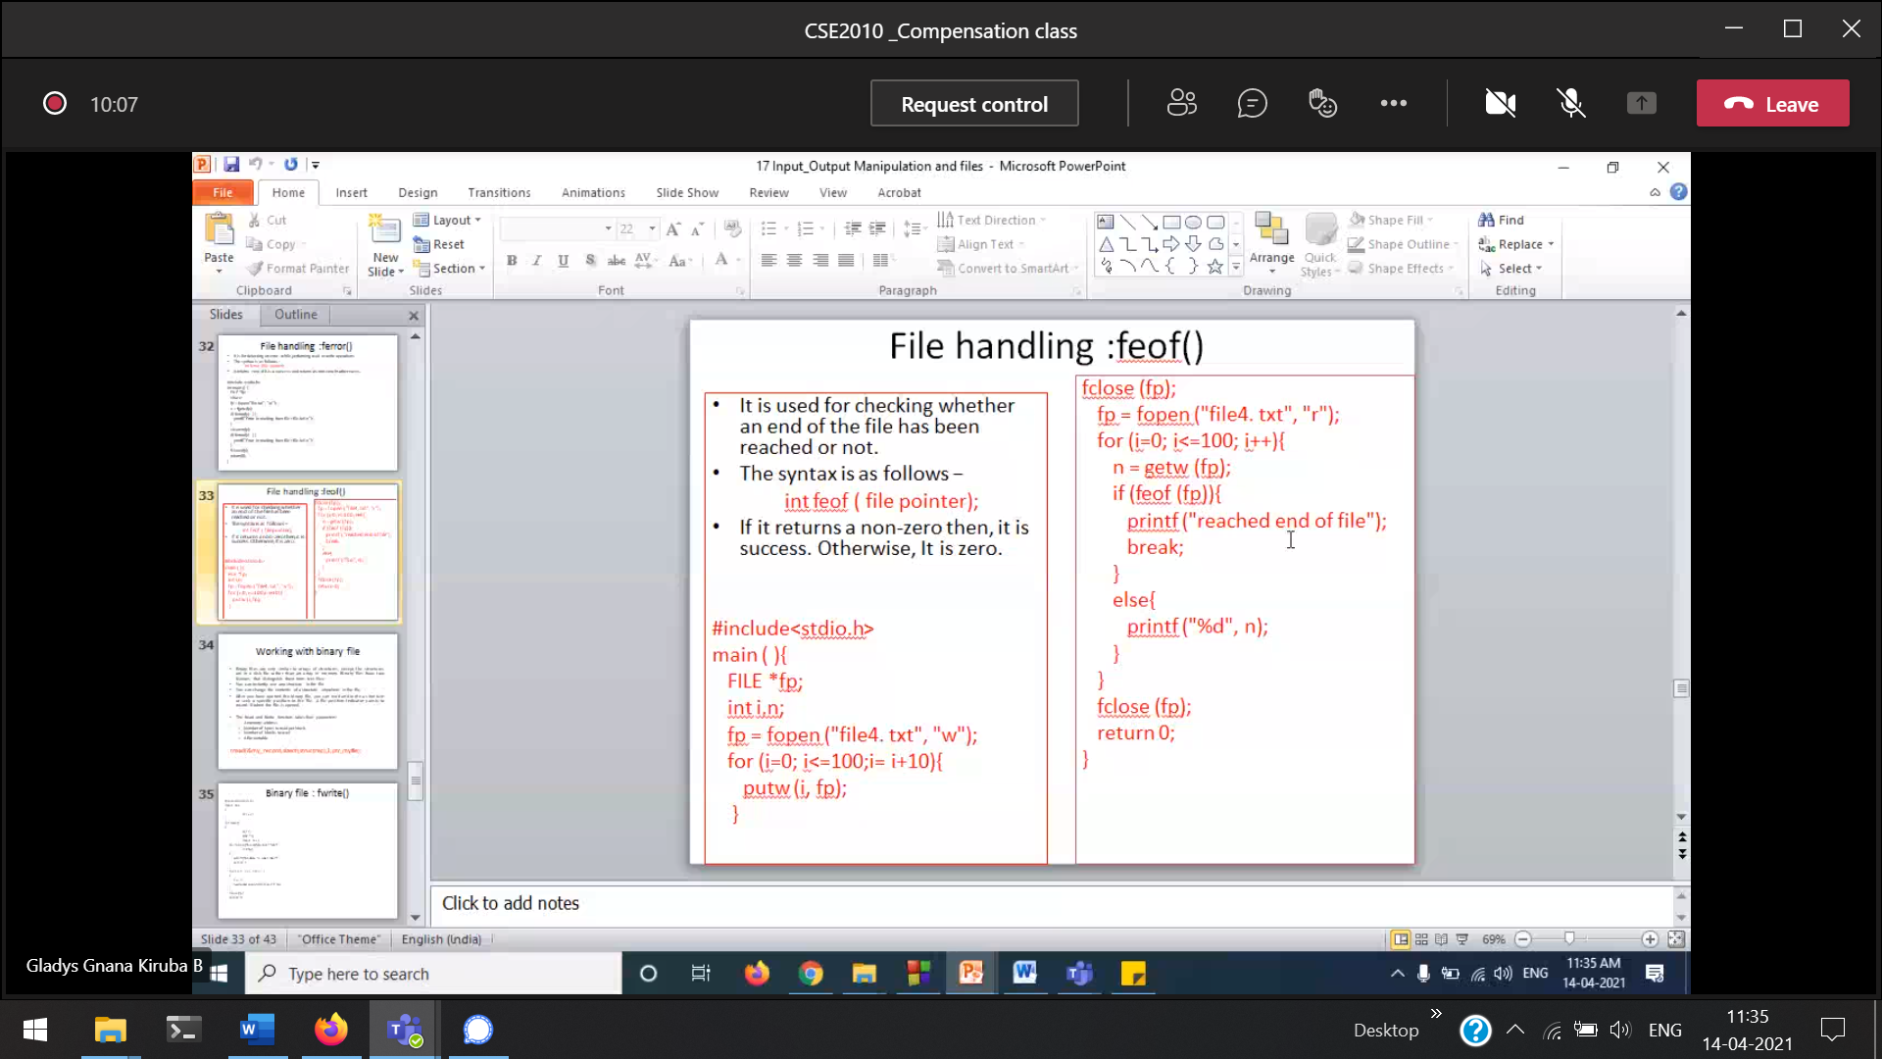

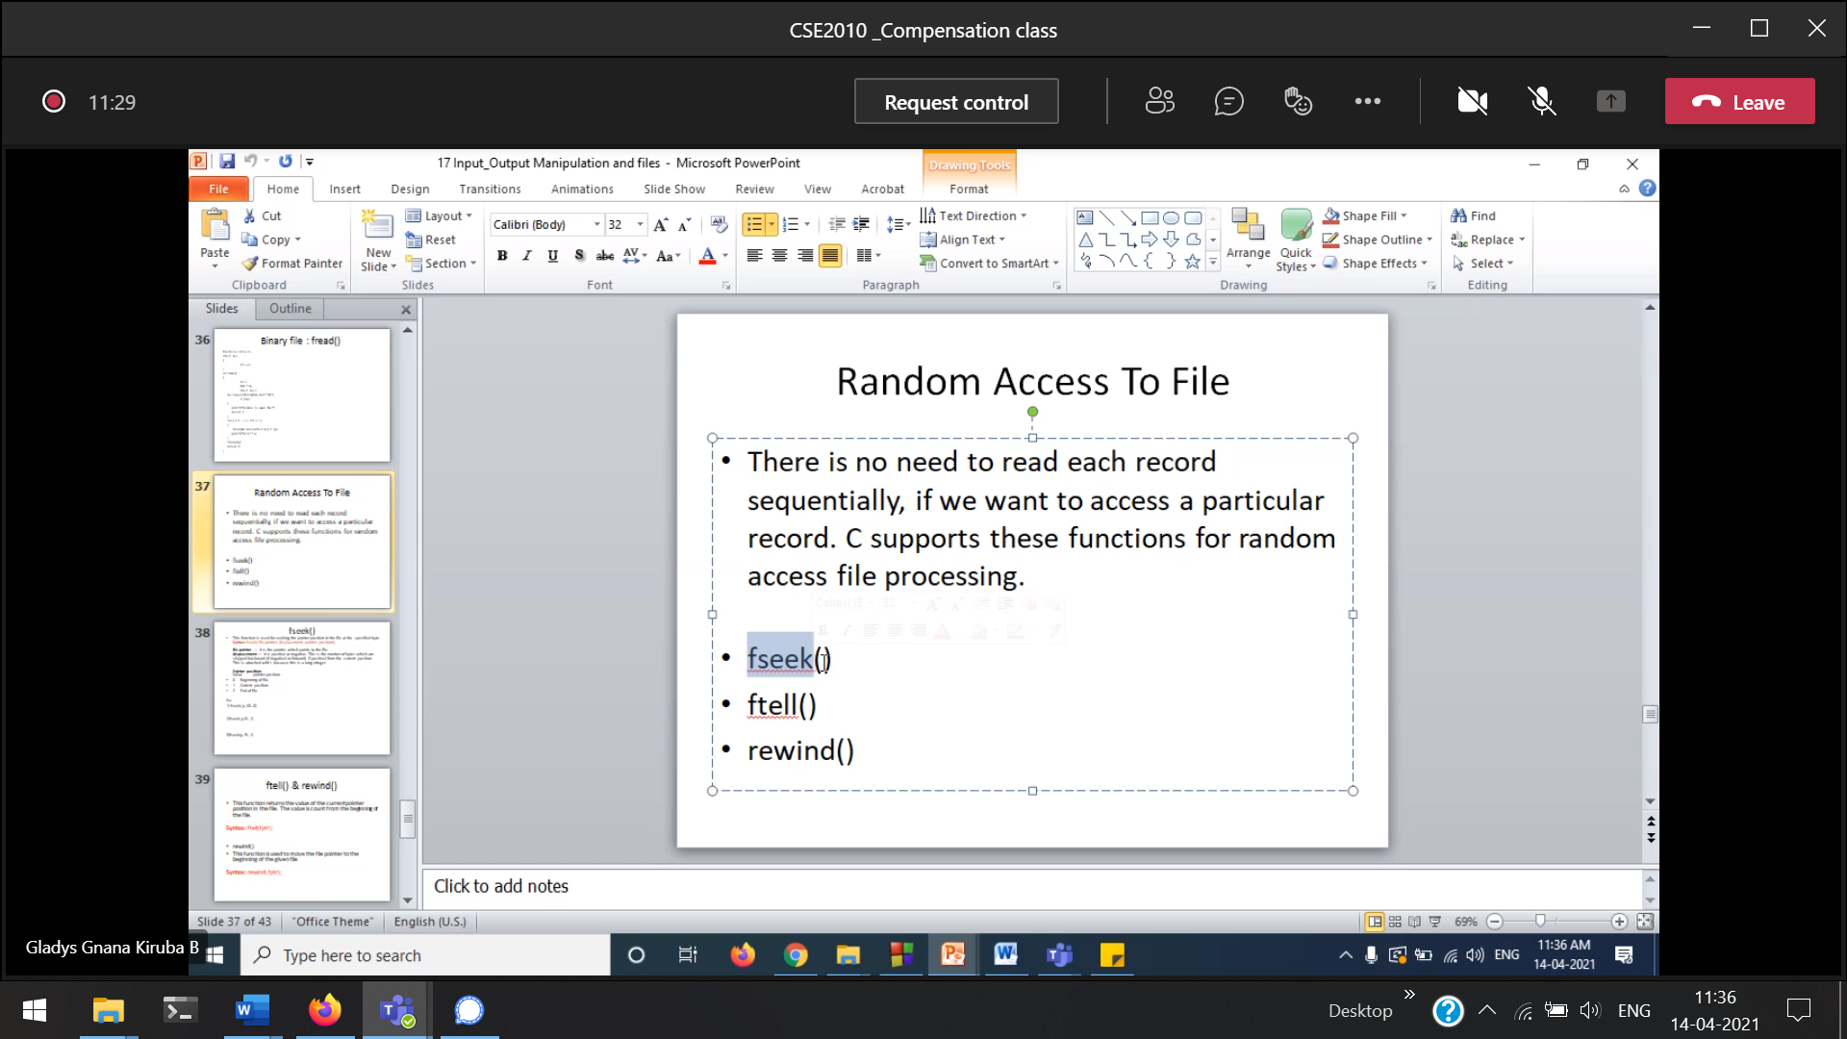

fseek() 🡪 to move a particular place

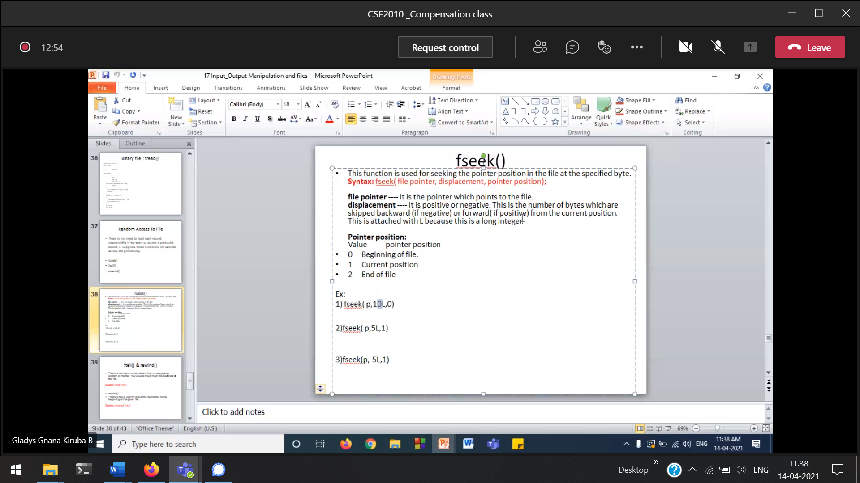

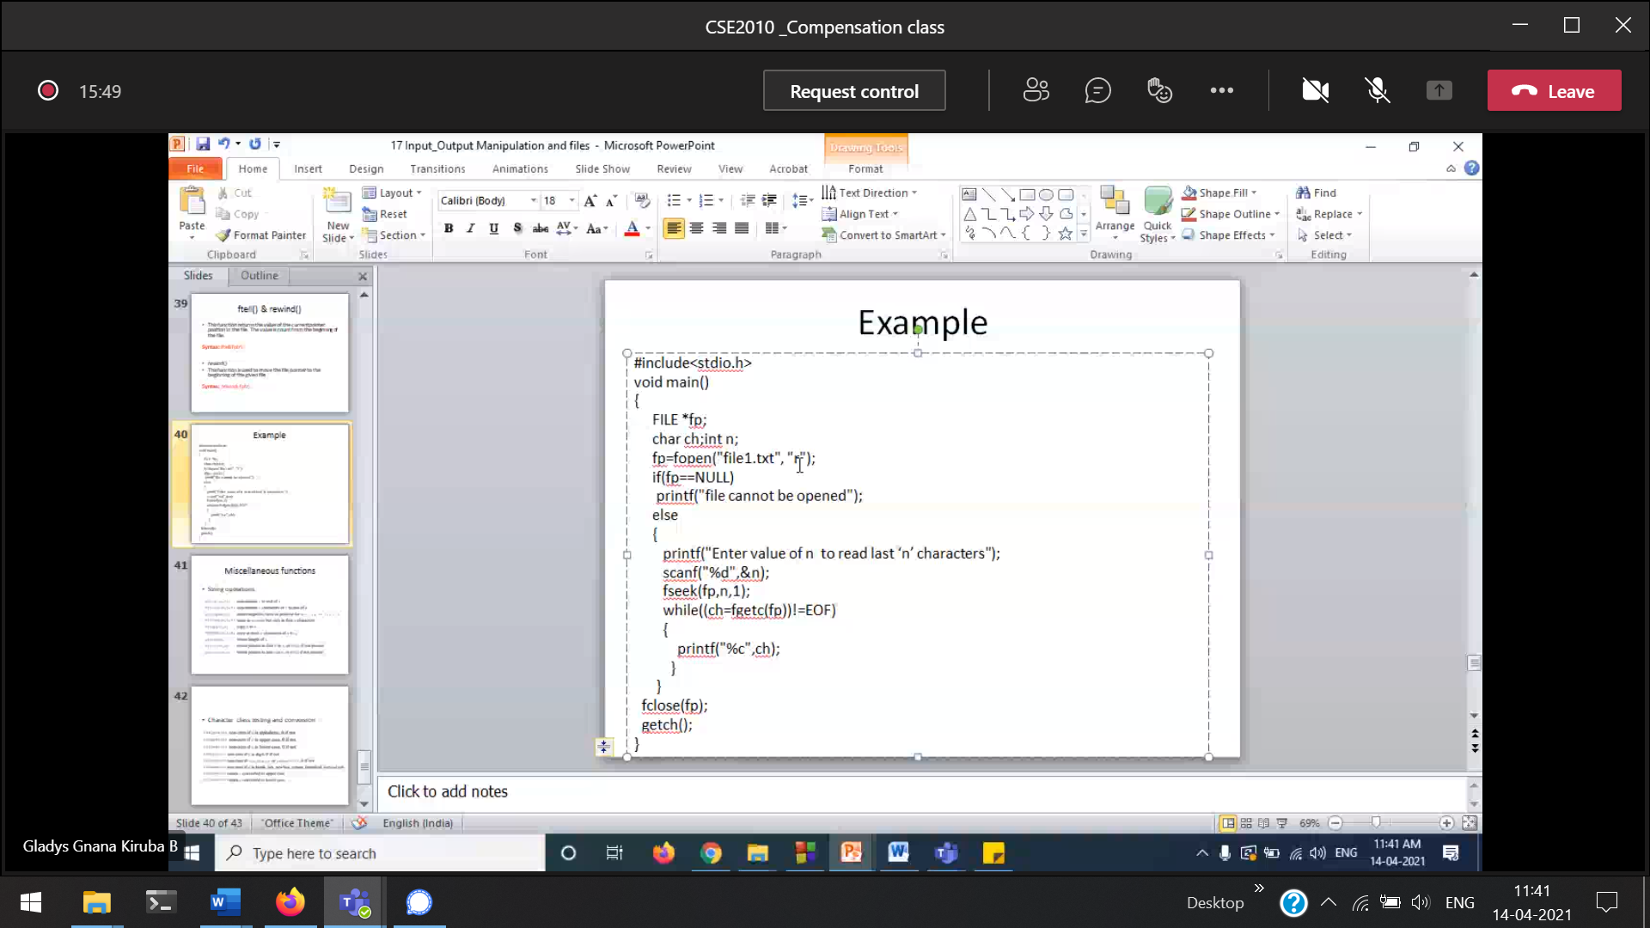

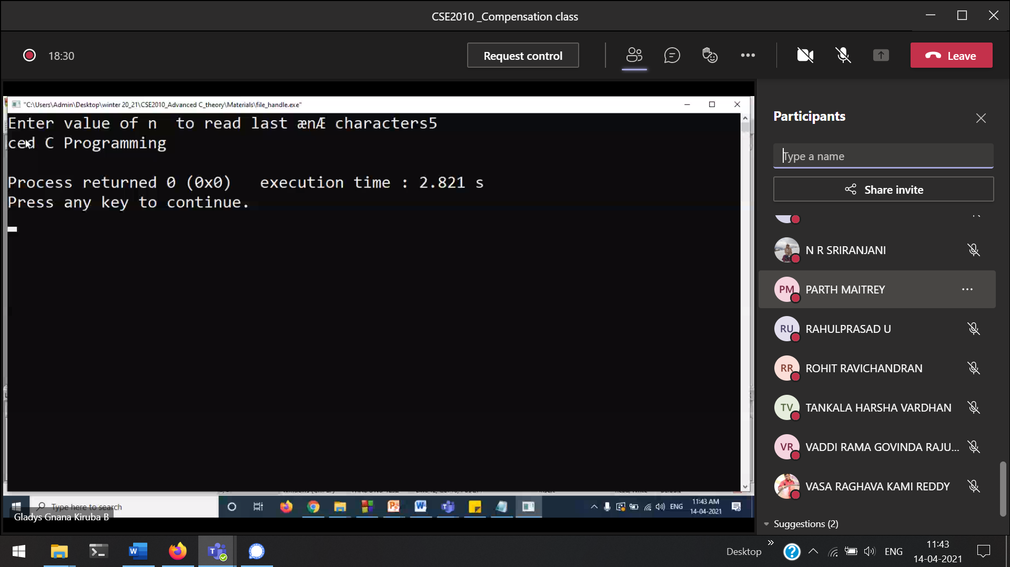

File 🡪 Advanced C programming

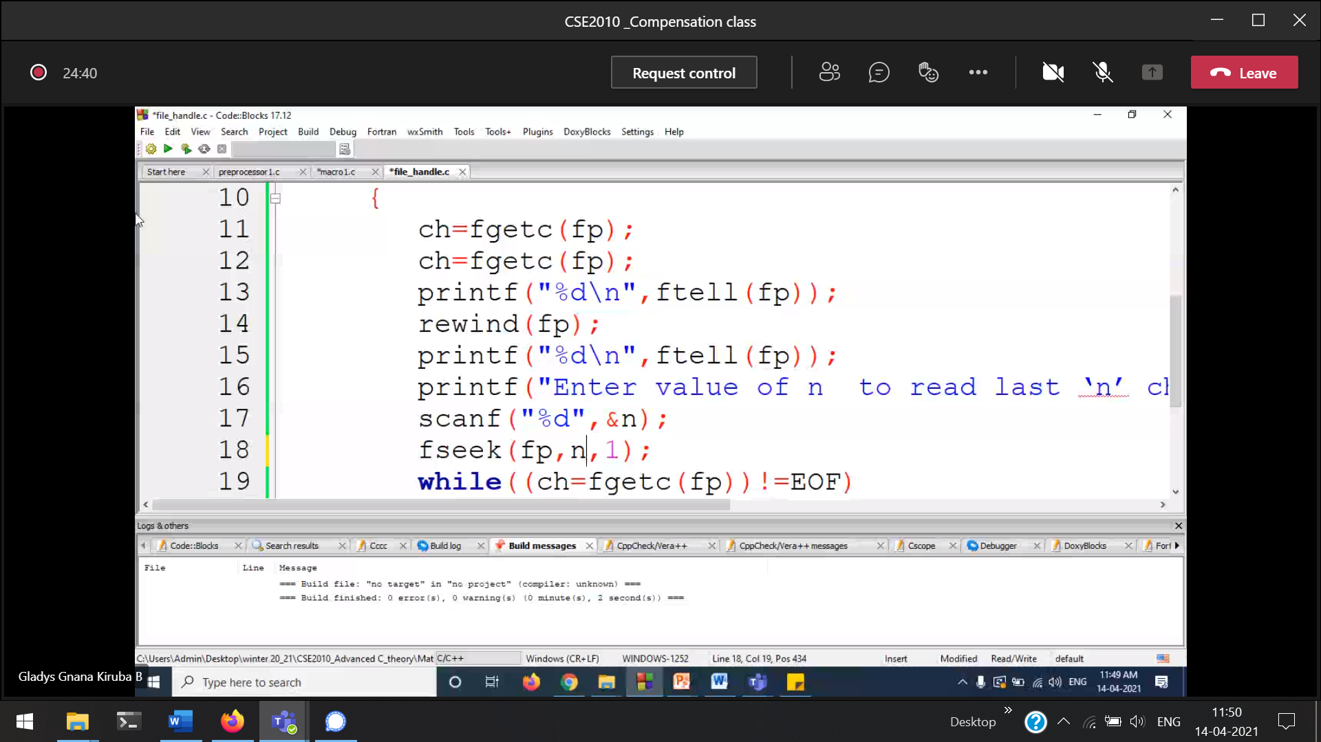

Binary files 🡪 we can access randomly  
Text files 🡪 we should access only sequentially

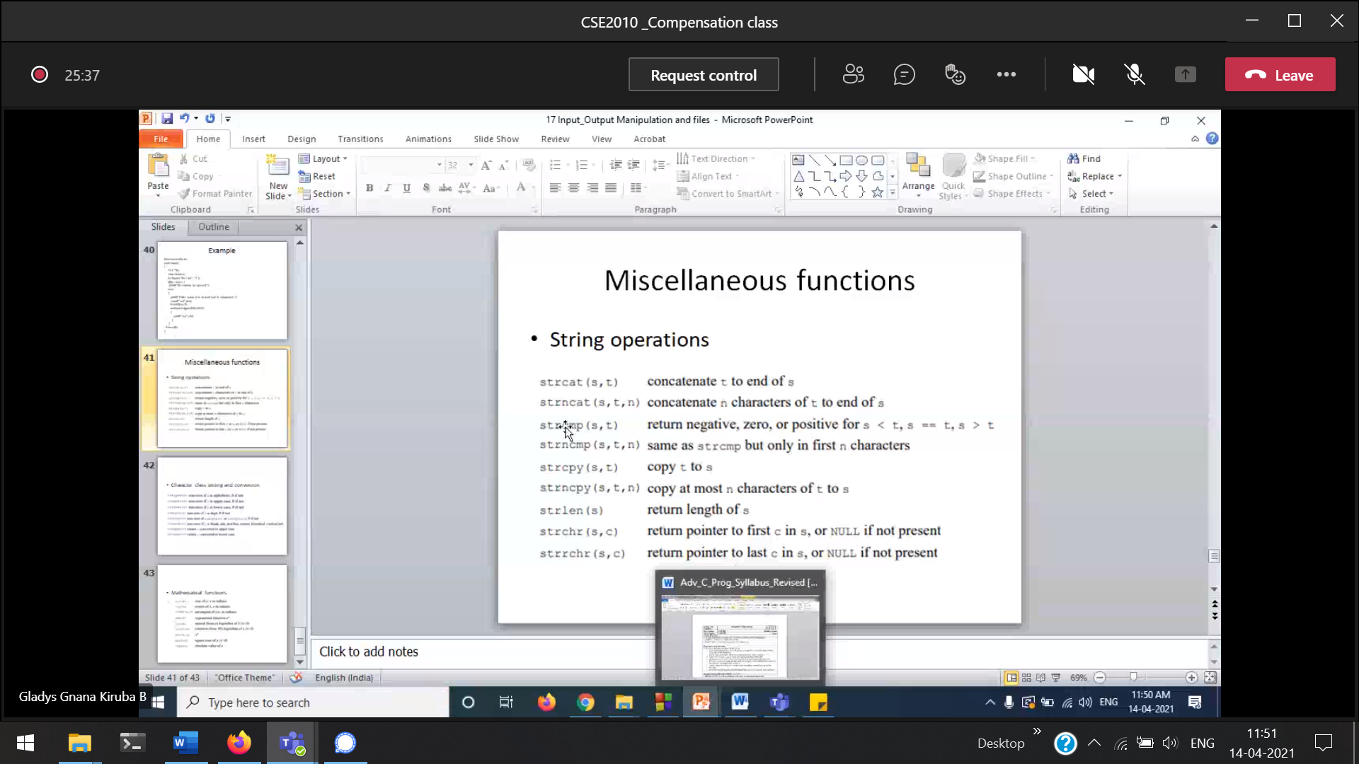

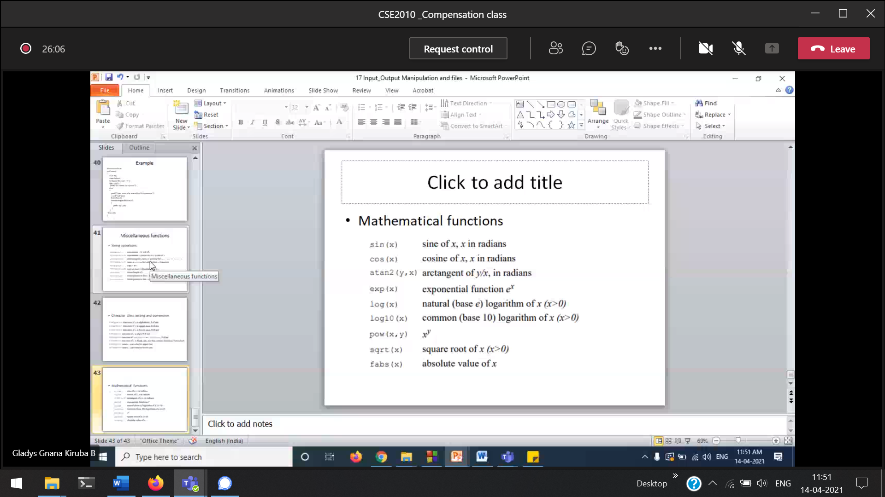

Pre-processor Directives

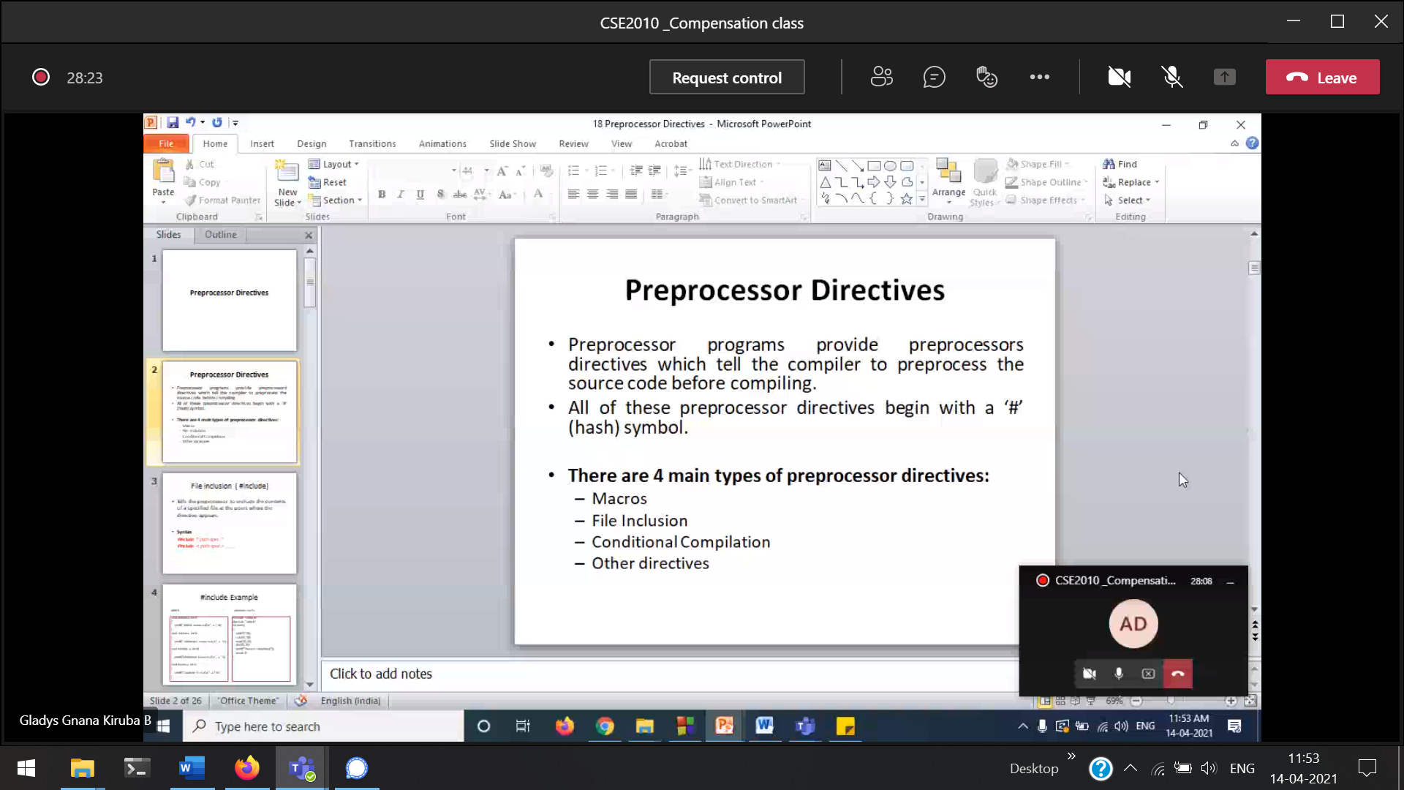

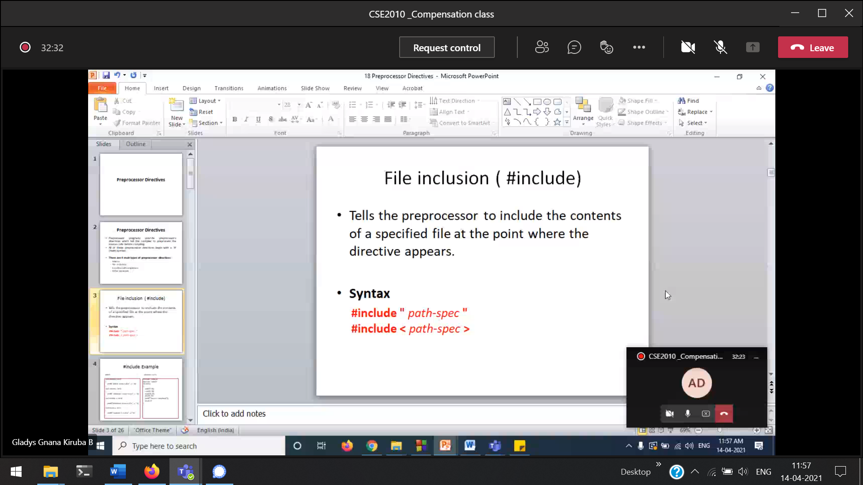

“path-spec” 🡪 current folder (user-defined header file)  
<path-spec> 🡪 predefined header file

We can also create your own header file and include in our program.

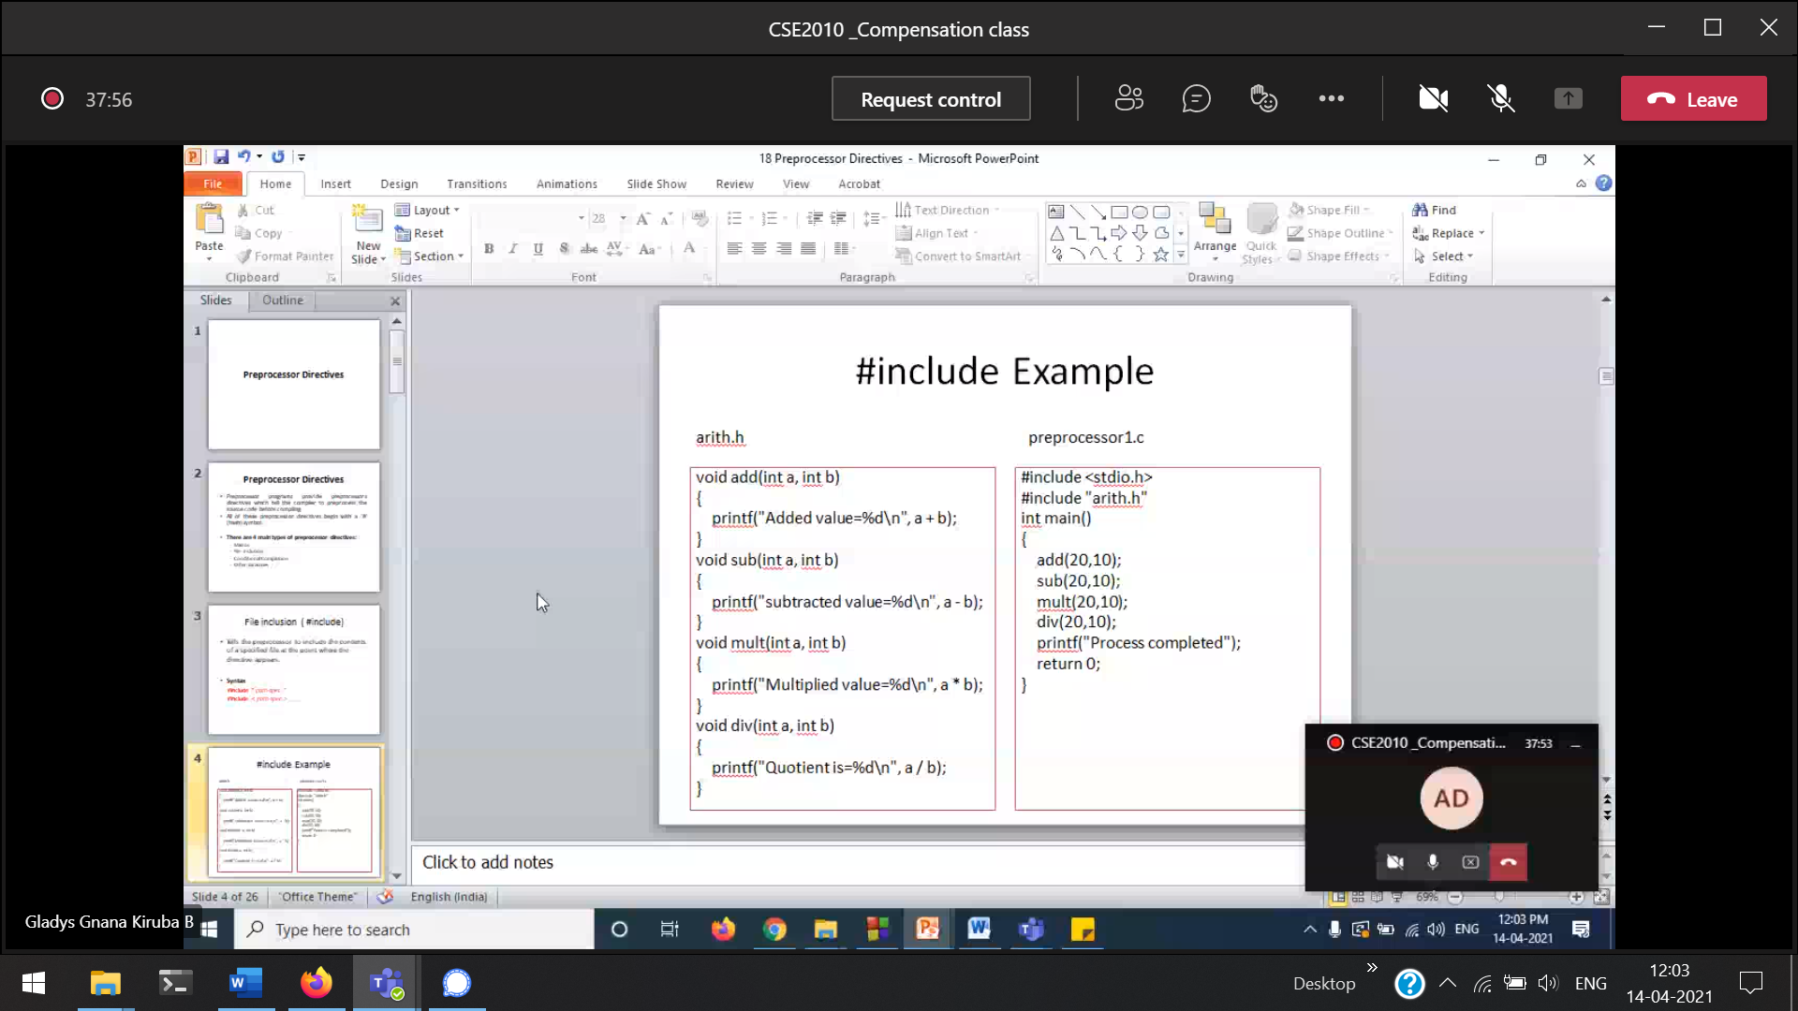

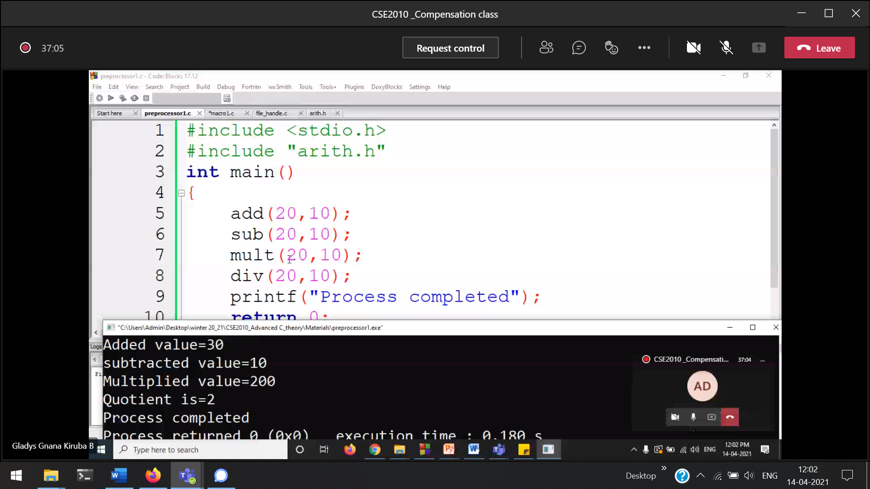

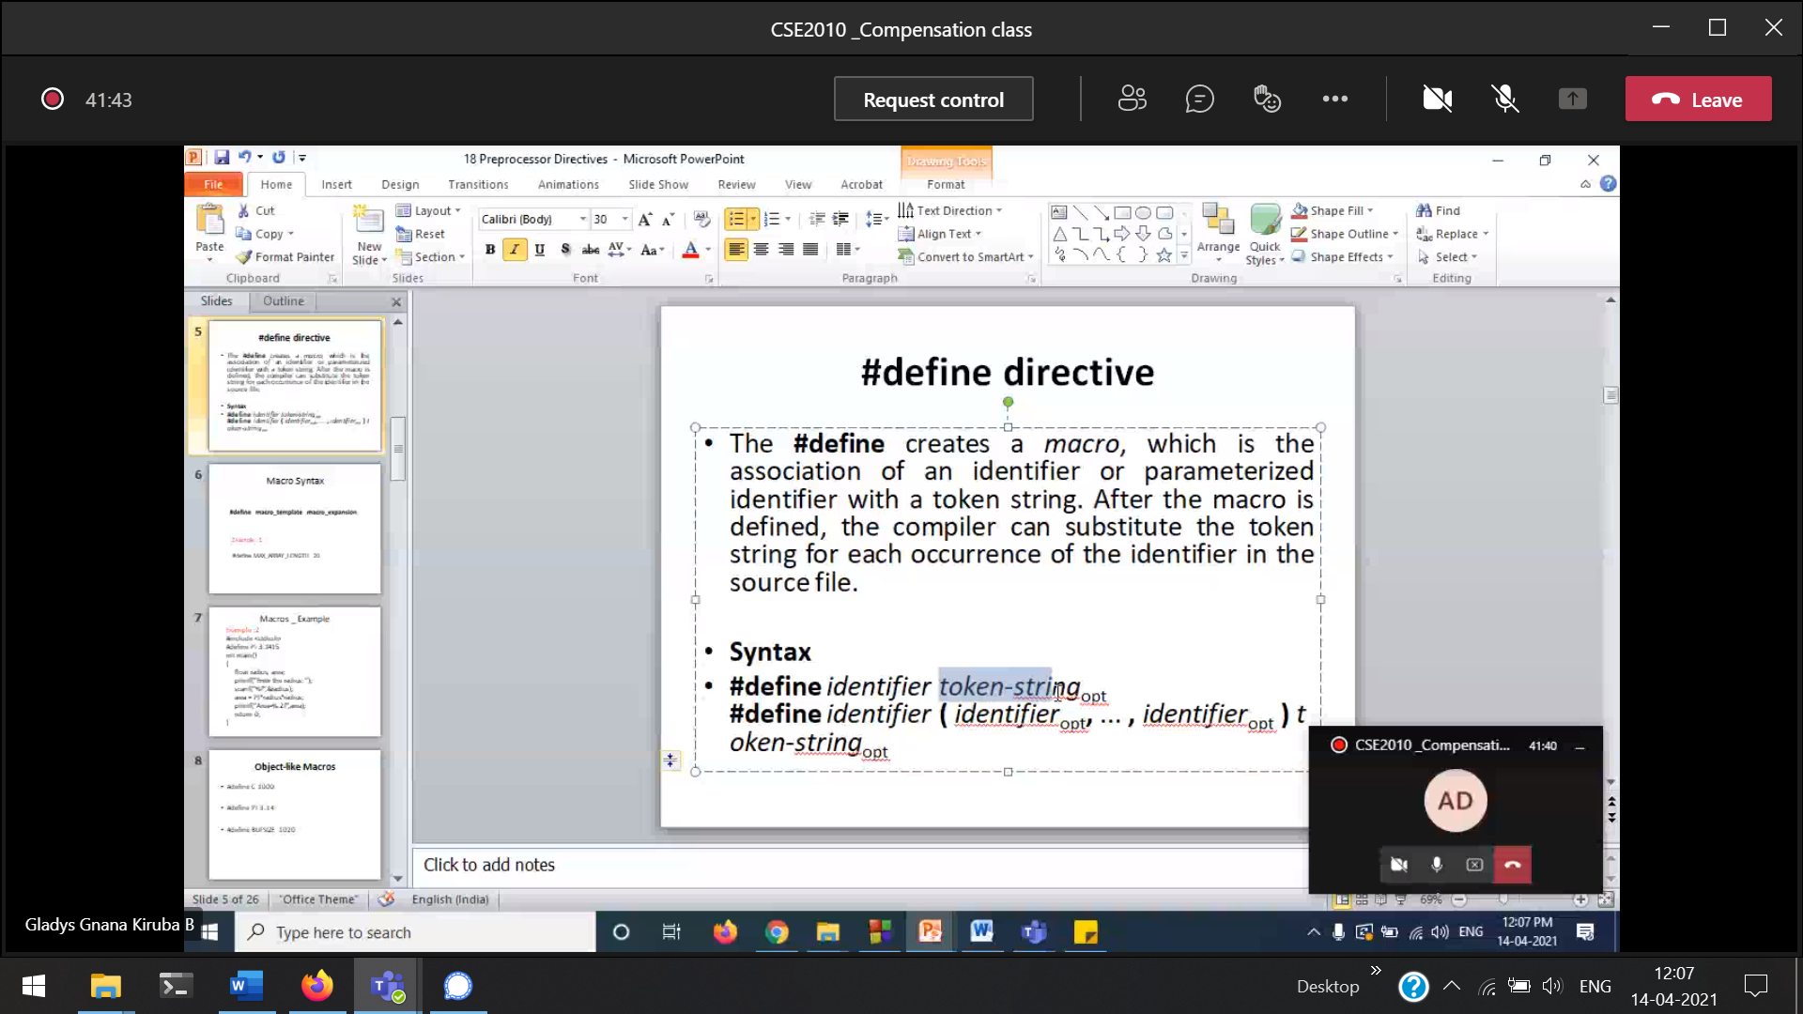

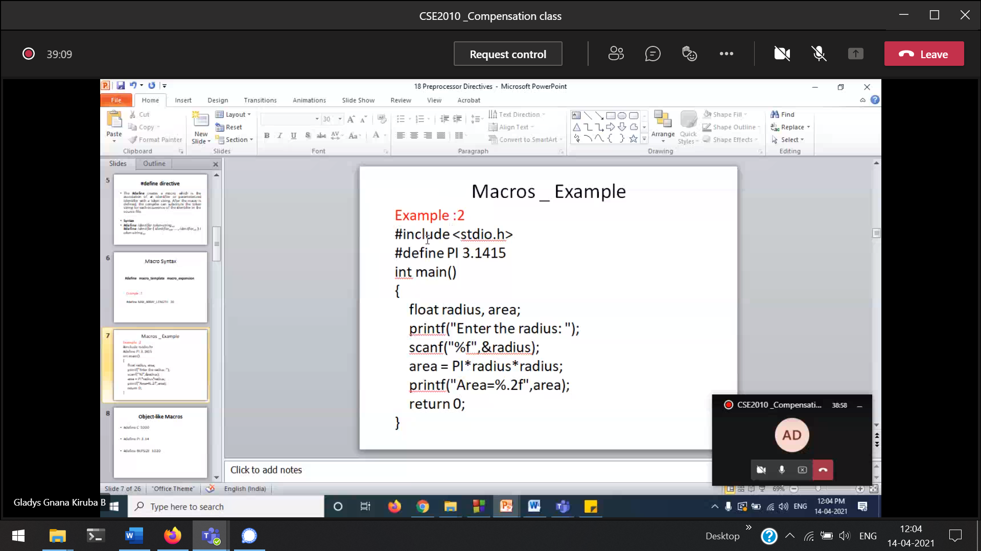

#define 🡪 can be a int, string, array etc ..

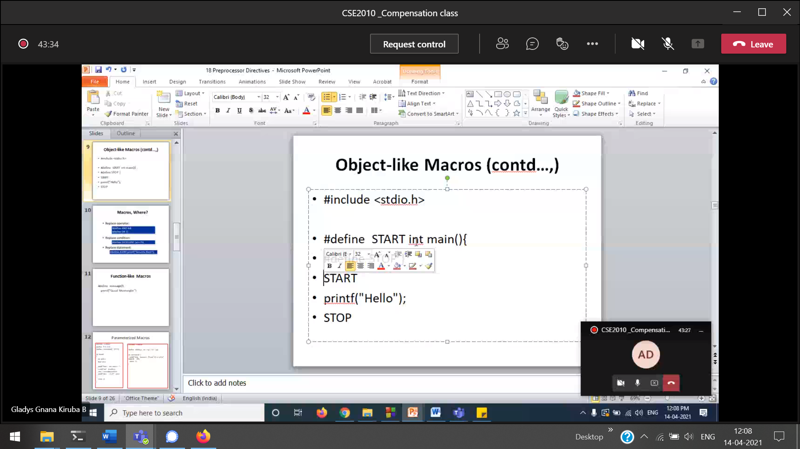

#define 🡪 just replacement

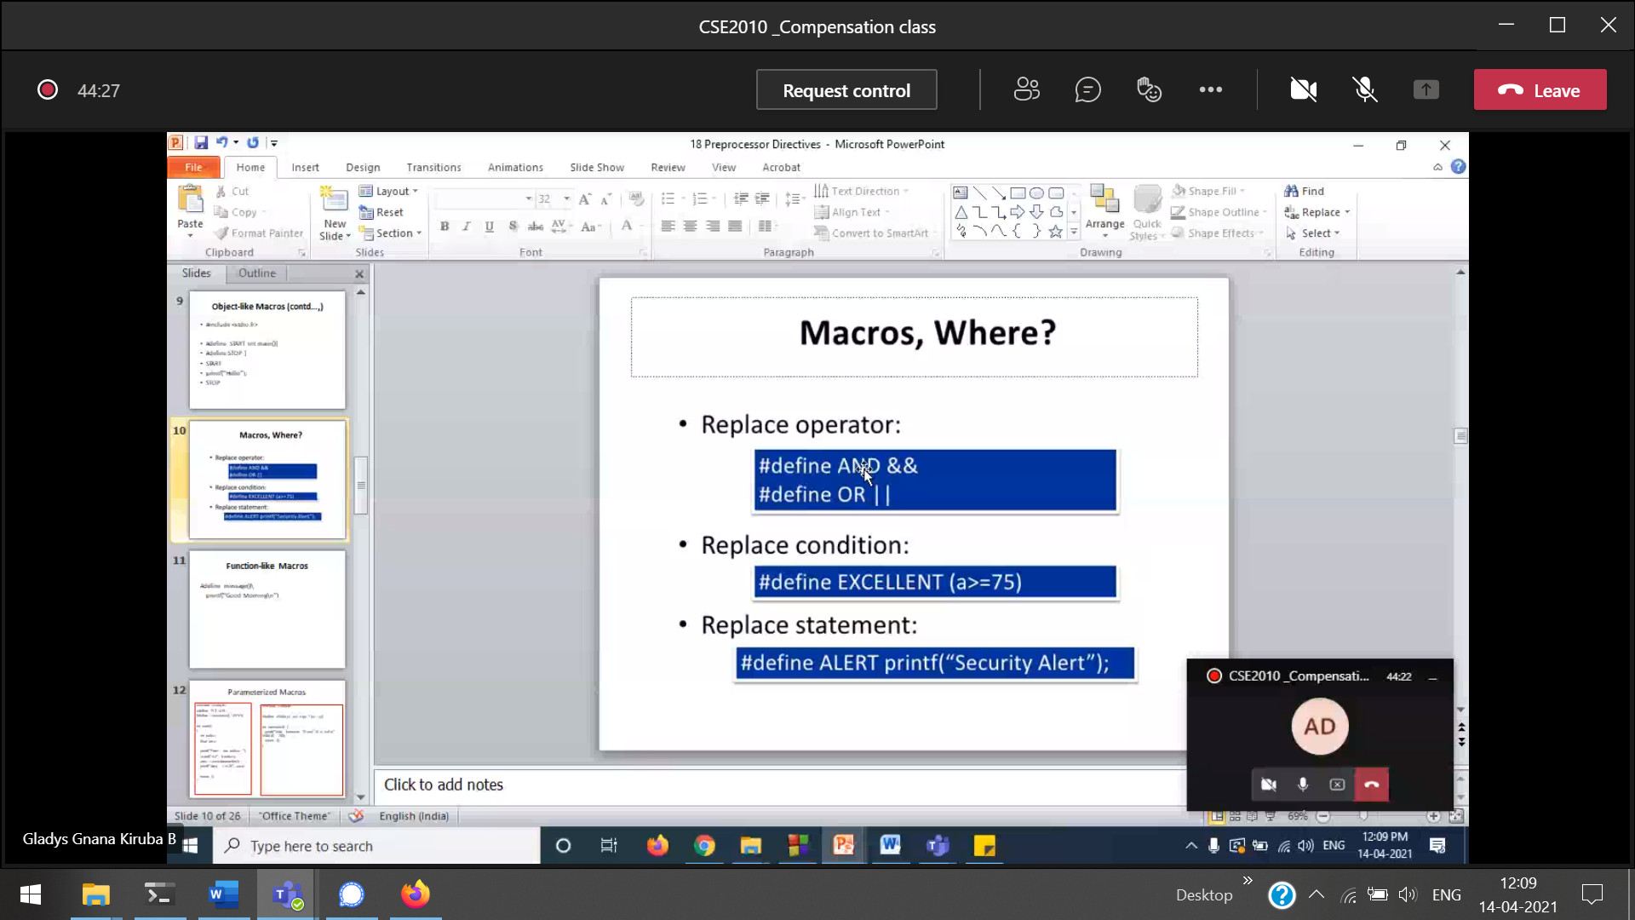

int a =100  
Instead of ‘ If (a>=75) { print(“the number is 75”); }’ we can write   
‘if EXCELLENT { print(“the number is 75”); }’  
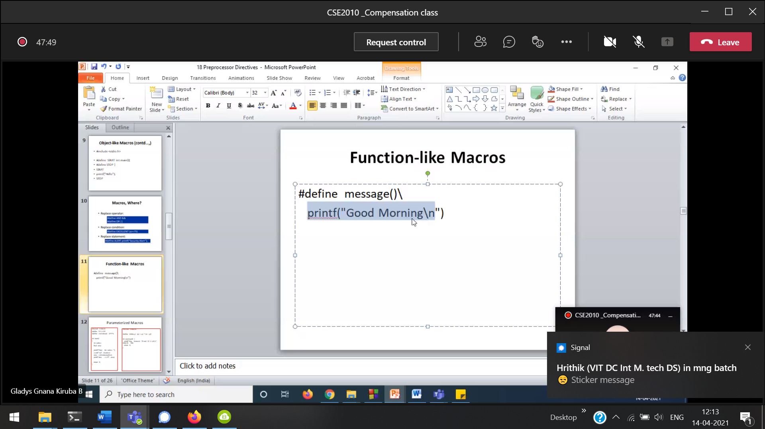

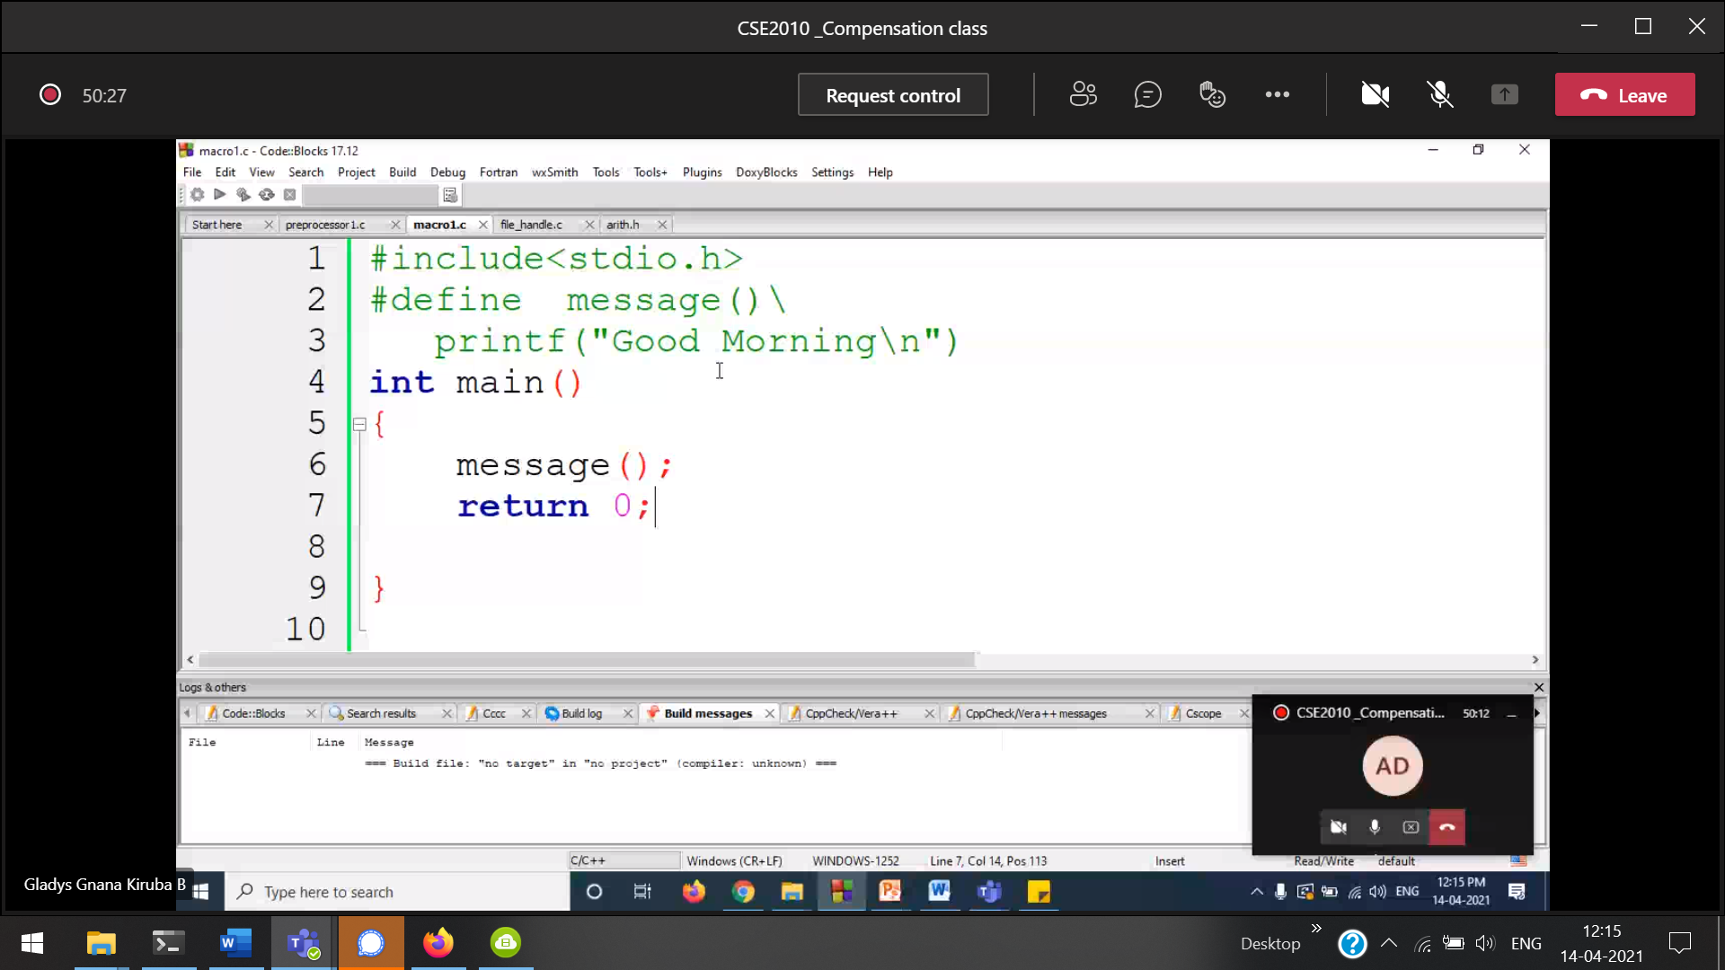

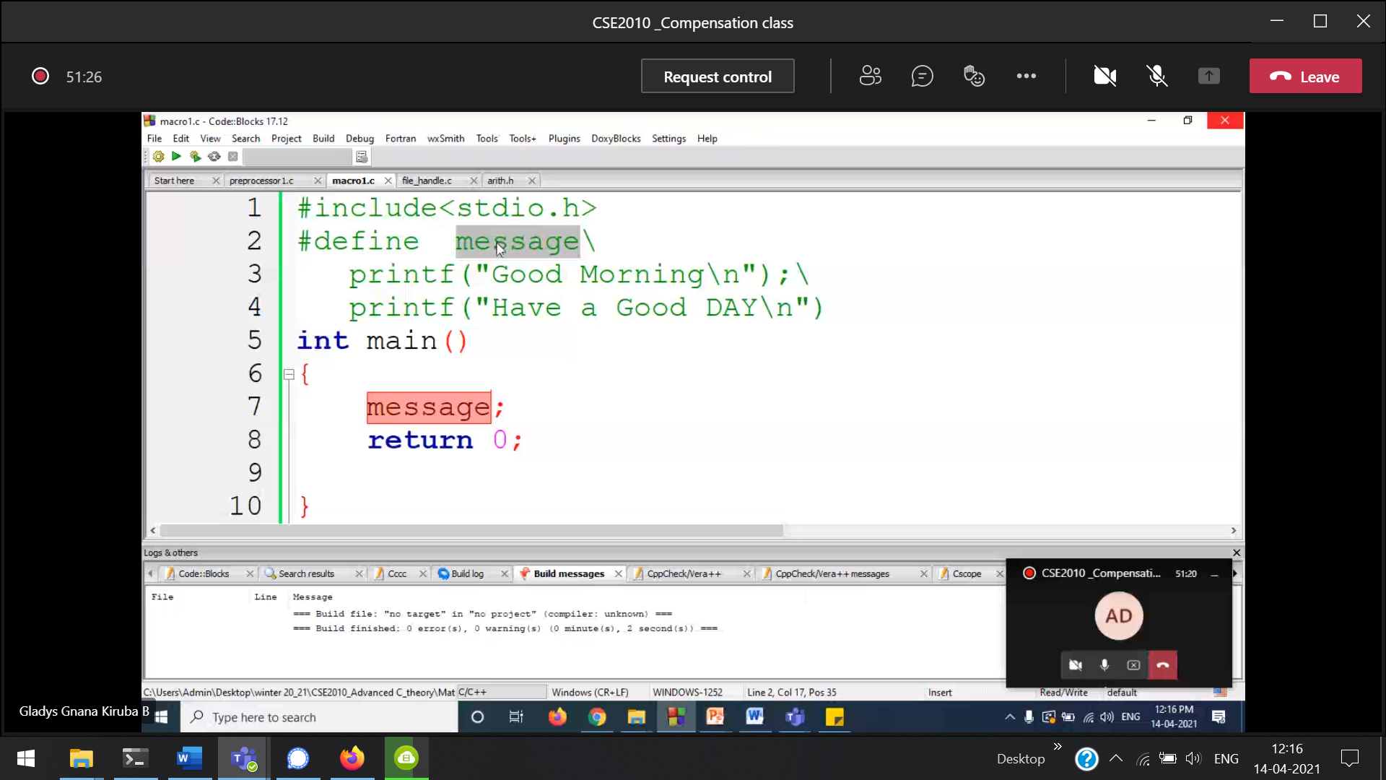

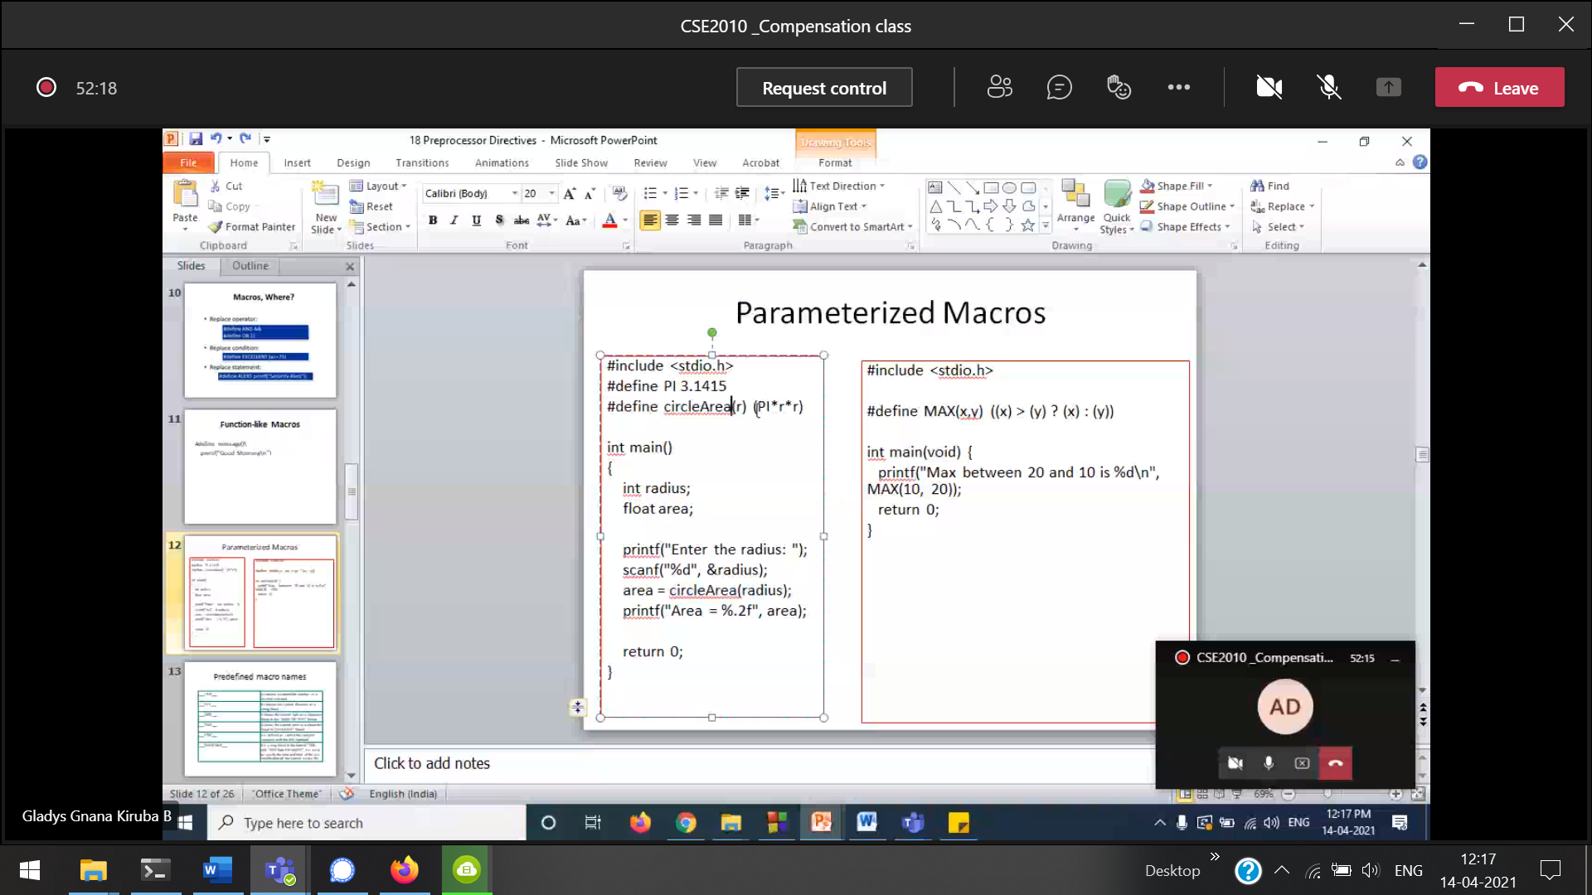

This is not like functions.  
Functions are different. MACROS are different.

